
Key Points

Vacancy Report
November 2016
Release date: 21 December 2016

The Internet Vacancy Index (IVI) fell marginally in November 2016 (in trend terms). The Index is 0.5% below the level recorded a year ago, although it remains 16.8% (or 23,500 advertisements) above the October 2013 low point.
Trend Series  Annual Change  - Four of the eight occupational groups recorded an increase in job advertisements, with Machinery Operators and Drivers recording the strongest increase (up by 6.8%), followed by Labourers (3.8%). Managers recorded the strongest fall (down by 3.8%).  - Job advertisements rose in three states and the ACT, with the strongest rises in South Australia (up by 8.9%) and the ACT (7.9%). The strongest decrease was in the Northern Territory (down by 16.4%), followed by Western Australia (14.9%).  Monthly Change  - Job advertisements fell in six of the eight occupational groups, with the strongest falls recorded for Labourers (down by 1.2%) and Sales Workers (0.9%). The strongest rise was for Clerical and Administrative workers (up by 0.6%).  - Three states and both territories recorded declines over the month. | Seasonally Adjusted Series  Annual Change  - Job advertisements rose in four of the eight occupational groups. The strongest rise was recorded for Machinery Operators and Drivers (up by 8.8%) and the strongest decline for Managers (down by 6.3%).  - Job advertisements rose in three states and the ACT, with the strongest rise recorded in South Australia (up by 10.9%) and the strongest fall in Western Australia (down by 15.1%).  Monthly Change  - Job advertisements rose in five of the eight occupational groups. The strongest rise was recorded for Clerical and Administrative Workers (up by 2.0%).  - Four states recorded increases in job advertisements, with South Australia recording the strongest rise (up by 2.4%). The strongest fall was in Tasmania (down by 4.9%).

Internet Job Advertisements
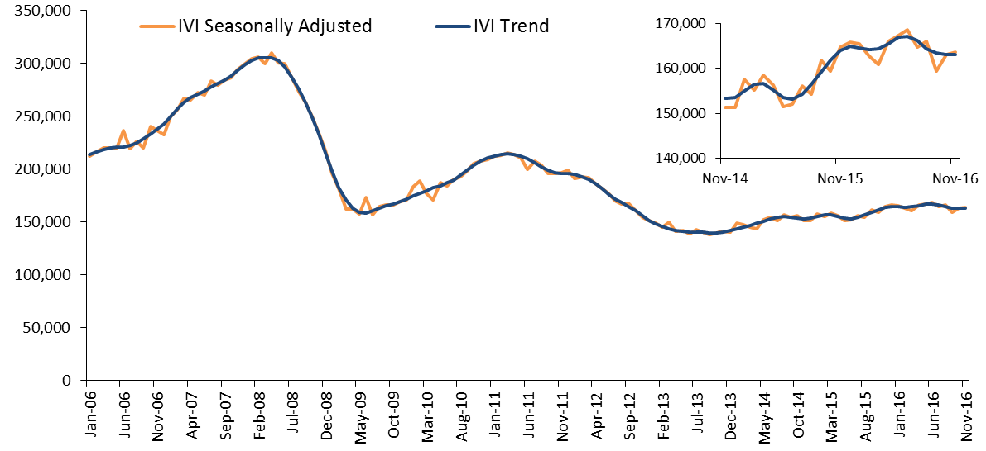

Internet Vacancy Index – Trend Series
In trend terms, the IVI fell marginally in November 2016 (down by 60), following a fall of 0.2% in October. Job advertisements fell in six of the eight occupational groups, and in three states and both territories. The strongest fall was in the Northern Territory (down by 3.0%), followed by Tasmania (1.7%) and the ACT (0.6%).
The pace of annual growth has slowed considerably over 2016. Over the year to November 2016, the IVI has decreased by 0.5%, compared with growth of 6.9% over the year to November 2015. Over the year to November 2016, job advertisements rose in four of the eight occupational groups, with the strongest gains recorded for Machinery Operators and Drivers (up by 6.8%) and Labourers (3.8%). Job advertisements rose in four jurisdictions.
IVI - Trend | Index  (Jan '06 = 100) | Monthly  % change | Yearly  % change | Number of job advertisements
Managers | 101.9 | -0.2 | -3.8 | 21,400
Professionals | 93.5 | 0.3 | -0.6 | 45,000
Technicians and Trades Workers | 84.8 | -0.2 | 1.9 | 20,800
Community and Personal Service Workers | 99.5 | -0.6 | -1.5 | 12,700
Clerical and Administrative Workers | 69.0 | 0.6 | 0.4 | 28,700
Sales Workers | 66.8 | -0.9 | -2.9 | 15,800
Machinery Operators and Drivers | 60.5 | -0.4 | 6.8 | 7700
Labourers | 38.2 | -1.2 | 3.8 | 11,100
States and Territories
New South Wales | 86.9 | 0.0 | 0.6 | 63,800
Victoria | 84.6 | 0.1 | 2.4 | 42,500
Queensland | 58.8 | -0.5 | -1.5 | 29,000
South Australia | 54.1 | -0.1 | 8.9 | 7100
Western Australia | 67.9 | 0.2 | -14.9 | 12,400
Tasmania | 49.7 | -1.7 | -3.3 | 1400
Northern Territory | 67.9 | -3.0 | -16.4 | 1700
Australian Capital Territory | 154.6 | -0.6 | 7.9 | 5100
Australia | 76.3 | 0.0 | -0.5 | 163,100

Internet Vacancy Index – Seasonally Adjusted Series
The seasonally adjusted IVI rose by 0.4% in November 2016, with increases in five of the eight occupational groups. Clerical and Administrative Workers recorded the strongest rise (up by 2.0%), followed by Machinery Operators and Drivers (1.5%). Job advertisements rose in four states, with the strongest increase in South Australia (up by 2.4%). The largest falls were in Tasmania (down by 4.9%) and the Northern Territory (1.6%).
Over the year to November 2016, the IVI fell by 0.7%. Falls were recorded for four of the eight occupational groups, with Managers recording the strongest fall (down by 6.3%). The largest rise was for Machinery Operators and Drivers (up by 8.8%). Job advertisements fell in four jurisdictions, with the strongest fall in Western Australia (down by 15.1%). South Australia recorded the strongest rise (up by 10.9%) followed by the ACT (7.4%).
IVI - Seasonally Adjusted | Index  (Jan '06 = 100) | Monthly  % change | Yearly  % change | Number of job advertisements
Managers | 103.0 | -0.9 | -6.3 | 21,300
Professionals | 94.1 | 1.1 | -0.2 | 45,300
Technicians and Trades Workers | 87.0 | 1.0 | 2.2 | 20,900
Community and Personal Service Workers | 101.8 | -0.4 | -3.5 | 12,800
Clerical and Administrative Workers | 69.5 | 2.0 | 0.3 | 28,900
Sales Workers | 67.4 | -0.9 | -4.8 | 15,700
Machinery Operators and Drivers | 61.9 | 1.5 | 8.8 | 7800
Labourers | 39.0 | 0.1 | 3.4 | 11,200
States and Territories
New South Wales | 87.7 | 0.8 | 0.2 | 64,100
Victoria | 86.4 | 0.9 | 2.4 | 42,700
Queensland | 58.8 | -0.9 | -2.1 | 29,300
South Australia | 55.2 | 2.4 | 10.9 | 7200
Western Australia | 69.2 | 0.9 | -15.1 | 12,500
Tasmania | 48.5 | -4.9 | -5.9 | 1400
Northern Territory | 65.4 | -1.6 | -14.6 | 1700
Australian Capital Territory | 159.2 | -0.7 | 7.4 | 5000
Australia | 77.1 | 0.4 | -0.7 | 163,700

Detailed Occupations – Trend Series
Over the year to November 2016, the largest increases in job advertisements at a more detailed occupational level were recorded for Automotive and Engineering Trades Workers (up by 680 job advertisements), Engineers (600), Engineering, ICT and Science Technicians (550) and Office Managers, Administrators and Secretaries (370). The largest decrease was recorded for Sales Assistants and Salespersons (down by 700), followed by Hospitality, Retail and Service Managers (540), Food Trades Workers (470) and Corporate Managers (400).
Largest growing and declining detailed occupations - Trend | Index  (Jan '06 = 100) | Yearly change | Yearly  % change | Number of job advertisements
Largest growing detailed occupations over the year
Automotive and Engineering Trades Workers | 79.4 | 680 | 16.0 | 5000
Engineers | 65.2 | 600 | 25.0 | 3000
Engineering, ICT and Science Technicians | 100.3 | 550 | 12.2 | 5100
Office Managers, Administrators and Secretaries | 77.1 | 370 | 7.5 | 5300
Other Labourers | 33.9 | 320 | 7.4 | 4600
Sales Representatives and Agents | 79.2 | 280 | 5.1 | 5700
Mobile Plant Operators | 96.4 | 220 | 10.6 | 2300
Machine and Stationary Plant Operators | 73.6 | 210 | 13.1 | 1800
Construction, Production and Distribution Managers | 99.3 | 200 | 4.2 | 4900
Legal, Social and Welfare Professionals | 93.3 | 190 | 4.9 | 4100
Largest declining detailed occupations over the year
General-Inquiry Clerks, Call Centre Workers, and Receptionists | 66.7 | -160 | -1.2 | 12,600
Business, Finance and Human Resource Professionals | 61.7 | -160 | -1.7 | 9400
Sports, Travel and Personal Service Workers | 101.1 | -170 | -8.5 | 1800
Hairdressers, Printing, Clothing and Wood Trades Workers | 70.5 | -180 | -12.5 | 1300
Medical Practitioners and Nurses | 206.0 | -230 | -4.1 | 5400
ICT Professionals | 82.9 | -390 | -3.9 | 9700
Corporate Managers | 100.8 | -400 | -4.1 | 9400
Food Trades Workers | 83.0 | -470 | -11.9 | 3500
Hospitality, Retail and Service Managers | 111.2 | -540 | -10.0 | 4900
Sales Assistants and Salespersons | 63.8 | -700 | -7.5 | 8700

Skill Level – Trend Series
Over the year to November 2016, job advertisements decreased for three of the five skill levels. Skill Level 5 (commensurate with a Certificate I or secondary education) recorded the strongest fall (down by 1.8%). Skill Level 3 (commensurate with a Certificate IV or III (Skilled VET)) recorded the strongest increase in job advertisements (up by 2.3%).
Skill Level IVI – Trend | Index (Jan '06 = 100) | Monthly  % change | Yearly  % change | Number of job advertisements
Skill Level 1 - Bachelor degree or higher | 95.8 | 0.4 | -1.3 | 61,300
Skill Level 2 - Advanced Diploma or Diploma | 110.0 | -0.2 | -1.2 | 17,000
Skill Level 3 - Certificate IV or III* (Skilled VET) | 79.9 | -0.4 | 2.3 | 19,800
Skill Level 4 - Certificate II or III | 71.5 | 0.3 | 0.2 | 44,600
Skill Level 5 - Certificate I or secondary education | 44.7 | -1.2 | -1.8 | 20,700
Australia | 76.3 | 0.0 | -0.5 | 163,100
The skill level of an occupation is based on the level of educational attainment/experience normally required to work in the occupation according to the Australian and New Zealand Standard Classification of Occupations (ANZSCO).
*Includes at least two years of on-the-job training.

State Commentary – Trend Series
Over the year to November 2016, the IVI increased in four jurisdictions, in trend terms. The strongest rise was recorded in South Australia (up by 8.9%), followed by the ACT (7.9%) and Victoria (2.4%).
The three resource-dependent jurisdictions recorded falls in job advertisements over the year, with declines recorded in the Northern Territory (down by 16.4%), Western Australia (14.9%) and Queensland (1.5%). In Western Australia and the Northern Territory, falls in job advertisements were recorded across all skill levels and occupational groups.

IVI – New South Wales, Western Australia and Australia

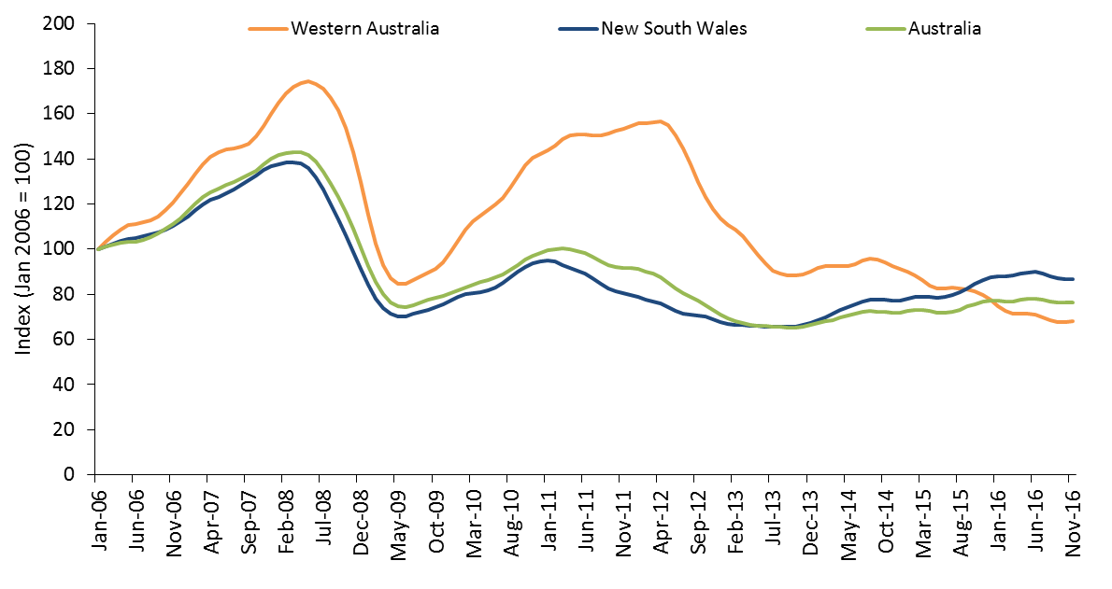
Western Australia’s share of job advertisements has fallen from its peak of 15.7% in June 2012, to stand at 7.6% in November 2016, while the share of job advertisements in New South Wales has increased from a low of 29.6% in March 2012 to 39.1% in November 2016.

Regional Internet Vacancy Index – Three Month Moving Average
Over the year to November 2016, job advertisements increased in 25 of the 37 IVI regions. The strongest growth was recorded in Outback Queensland (up by 30.8%), Port Augusta & Eyre Peninsula SA (up by 29.1%), Riverina & Murray NSW (23.4%), Yorke Peninsula & Clare Valley SA (20.2%) and Goldfields & Southern WA (16.2%). A number of these regions had low levels of job advertisements over the three months to November 2015.
Eight of the 12 regions in which job advertisements fell were in the resource-dependent jurisdictions of Queensland, Western Australia and the Northern Territory, with the largest falls recorded in South West WA (down by 25.2%), Perth (18.4%), Darwin (13.5%), Pilbara & Kimberley WA (13.1%), and Hobart & Southeast Tasmania (12.4%).

Change in internet job advertisements over the year to November 2016
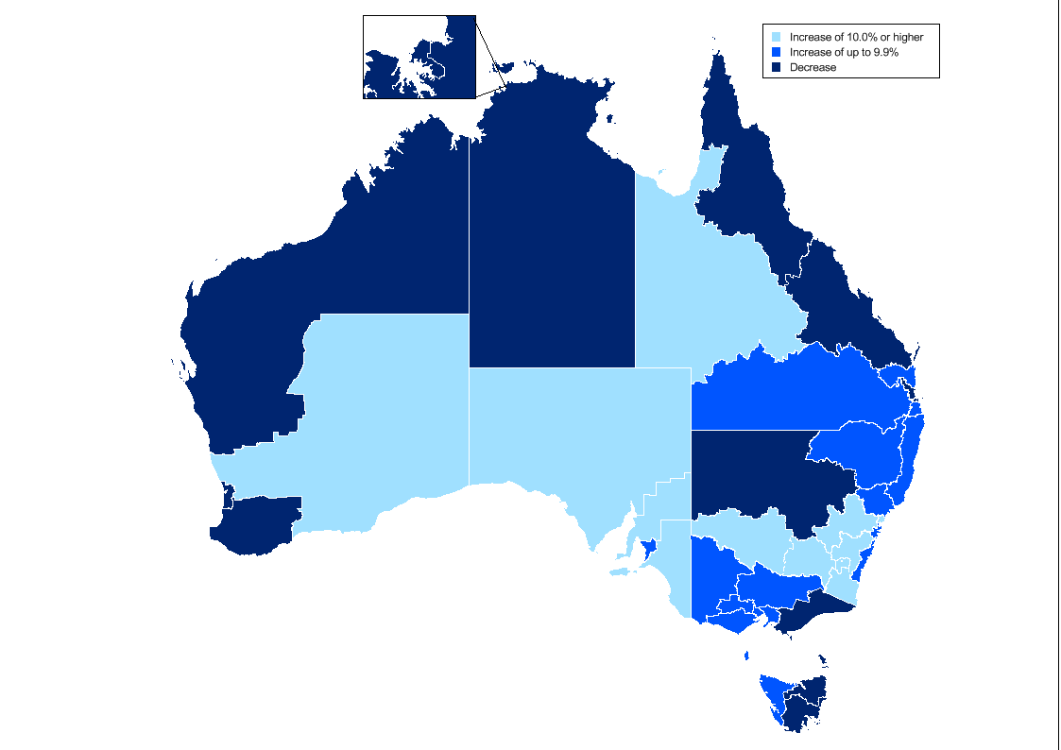

Regional IVI – Three Month Moving Average
Regional IVI – November 2016 | Index  (May '10 = 100) | Yearly % change* | Number of job advertisements
New South Wales
Blue Mountains, Bathurst & Central West NSW | 98.9 | 13.4 | 930
Dubbo & Western NSW | 109.7 | -11.6 | 600
Gosford & Central Coast | 144.7 | 12.3 | 1200
Illawarra & South Coast | 137.7 | 0.8 | 1400
NSW North Coast | 136.5 | 2.1 | 2100
Newcastle & Hunter | 90.2 | 9.9 | 2900
Riverina & Murray | 143.2 | 23.4 | 860
Southern Highlands & Snowy | 143.6 | 14.8 | 480
Sydney | 114.5 | 1.3 | 55,100
Tamworth & North West NSW | 84.6 | 3.3 | 690
Victoria
Ballarat & Central Highlands | 166.4 | 4.3 | 590
Bendigo & High Country | 133.2 | 8.8 | 1500
Geelong & Surf Coast | 118.6 | 5.2 | 1500
Gippsland | 203.5 | -3.8 | 1100
Melbourne | 100.5 | 1.9 | 38,400
Wimmera & Western | 104.0 | 4.4 | 510
Queensland
Brisbane | 83.4 | -3.3 | 18,600
Central Queensland | 70.8 | -3.1 | 1800
Far North Queensland | 99.5 | -3.0 | 3400
Gold Coast | 113.3 | 4.0 | 4000
Outback Queensland | 94.5 | 30.8 | 280
Sunshine Coast | 147.1 | 3.6 | 1700
Toowoomba & South West QLD | 127.2 | 7.6 | 1300
South Australia
Adelaide | 69.8 | 7.9 | 6800
Fleurieu Peninsula & Murray Mallee | 118.6 | 13.4 | 480
Port Augusta & Eyre Peninsula | 102.3 | 29.1 | 280
Yorke Peninsula & Clare Valley | 98.5 | 20.2 | 140
Western Australia
Goldfields & Southern WA | 212.4 | 16.2 | 1000
Perth | 63.1 | -18.4 | 10,500
Pilbara & Kimberley | 218.2 | -13.1 | 1100
South West WA | 68.3 | -25.2 | 550
Tasmania
Hobart & Southeast Tasmania | 61.6 | -12.4 | 910
Launceston & Northeast Tasmania | 108.9 | -1.1 | 380
North West Tasmania | 138.0 | 9.8 | 280
Northern Territory
Darwin | 53.0 | -13.5 | 1400
Regional Northern Territory | 44.2 | -4.4 | 400
Australian Capital Territory
Canberra & ACT | 115.2 | 10.1 | 5200

State and Territory IVI – Trend
State IVI - November 2016 | Index  (Jan '06 = 100) | Monthly % change | Yearly % change | Number of job advertisements
Australia | 76.3 | 0.0 | -0.5 | 163,100
Managers | 101.9 | -0.2 | -3.8 | 21,400
Professionals | 93.5 | 0.3 | -0.6 | 45,000
Technicians and Trades Workers | 84.8 | -0.2 | 1.9 | 20,800
Community and Personal Service Workers | 99.5 | -0.6 | -1.5 | 12,700
Clerical and Administrative Workers | 69.0 | 0.6 | 0.4 | 28,700
Sales Workers | 66.8 | -0.9 | -2.9 | 15,800
Machinery Operators and Drivers | 60.5 | -0.4 | 6.8 | 7700
Labourers | 38.2 | -1.2 | 3.8 | 11,100
New South Wales | 86.9 | 0.0 | 0.6 | 63,800
Managers | 106.0 | 0.0 | -1.8 | 9400
Professionals | 93.6 | 0.0 | -1.2 | 18,100
Technicians and Trades Workers | 109.7 | -0.6 | 3.8 | 7200
Community and Personal Service Workers | 116.2 | -0.3 | 3.8 | 4500
Clerical and Administrative Workers | 77.4 | 0.6 | 3.0 | 12,200
Sales Workers | 71.1 | -0.3 | -0.3 | 6100
Machinery Operators and Drivers | 78.4 | -0.8 | -0.4 | 2500
Labourers | 54.7 | -1.6 | 4.5 | 3800
Victoria | 84.6 | 0.1 | 2.4 | 42,500
Managers | 119.8 | -0.5 | -3.3 | 5700
Professionals | 108.2 | 1.6 | 7.0 | 12,100
Technicians and Trades Workers | 97.3 | -0.6 | 6.9 | 5100
Community and Personal Service Workers | 102.4 | -0.5 | -6.8 | 3100
Clerical and Administrative Workers | 74.4 | 1.0 | 2.8 | 7600
Sales Workers | 72.0 | -0.4 | -1.4 | 4200
Machinery Operators and Drivers | 65.6 | -0.4 | 4.5 | 1900
Labourers | 39.4 | -0.8 | 2.8 | 2700
Queensland | 58.8 | -0.5 | -1.5 | 29,000
Managers | 81.6 | -0.2 | -6.1 | 3100
Professionals | 75.8 | -0.6 | -5.9 | 7300
Technicians and Trades Workers | 57.4 | 0.1 | -0.6 | 4300
Community and Personal Service Workers | 82.7 | -0.6 | -0.6 | 2700
Clerical and Administrative Workers | 52.6 | -0.5 | -4.3 | 4500
Sales Workers | 58.1 | -1.8 | -6.4 | 2900
Machinery Operators and Drivers | 46.7 | 1.0 | 18.7 | 1700
Labourers | 30.8 | -1.0 | 11.4 | 2500
South Australia | 54.1 | -0.1 | 8.9 | 7100
Managers | 67.5 | -1.9 | -6.5 | 710
Professionals | 78.0 | 0.0 | 6.4 | 1600
Technicians and Trades Workers | 55.1 | 0.7 | 8.9 | 1000
Community and Personal Service Workers | 65.7 | -0.7 | 4.7 | 690
Clerical and Administrative Workers | 53.1 | -0.6 | 13.0 | 1100
Sales Workers | 48.2 | -0.5 | 0.0 | 730
Machinery Operators and Drivers | 47.6 | -0.4 | 29.0 | 480
Labourers | 31.8 | 0.1 | 32.6 | 830
Western Australia | 67.9 | 0.2 | -14.9 | 12,400
Managers | 101.2 | -0.2 | -18.9 | 1400
Professionals | 79.4 | 0.7 | -7.8 | 3200
Technicians and Trades Workers | 91.2 | 0.9 | -15.4 | 2100
Community and Personal Service Workers | 124.3 | -0.8 | -12.5 | 1000
Clerical and Administrative Workers | 50.3 | 0.4 | -17.7 | 1900
Sales Workers | 70.6 | -3.1 | -23.4 | 1200
Machinery Operators and Drivers | 62.1 | 1.1 | -2.1 | 910
Labourers | 25.3 | -1.7 | -22.4 | 770
Tasmania | 49.7 | -1.7 | -3.3 | 1400
Managers | 82.2 | 0.5 | 5.6 | 150
Professionals | 92.4 | -1.2 | 3.2 | 330
Technicians and Trades Workers | 48.0 | -3.4 | -14.3 | 180
Community and Personal Service Workers | 69.5 | -0.1 | -1.7 | 180
Clerical and Administrative Workers | 61.2 | -2.0 | 0.0 | 200
Sales Workers | 43.7 | -3.0 | -6.2 | 150
Machinery Operators and Drivers | 33.8 | -1.3 | 28.5 | 90
Labourers | 21.9 | -1.5 | 1.0 | 170
Northern Territory | 67.9 | -3.0 | -16.4 | 1700
Managers | 92.2 | -1.4 | -11.8 | 200
Professionals | 124.1 | -2.9 | -18.0 | 430
Technicians and Trades Workers | 65.0 | -1.9 | -11.3 | 280
Community and Personal Service Workers | 79.4 | -3.7 | -11.3 | 190
Clerical and Administrative Workers | 66.8 | -3.4 | -22.3 | 240
Sales Workers | 60.2 | -0.9 | -11.3 | 140
Machinery Operators and Drivers | 49.6 | -0.3 | -12.4 | 90
Labourers | 29.7 | -1.6 | -9.4 | 140
Australian Capital Territory | 154.6 | -0.6 | 7.9 | 5100
Managers | 148.2 | -1.2 | -6.6 | 650
Professionals | 153.6 | -0.1 | 9.6 | 2000
Technicians and Trades Workers | 198.6 | -1.3 | 3.9 | 460
Community and Personal Service Workers | 270.4 | -0.4 | 12.0 | 380
Clerical and Administrative Workers | 146.5 | 1.6 | 14.0 | 940
Sales Workers | 124.8 | 0.9 | 11.6 | 330
Machinery Operators and Drivers | 112.8 | -3.9 | 14.4 | 70
Labourers | 121.5 | -2.2 | 22.0 | 240

Occupational IVI – Trend
Occupational IVI – November 2016 | Index  (Jan '06 = 100) | Monthly % change | Yearly % change | Number of job advertisements
Managers | 101.9 | -0.2 | -3.8 | 21,400
Chief Executives, Managing Directors & Legislators | 157.0 | 1.1 | 3.2 | 780
Farmers and Farm Managers | 76.5 | -0.1 | 12.8 | 90
Hospitality, Retail and Service Managers | 111.2 | -1.8 | -10.0 | 4900
Corporate Managers | 100.8 | 0.0 | -4.1 | 9400
Construction, Production and Distribution Managers | 99.3 | 0.4 | 4.2 | 4900
Health, Education, ICT and Other Managers | 76.9 | -1.0 | -8.6 | 1300
Professionals | 93.5 | 0.3 | -0.6 | 45,000
Arts and Media Professionals | 84.2 | -0.3 | 5.9 | 790
Education Professionals | 123.6 | 0.4 | -1.1 | 1600
ICT Professionals | 82.9 | -0.5 | -3.9 | 9700
Legal, Social and Welfare Professionals | 93.3 | 1.0 | 4.9 | 4100
Business, Finance and Human Resource Professionals | 61.7 | 1.0 | -1.7 | 9400
Information Professionals | 146.4 | 1.3 | 3.5 | 2000
Sales, Marketing & Public Relations Professionals | 126.2 | 0.8 | -3.4 | 3100
Transport and Design Professionals, and Architects | 151.7 | -0.8 | -1.6 | 2600
Engineers | 65.2 | 3.0 | 25.0 | 3000
Science Professionals and Veterinarians | 67.7 | -0.7 | 9.2 | 580
Health Diagnostic and Therapy Professionals | 212.0 | 0.2 | 6.6 | 2900
Medical Practitioners and Nurses | 206.0 | -1.9 | -4.1 | 5400
Technicians and Trades Workers | 84.8 | -0.2 | 1.9 | 20,800
Engineering, ICT and Science Technicians | 100.3 | 0.9 | 12.2 | 5100
Automotive and Engineering Trades Workers | 79.4 | 1.2 | 16.0 | 5000
Construction Trades Workers | 98.1 | -1.8 | -2.3 | 2800
Electrotechnology and Telecommunications Trades Workers | 73.8 | 1.2 | -2.0 | 1800
Food Trades Workers | 83.0 | -1.9 | -11.9 | 3500
Skilled Animal and Horticultural Workers | 79.8 | -1.4 | 1.6 | 840
Hairdressers, Printing, Clothing and Wood Trades Workers | 70.5 | -1.7 | -12.5 | 1300
Jewellers, Arts and Other Trades Workers | 95.8 | -1.3 | 6.1 | 510
Community and Personal Service Workers | 99.5 | -0.6 | -1.5 | 12,700
Health and Welfare Support Workers | 171.8 | 0.4 | 2.1 | 1100
Carers and Aides | 148.1 | 0.1 | 2.5 | 6000
Hospitality Workers | 61.3 | -0.9 | -2.7 | 3100
Protective Service Workers | 60.4 | -0.3 | 17.6 | 760
Sports, Travel and Personal Service Workers | 101.1 | -1.0 | -8.5 | 1800
Clerical and Administrative Workers | 69.0 | 0.6 | 0.4 | 28,700
Numerical Clerks | 56.4 | 0.1 | -2.4 | 5900
Clerical and Office Support Workers | 66.6 | -1.5 | -10.2 | 650
Other Clerical and Administrative Workers | 94.9 | 1.1 | 2.8 | 4200
Office Managers, Administrators and Secretaries | 77.1 | 1.5 | 7.5 | 5300
General-Inquiry Clerks, Call Centre Workers, and Receptionists | 66.7 | 0.0 | -1.2 | 12,600
Sales Workers | 66.8 | -0.9 | -2.9 | 15,800
Sales Representatives and Agents | 79.2 | 0.1 | 5.1 | 5700
Sales Assistants and Salespersons | 63.8 | -2.1 | -7.5 | 8700
Sales Support Workers | 46.5 | -0.7 | -9.2 | 1300
Machinery Operators and Drivers | 60.5 | -0.4 | 6.8 | 7700
Machine and Stationary Plant Operators | 73.6 | 0.2 | 13.1 | 1800
Mobile Plant Operators | 96.4 | 0.4 | 10.6 | 2300
Drivers and Storepersons | 46.5 | -1.5 | 2.1 | 3700
Labourers | 38.2 | -1.2 | 3.8 | 11,100
Cleaners and Laundry Workers | 41.7 | -2.0 | 7.2 | 1900
Construction and Mining Labourers | 62.8 | 0.2 | 1.9 | 1200
Factory Process Workers | 50.4 | -1.1 | 0.7 | 2000
Farm, Forestry and Garden Workers | 27.1 | -2.1 | 9.5 | 640
Food Preparation Assistants | 31.2 | -4.2 | -1.2 | 780
Other Labourers | 33.9 | -1.0 | 7.4 | 4600
Australian Total | 76.3 | 0.0 | -0.5 | 163,100

State and Territory Skill Level Internet Vacancy Index – Trend
Skill level by State/Territory – November 2016 | Index  (Jan '06 = 100) | Monthly % change | Yearly % change | Number of job advertisements
Australia | 76.3 | 0.0 | -0.5 | 163,100
Skill Level 1 - Bachelor degree or higher | 95.8 | 0.4 | -1.3 | 61,300
Skill Level 2 - Advanced Diploma or Diploma | 110.0 | -0.2 | -1.2 | 17,000
Skill Level 3 - Certificate IV or III* (Skilled VET) | 79.9 | -0.4 | 2.3 | 19,800
Skill Level 4 - Certificate II or III | 71.5 | 0.3 | 0.2 | 44,600
Skill Level 5 - Certificate I or secondary education | 44.7 | -1.2 | -1.8 | 20,700
New South Wales | 86.9 | 0.0 | 0.6 | 63,800
Skill Level 1 - Bachelor degree or higher | 96.6 | 0.2 | -1.9 | 25,500
Skill Level 2 - Advanced Diploma or Diploma | 123.8 | 0.1 | 3.0 | 6600
Skill Level 3 - Certificate IV or III* (Skilled VET) | 94.3 | -0.2 | 3.0 | 7100
Skill Level 4 - Certificate II or III | 81.6 | 0.3 | 2.2 | 17,300
Skill Level 5 - Certificate I or secondary education | 58.6 | -1.7 | 1.2 | 7400
Victoria | 84.6 | 0.1 | 2.4 | 42,500
Skill Level 1 - Bachelor degree or higher | 110.8 | 1.4 | 5.3 | 16,500
Skill Level 2 - Advanced Diploma or Diploma | 133.5 | -0.6 | -1.5 | 4400
Skill Level 3 - Certificate IV or III* (Skilled VET) | 89.6 | -0.2 | 12.6 | 5100
Skill Level 4 - Certificate II or III | 75.6 | 0.3 | -0.8 | 11,400
Skill Level 5 - Certificate I or secondary education | 47.0 | -1.2 | -1.4 | 5200
Queensland | 58.8 | -0.5 | -1.5 | 29,000
Skill Level 1 - Bachelor degree or higher | 77.0 | -0.5 | -5.7 | 9600
Skill Level 2 - Advanced Diploma or Diploma | 78.4 | -0.4 | -4.9 | 3000
Skill Level 3 - Certificate IV or III* (Skilled VET) | 57.7 | -0.2 | -0.6 | 3900
Skill Level 4 - Certificate II or III | 57.3 | -0.1 | 1.2 | 8200
Skill Level 5 - Certificate I or secondary education | 37.0 | -1.2 | 1.7 | 4400
South Australia | 54.1 | -0.1 | 8.9 | 7100
Skill Level 1 - Bachelor degree or higher | 74.8 | 0.1 | 5.7 | 2100
Skill Level 2 - Advanced Diploma or Diploma | 79.5 | 0.7 | 1.5 | 720
Skill Level 3 - Certificate IV or III* (Skilled VET) | 52.6 | 0.3 | 10.3 | 920
Skill Level 4 - Certificate II or III | 52.0 | -1.0 | 9.4 | 2100
Skill Level 5 - Certificate I or secondary education | 35.4 | -0.4 | 18.8 | 1400
Western Australia | 67.9 | 0.2 | -14.9 | 12,400
Skill Level 1 - Bachelor degree or higher | 82.1 | 1.1 | -10.3 | 4100
Skill Level 2 - Advanced Diploma or Diploma | 102.7 | -0.3 | -13.4 | 1400
Skill Level 3 - Certificate IV or III* (Skilled VET) | 94.5 | 0.4 | -19.4 | 2000
Skill Level 4 - Certificate II or III | 64.5 | 0.8 | -12.1 | 3600
Skill Level 5 - Certificate I or secondary education | 32.0 | -3.6 | -23.2 | 1400
Tasmania | 49.7 | -1.7 | -3.3 | 1400
Skill Level 1 - Bachelor degree or higher | 86.7 | -0.6 | 2.1 | 430
Skill Level 2 - Advanced Diploma or Diploma | 86.8 | -1.3 | -8.8 | 150
Skill Level 3 - Certificate IV or III* (Skilled VET) | 43.4 | -1.8 | -4.4 | 150
Skill Level 4 - Certificate II or III | 51.8 | -1.1 | 1.1 | 430
Skill Level 5 - Certificate I or secondary education | 26.6 | -3.8 | -7.9 | 280
Northern Territory | 67.9 | -3.0 | -16.4 | 1700
Skill Level 1 - Bachelor degree or higher | 112.0 | -2.6 | -15.9 | 560
Skill Level 2 - Advanced Diploma or Diploma | 101.4 | -1.9 | -16.5 | 210
Skill Level 3 - Certificate IV or III* (Skilled VET) | 65.9 | -0.8 | -12.1 | 260
Skill Level 4 - Certificate II or III | 59.9 | -2.7 | -15.9 | 440
Skill Level 5 - Certificate I or secondary education | 36.8 | -2.0 | -9.6 | 230
Australian Capital Territory | 154.6 | -0.6 | 7.9 | 5100
Skill Level 1 - Bachelor degree or higher | 155.3 | -0.4 | 6.4 | 2500
Skill Level 2 - Advanced Diploma or Diploma | 177.6 | 0.1 | 3.3 | 560
Skill Level 3 - Certificate IV or III* (Skilled VET) | 202.6 | -0.4 | 3.0 | 430
Skill Level 4 - Certificate II or III | 164.2 | 0.9 | 18.0 | 1100
Skill Level 5 - Certificate I or secondary education | 106.1 | -1.6 | 14.8 | 470
The skill level is derived based on a classification used by the Australian Bureau of Statistics that measures skill level of occupations according to the level of educational attainment/experience commensurate with each occupation.
*Includes at least 2 years on-the-job training.

Explanatory Notes
- The monthly Internet Vacancy Index (IVI) is based on a count of online job advertisements newly lodged on SEEK, CareerOne and Australian JobSearch during the month. Duplicate advertisements are removed before the IVI job advertisements are coded by the Department of Employment to occupations based on the Australian and New Zealand Standard Classification of Occupations (ANZSCO). The data are seasonally adjusted and trended, and then indexed (January 2006 = 100).
- The IVI does not reflect the total number of job advertisements in the labour market as it does not include jobs advertised through other online job boards, employer websites, or in newspapers. Nor does it take account of vacancies filled using informal methods such as word of mouth. The IVI also does not take account of multiple positions being advertised in a single job advertisement. In addition, Department of Employment research indicates that around one third of vacancies are not formally advertised. More information on this research can be found at http://lmip.gov.au/default.aspx?LMIP/RecruitmentAnalysis.
- The Regional IVI was first published in September 2010 and back cast to May 2010. The Regional IVI concords job advertisements to 37 best fit regions across the states and territories from the three job boards. There were 38 regions until February 2016, after which the Blue Mountains region was amalgamated with the Bathurst and Central West NSW region to create the Blue Mountains, Bathurst and Central West Region NSW.
- Over the five months to August 2015, there was a reduction in the number of new job advertisements listed on the Australian JobSearch (AJS) website. This may have been as a result of the transition of employment services from Job Services Australia to jobactive, and had a relatively larger impact on the number of job advertisements advertised in some regional areas.
- For more information, please contact James Jordan (02 6240 2597) or email James.jordan@employment.gov.au. Media enquiries should be directed to the Department of Employment media unit (media@employment.gov.au).

Acknowledgements
The Department of Employment thanks the following job boards for their contribution to the Vacancy Report:


Forthcoming release dates (release time 11am):
For data covering: | Release date:
December 2016 | 25 January 2017
January 2017 | 22 February 2017
February 2017 | 22 March 2017
March 2017 | 26 April 2017
April 2017 | 24 May 2017
May 2017 | 21 June 2017
June 2017 | 26 July 2017
July 2017 | 23 August 2017
August 2017 | 20 September 2017
September 2017 | 25 October 2017
October 2017 | 22 November 2017
November 2017 | 20 December 2017
December 2017 | 24 January 2018

At Census 2011, only 4 per cent of Automotive and Engineering Trades Workers were employed in Motor Vehicle and Motor Vehicle Parts Manufacturing, while the largest employing sector of these workers was Automotive Repair and Maintenance (22 per cent).
There were 38 regions until February 2016, after which the Blue Mountains region was amalgamated with the Bathurst and Central West NSW region to create the Blue Mountains, Bathurst and Central West Region NSW.

