BLEAKER EXPECTATIONS BEFORE RECENT SHOCKS

Further weakness in business conditions is expected for the three-month period to 30 September 2016. According to Dun & Bradstreet’s June Business Expectations Survey, expectations for Sales and Selling Prices have plunged to their lowest levels since 2014, while the outlook for Capital Investment is showing signs of recovery.
The survey pre-dates the ‘Brexit’ vote and Australian Federal election which can only be expected to damage relatively fragile business confidence.
Dun & Bradstreet’s Business Expectations Index, the average of the survey’s measures of Sales, Profits, Employment and Capital Investment, has consolidated at 12.3 points for the third quarter of 2016, compared to 12.7 points for Q2 2016, and down from 17.6 points in Q3 2015. The figure is 5.0 points above the 10-year average of 7.3 points.
The Actuals Index halved to 6.1 points from 12.7 points last quarter, and brought an end to three consecutive quarters of growth. The Actual Employment Index plummeted to 2.3 points - its lowest level since late-2013, with the Construction and Retail sectors reporting more decreases than increases in staff numbers. Both sectors maintain a weak outlook for the quarter ahead.
According to Stephen Koukoulas, Economic Advisor to Dun & Bradstreet: “The slide in business expectations over the past year appears to have been arrested in the most recent survey. It should be noted that the survey was conducted prior to the shock Brexit vote, so the results must be treated with caution.”
Koukoulas also observed “there were some mildly encouraging signs, with expectations for capital expenditure edging up from the recent low point. There were, worryingly, signs of further weakness in expected sales and selling prices, the latter of which points to ongoing low inflation.”

The Business Expectations Index is an aggregate of the survey’s
measures of sales, profits employment and investment expectations.

All indices experienced a decline, with the exception of Capital Investment Expectations, which increased by 1.6 points. However, at 10.3 points, the index is still at its lowest level since mid-2014. Despite this, the Manufacturing and Services industries forecast significant improvement in conditions for the quarter ahead, particularly in respect to Sales, Profits, Employment and Capital Investment.

The Actual Profits Index fell to a four-year low of 1.1 points, while the Actual Employment and Actual Selling Prices indices fell to two-and-a-half year lows of 2.3 points and 8.4 points, respectively. The Construction industry was particularly hard-hit, with its Sales, Profits, Employment and Selling Prices plunging into negative territory.

The Construction sector also faces the bleakest outlook, with its Expectations Index falling to a three-year low of 3.0 points, compared to 11.3 points for the first six months of the year. The industry’s Profits Expectations Index plunged to -5.4 points, down from 5.6 points in Q2 2016 and 3.4 points in Q3 2015. The survey found 27.6% of Construction businesses believe their operations will be mostly influenced by consumer confidence in the quarter ahead, while an equal number believe cash flow is the biggest issue.

The Retail industry fared poorly for the first three months of the year, with its Actual Sales and Actual Employment indices falling to -3.9 points and -4.3 points respectively. The sector’s Sales Expectations, at 17.5 points, are also at their lowest level since Q4 2013, while Employment Expectations, at 0.2 points, are at their lowest level since Q3 2013.
Market shocks in the wake of the United Kingdom’s decision to withdraw from the European Union are expected to further impact economic confidence; however, interest rates are anticipated to remain low. The latest survey found 22.2% of businesses see weak demand for products and services as the biggest barrier to growth in the year ahead, down from 26.0% during the same period last year.
“The next few Business Expectations Surveys will, arguably, hold a great sway as they will reflect the business reaction to Brexit and the result of the recent Federal election. Any slide in expectations will likely see the Reserve Bank opt to cut interest rates to fresh record lows”, Koukoulas added.

===

Contacts:
James Malkin | Stephen Koukoulas
MalkinJ@dnb.com.au | Stephen@thekouk.com
+61 3 9828 3273 | +61 467 647 508
The latest D&B Business Expectations Survey shows:
Expectations index for the September quarter 2016:
- The Employment Expectations Index has decreased to 8.2 points, down from 8.3 points in the previous quarter and 11.6 points a year ago.
- The Sales Expectations Index has dropped to 21.4 points, down from 23.6 points in the previous quarter and 28.8 points a year ago.
- Profits expectations for the quarter have fallen to 9.4 points, compared to 10.2 points in the previous quarter and 17.1 points at the same time last year.
- Plans for Capital Investment are up, with the index at 10.3 points, from 8.7 points in the previous quarter, but down from 12.9 points in Q3 2015.
- The Selling Prices Expectations Index has decreased to 9.2 points, down from 13.7 points in the previous quarter and 14.4 points at the same time last year.
Issues expected to influence operations in the September quarter 2016:
- 62.0 per cent of businesses are more optimistic about growth in the next 12 months compared to 2015, while 29.0 per cent are less optimistic and 9.0 per cent are undecided.
- Consumer confidence (34.4 per cent) is identified as the issue most likely to influence business operations in the next quarter, followed by cash flow (15.4 per cent) and the level of the Australian dollar (13.4 per cent)
- 22.2 per cent of businesses see weak demand for their products and services as the biggest barrier to growth in the year ahead, while 12.4 per cent see a shortage of skilled labour as the biggest barrier.
- 30.8 per cent of businesses reported having a customer or supplier that became insolvent, or was otherwise unable to pay them in the past year.
- 43.4 per cent of businesses would choose to miss payments to trade suppliers if unable to pay all their bills on time, followed by a business credit card (21.0 per cent).
- 25.6 per cent of businesses would prefer a higher Australian dollar and 15.8 per cent a lower dollar, while 53.2 per cent think that it doesn’t matter. 5.4 per cent are unsure.
- 11.9 per cent of businesses intend to seek finance or new credit in the quarter ahead to help their business grow, while 79.8 per cent will not, and 8.3 per cent are undecided.
Actual results reported for the March quarter 2016:
- Actual employment for the March quarter was down significantly, with the index at 2.3 points, compared to 8.5 points in the previous quarter, and down from 5.1 points last year.
- Sales activity was down at 12.7 points, compared to 22.4 points in the previous quarter, and down from 10.1 points last year.
- The Actual Profits Index decreased from 8.0 points in Q4 2015 to 1.1 points, and 4.8 points recorded at the same time last year.
- Capital Investment activity decreased to 8.2 points from 11.9 points in the previous quarter, but was up from 6.2 points last year.
- Selling prices were down, with the index at 8.4 points compared to 11.2 points in the previous quarter and 10.9 points last year.

About Dun & Bradstreet
Established in 1887, Dun & Bradstreet is Australia and New Zealand's longest established credit information bureau. Backed by its extensive financial database, D&B helps businesses to make informed credit decisions, and consumers to access personal credit information.
D&B works across the entire credit lifecycle to deliver data-driven solutions in sales and marketing, credit reporting and debt management. Through analysis of financial and behavioural information, D&B also provides current and predictive assessments of the economy, business conditions and credit activity.

About the survey

Each month business owners and senior executives representing the manufacturing; wholesale; retail; construction; transport, communications and utilities; finance, insurance and real estate; and services sectors across Australia are asked if they expect increases, decreases or no changes in their upcoming quarterly sales, profits, employment, capital investment and selling prices. Since its introduction in Australia in 1988, the survey has proven to be a highly reliable measure of economic performance.

The index figures used in the survey represent the net percentage of survey respondents expecting higher sales, profits, etc., compared with the same quarter of the previous year. The indices are calculated by subtracting the percentage of respondents expecting decreases from the percentage expecting increases. The Business Expectations Index is a composite of four of the five indices surveyed: sales, profits, employment and capital investment.

Methodology

Each month D&B asks a sample of executives if they expect an increase, decrease or no change in their quarter-ahead sales, profits, employees, capital investment and selling prices compared with the same quarter a year ago.

The executives are also asked for actual changes over the twelve months to the latest completed quarter.

The Australian survey began in March 1988 obtaining some 900 responses in the third month of each quarter. Since the middle of 1999, the survey has been conducted monthly, initially with about 300 responses each month. From September 2000, responses have been obtained from 400 executives each month.

From July 2005, to simplify the interpretation of the survey data, the results have been presented as a sequence of preliminary, interim and final indexes. The 400 responses from the first month of each quarter give preliminary estimates of the quarter-ahead expectations and the quarter behind actual indexes. The 400 responses from the second month of the quarter are combined with those from the first month as interim estimates of the indexes based on 800 responses. The 400 responses from the third month are combined with those from the first two months to give the final expectations and actual indexes based on all 1,200 responses obtained during each quarter.

In this issue, the final indexes for the latest quarters are based on approximately 1,200 responses obtained during April, May and June 2016.

Charts and tables

It is common practice to present the results of business expectations surveys as indexes showing the net balance of the positive and negative responses. However, this method of aggregating responses loses relevant information about the relative proportions and rates of change of the two (positive and negative) groups.

Accordingly, the detailed charts at the top of pages six to 10 in the D&B National Business Expectations Survey show separately the positive and negative components of each of the various indexes. These charts help provide a better insight into the expectations and performance of Australian business than that shown by movements in the simple aggregation of the positive and negative responses.

The aggregate net balance indexes are shown in the charts at the bottom of pages six to 10.

About Dun & Bradstreet

Established in 1887, Dun & Bradstreet is Australia and New Zealand's oldest credit information bureau. Backed by its extensive financial database, D&B helps businesses to make informed credit decisions, and consumers to access personal credit information.
D&B works across the entire credit lifecycle to deliver data-driven solutions in sales and marketing, credit reporting and debt management.

Through analysis of financial and behavioural information, D&B also provides current and predictive assessments of the economy, business conditions and credit activity.

Sales outlook
(Quarterly Net Index) (21.4 points, down from 23.6)
The positive and negative components of the D&B net indexes are shown in the adjacent chart.

Expectations
The September quarter 2016 Sales Expectations Index is 21.4 points, down from 23.6 points in the previous quarter and 28.8 points in the year prior.
The index is now 6.8 points above its 10-year average of 14.6 points.

37.0 per cent of businesses expect an increase in their sales, while 15.6 per cent forecast a decrease, compared to the same time last year.

Actual performance
The Actual Sales Index for the first quarter of 2016 is 12.7 points, down from 22.4 points in the previous quarter and 10.1 points a year earlier.

34.4 per cent of firms reported increased sales in the March quarter and 21.7 per cent had decreased sales compared to the previous year.

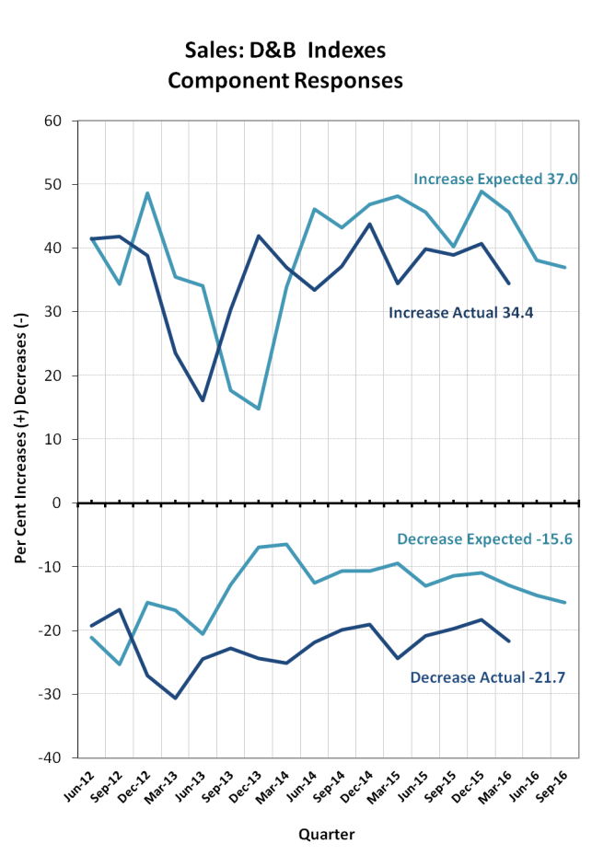
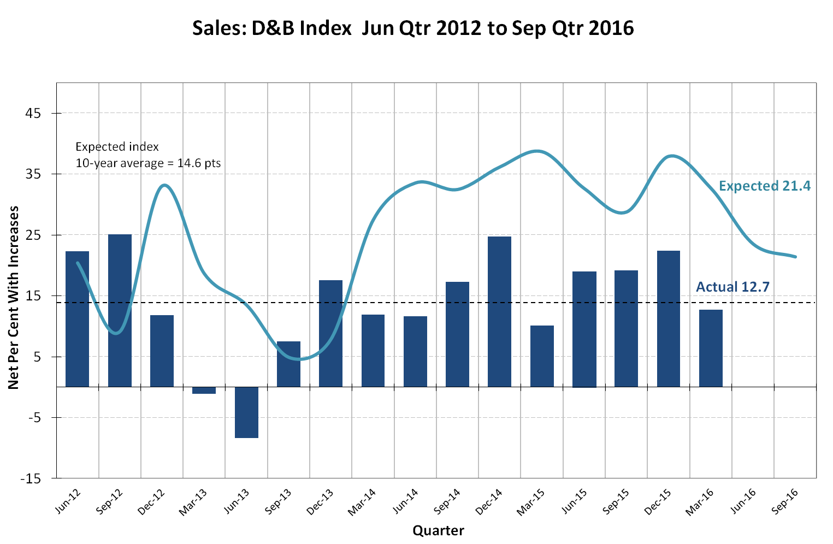

Profits outlook
(Quarterly Net Index) (9.4 points, down from 10.2)
The positive and negative components of the D&B net indexes are shown in the adjacent chart.

Expectations
The outlook for profits in the September 2016 quarter is an index of 9.4 points, down from 10.2 points in the previous quarter and 17.1 points last year.

The outlook for profits is 3.4 points above the 10-year average index of 6.0 points.

29.4 per cent of businesses expect an increase in their profits during the quarter ahead, while 20.0 per cent forecast a decrease, compared to last year.

Actual performance
The Actual Profits Index for the March 2016 quarter is 1.1 points, down from 8.0 points in the previous quarter and 4.8 points recorded a year earlier.
24.6 per cent of businesses increased their profits, while 23.4 per cent experienced a decrease.

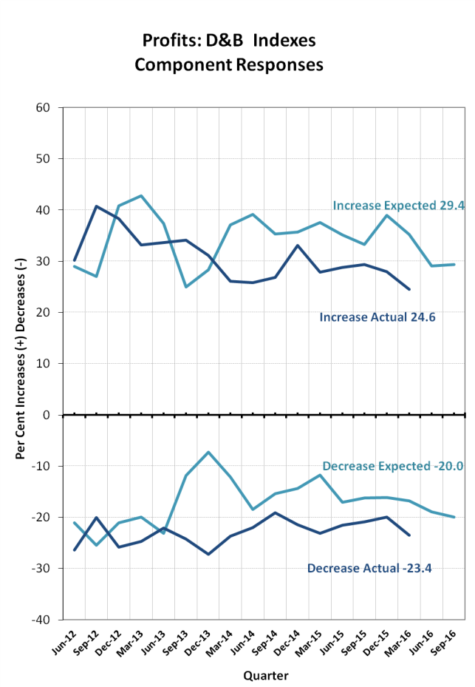

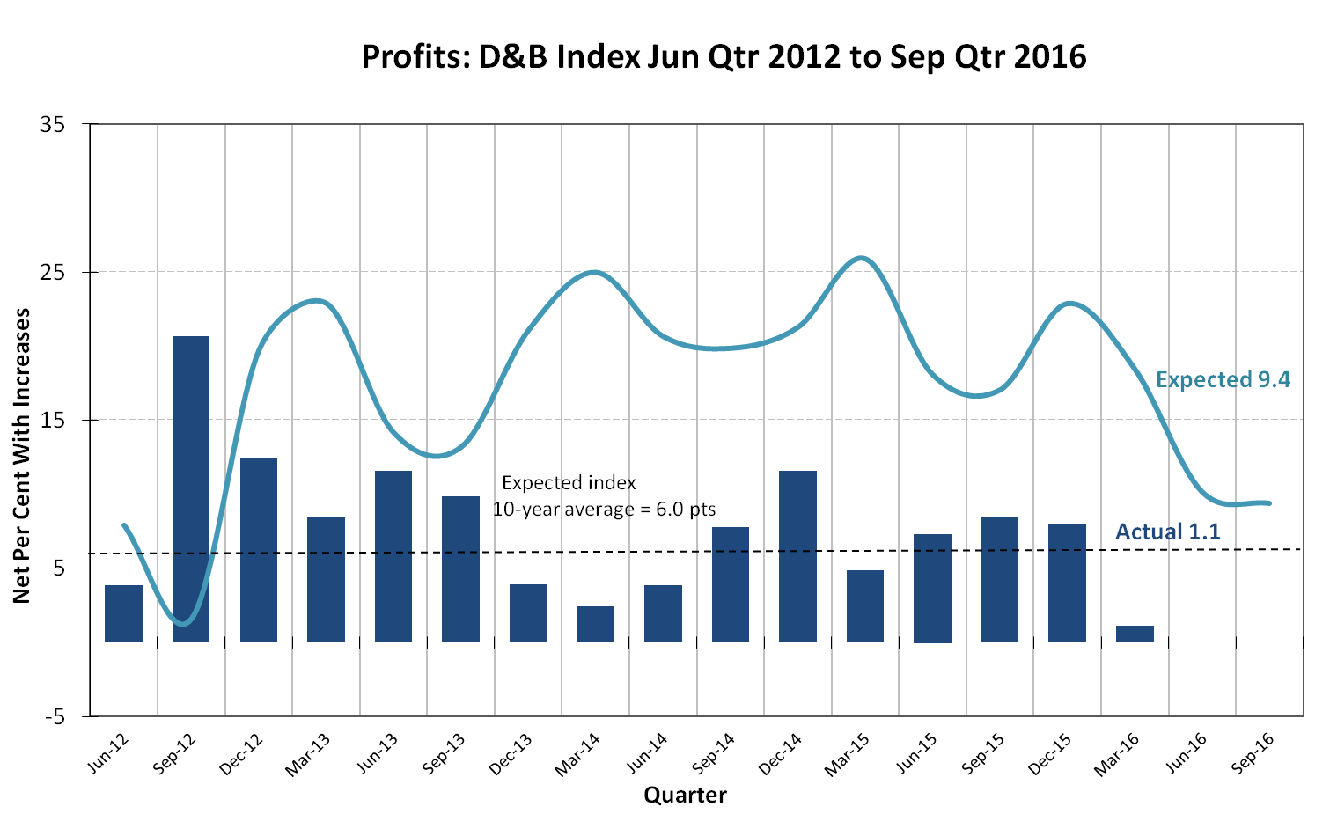

Employment outlook
(Quarterly Net Index) (8.2 points, down from 8.3)
The positive and negative components of the D&B net indexes are shown in the adjacent chart.

Expectations
The employment outlook for the September quarter 2016 has decreased to 8.2 points, down from 8.3 points in the previous quarter and 11.6 points a year earlier.

The outlook for employment is 5.8 points above the 10-year average index of 2.4 points.

Some 20.2 per cent of executives expect to employ more staff compared to a year ago, while 11.9 per cent expect to decrease their staff numbers.

Actual performance
The Actual Employment Index for the March 2016 quarter is 2.3 points, down from 8.5 points in the previous quarter and 5.1 points a year earlier.

In the March quarter 2016, 17.4 per cent of businesses hired new staff, compared to the 15.1 per cent that reduced their employment levels.

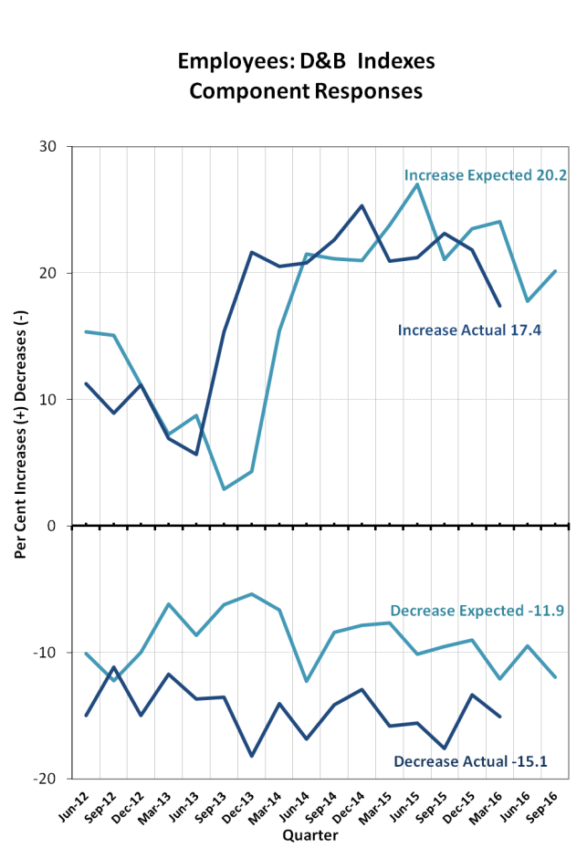

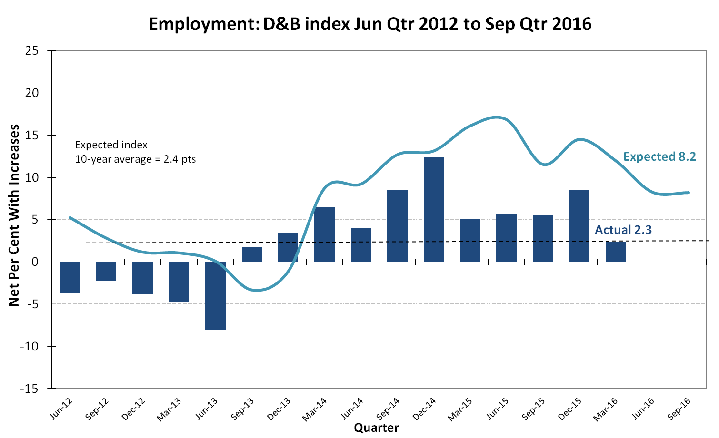

Capital Investment outlook
(Quarterly Net Index) (10.3 points, up from 8.7)
The positive and negative components of the D&B indexes are shown in the adjacent chart.

Expectations
The capital investment outlook for the September quarter 2016 is 10.3 points, up from 8.7 in the previous quarter and 12.9 points last year.

The outlook for capital investment is 4.0 points above the 10-year average index of 6.3 points.

While 19.7 per cent of businesses expect an increase in their investment level, 9.3 per cent forecast a decrease compared with a year earlier.

Actual performance
For the March quarter 2016, the actual index for investment is 8.2 points, down from 11.9 in the previous quarter but up from 6.2 a year ago.

16.9 per cent of firms increased their capital investment in the March quarter, while 8.7 per cent decreased capital spending.

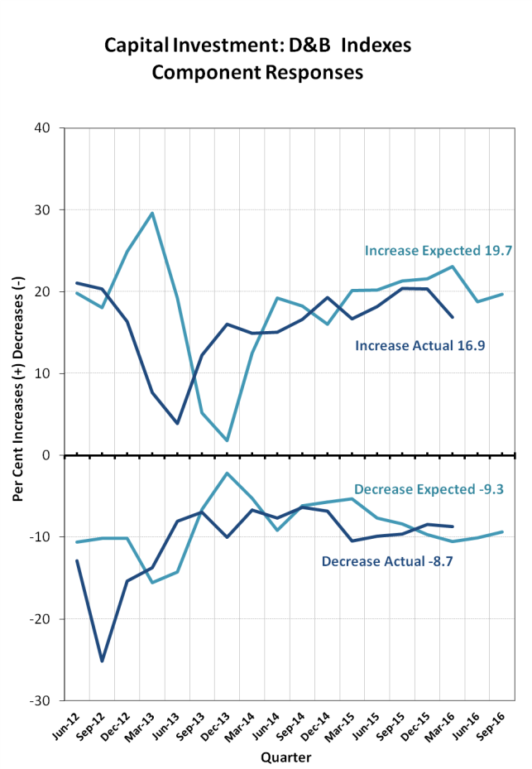

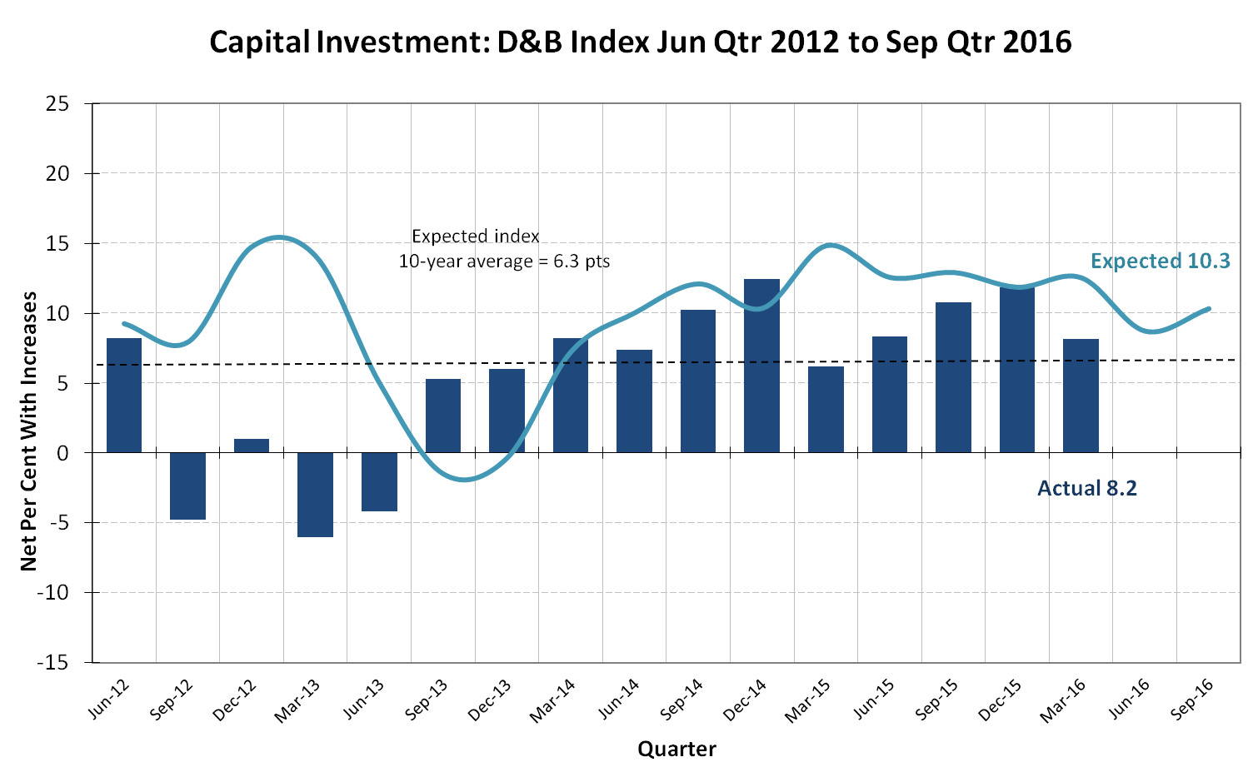

Selling Prices outlook
(Quarterly Net Index) (9.2 points, down from 13.7)
The positive and negative components of the D&B net indexes are shown in the adjacent chart.

Expectations
The Selling Prices Expectations Index for the September quarter 2016 is 9.2 points, down from 13.7 points in the previous quarter and 14.4 points recorded a year earlier.

The outlook for selling prices is 18.2 points lower than the 10-year average of 27.4 points.
The proportion of firms expecting to have higher selling prices in the quarter ahead is 19.4 per cent, with 10.2 per cent expecting to have lower prices.

Actual performance
At 8.4 points, the actual Selling Prices Index for the March 2016 quarter is down from 11.2 points in the previous quarter and 10.9 points last year.

19.8 per cent of businesses increased the level of their selling prices, while 11.4 per cent had decreased, compared to the same time the previous year.

