Key Points

Vacancy Report
May 2016
Release date: 22 June 2016

Trend Series  Annual Change  - All eight occupational groups recorded a rise in job advertisements. The strongest growth was recorded for Machinery Operators and Drivers (up by 15.7%).  - Increased across all states and territories, except for Western Australia (down by 12.0%). The strongest growth was in the Australian Capital Territory (up by 23.2%), followed by New South Wales (14.3%) and Victoria (9.8%).  Monthly Change  - Job advertisements rose in all eight occupational groups. The strongest growth was recorded for Clerical and Administrative Workers (up by 1.1%).  - Increased across all states and territories, except for Queensland (down by 0.1%). The Australian Capital Territory recorded the strongest rise (up by 2.0%). | Seasonally Adjusted Series  Annual Change  - Job advertisements rose in all eight occupational groups. The strongest growth was recorded for Machinery Operators and Drivers (up by 14.6%).  - Increased across all states and territories, except for Western Australia (down by 8.6%). The strongest growth was in the Australian Capital Territory (up by 28.4%).  Monthly Change  - Job advertisements rose in five of the eight occupational groups. The strongest growth was in Professionals (1.8%).  - Increased in four states and both territories, with Tasmania and South Australia recording falls in job advertisements (down by 0.5% and 0.4%, respectively).

Internet Job Advertisements
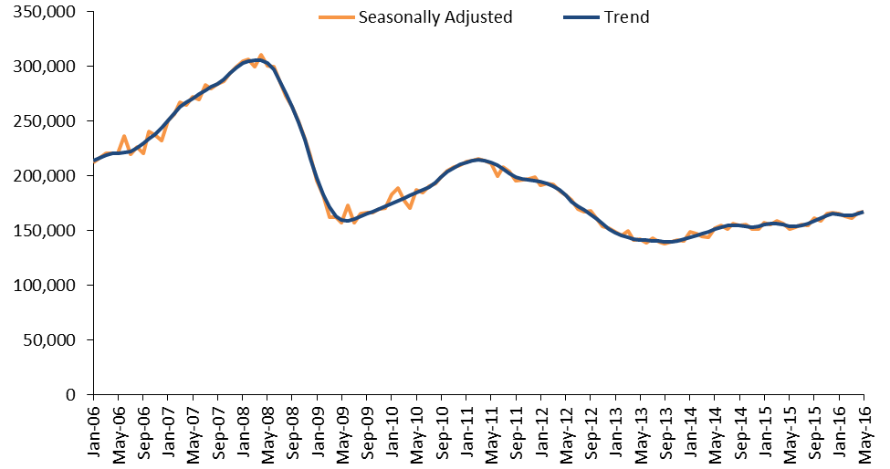

Internet Vacancy Index – Trend Series
In trend terms, the IVI rose by 1.0% in May 2016 and is now 19.8% (or 27,600 advertisements) above the October 2013 low point. Job advertisements increased in all of the eight occupational groups, with the largest rise recorded for Clerical and Administrative Workers (up by 1.1%), followed by Professionals and Sales Workers (both up by 0.8%). The only state to record a fall in advertised jobs over the month was Queensland (down by 0.1%). The strongest increases were recorded in the Australian Capital Territory (up by 2.0%), Victoria (1.3%) and New South Wales (1.0%).
Over the year to May 2016, job advertisements rose by 8.4%. Job advertisements rose for all occupational groups, with the strongest gains recorded for Machinery Operators and Drivers (up by 15.7%), Professionals (9.2%) and Managers (8.9%). The Australian Capital Territory recorded the strongest rise (up by 23.2%), followed by New South Wales (14.3%) and Victoria (9.8%). By contrast, Western Australia was the only jurisdiction to record a fall in job advertisements (down by 12.0%).
IVI - Trend | Index  (Jan '06 = 100) | Monthly  % change | Yearly  % change | Number of job advertisements
Managers | 107.5 | 0.6 | 8.9 | 22,533
Professionals | 95.1 | 0.8 | 9.2 | 45,624
Technicians and Trades Workers | 85.9 | 0.7 | 7.4 | 21,031
Community and Personal Service Workers | 102.4 | 0.7 | 5.2 | 13,124
Clerical and Administrative Workers | 71.2 | 1.1 | 8.5 | 29,490
Sales Workers | 71.0 | 0.8 | 5.3 | 16,673
Machinery Operators and Drivers | 60.3 | 0.7 | 15.7 | 7,702
Labourers | 38.4 | 0.7 | 6.7 | 11,173
States and Territories
New South Wales | 90.2 | 1.0 | 14.3 | 66,106
Victoria | 85.4 | 1.3 | 9.8 | 42,852
Queensland | 59.7 | -0.1 | 3.0 | 29,303
South Australia | 52.1 | 0.6 | 7.1 | 6,865
Western Australia | 72.7 | 0.8 | -12.0 | 13,328
Tasmania | 54.4 | 0.8 | 7.9 | 1,562
Northern Territory | 83.2 | 0.7 | 2.3 | 2,033
Australian Capital Territory | 157.2 | 2.0 | 23.2 | 5,142
Australia | 78.2 | 1.0 | 8.4 | 167,031

Internet Vacancy Index – Seasonally Adjusted Series
In seasonally adjusted terms, the IVI increased by 0.9% in May 2016, with increases recorded for five of the eight occupational groups. Tasmania and South Australia were the only states to record a fall in job advertisements.
Over the year to May 2016, the IVI increased by 10.5%. The strongest annual growth was recorded for Machinery Operators and Drivers (up by 14.6%) and Managers (13.5%). Job advertisements rose in all states and territories except for Western Australia (down by 8.6%).
IVI - Seasonally Adjusted | Index  (Jan '06 = 100) | Monthly  % change | Yearly  % change | Number of job advertisements
Managers | 109.1 | 0.9 | 13.5 | 22,567
Professionals | 96.1 | 1.8 | 13.2 | 46,058
Technicians and Trades Workers | 87.7 | 0.1 | 7.5 | 21,039
Community and Personal Service Workers | 105.0 | 0.9 | 5.4 | 13,185
Clerical and Administrative Workers | 71.1 | 0.1 | 9.6 | 29,482
Sales Workers | 71.5 | -0.4 | 10.8 | 16,658
Machinery Operators and Drivers | 60.3 | -2.1 | 14.6 | 7,579
Labourers | 39.2 | 0.0 | 5.7 | 11,215
States and Territories
New South Wales | 90.7 | 0.4 | 15.9 | 66,255
Victoria | 87.3 | 1.7 | 11.7 | 43,085
Queensland | 58.9 | 0.3 | 4.5 | 29,273
South Australia | 52.5 | -0.4 | 8.7 | 6,867
Western Australia | 74.8 | 2.2 | -8.6 | 13,523
Tasmania | 55.2 | -0.5 | 11.0 | 1,593
Northern Territory | 81.0 | 5.9 | 11.9 | 2,073
Australian Capital Territory | 165.4 | 4.3 | 28.4 | 5,224
Australia | 78.9 | 0.9 | 10.5 | 167,523

Detailed Occupations – Trend Series
Over the year to May 2016, the largest increases in job advertisements at a more detailed occupational level were recorded for General Inquiry Clerks, Call Centre Workers and Receptionists (up by 1,048 job advertisements), Medical Practitioners and Nurses (977), Carers and Aides (900), Hospitality, Retail and Service Managers (672) and Corporate Managers (644).
Just five of the 48 detailed occupations recorded falls in job advertisements. The largest decline was for Hospitality Workers (down by 552 job advertisements), followed by Food Preparation Assistants (55) and Electrotechnology and Telecommunications Trades Workers (36).
Largest growing and declining detailed occupations - Trend | Index (Jan '06 = 100) | Yearly change | Yearly  % change | Number of job advertisements
Largest growing detailed occupations over the year
General-Inquiry Clerks, Call Centre Workers, and Receptionists | 70.4 | 1,048 | 8.6 | 13,244
Medical Practitioners and Nurses | 221.0 | 977 | 20.2 | 5,805
Carers and Aides | 149.8 | 900 | 17.3 | 6,098
Hospitality, Retail and Service Managers | 126.7 | 672 | 13.7 | 5,596
Corporate Managers | 106.7 | 644 | 7.0 | 9,829
Office Managers, Administrators and Secretaries | 78.5 | 599 | 12.5 | 5,404
Automotive and Engineering Trades Workers | 73.1 | 544 | 13.5 | 4,572
Sales Assistants and Salespersons | 70.7 | 535 | 5.9 | 9,585
Engineering, ICT and Science Technicians | 97.6 | 494 | 11.1 | 4,953
Mobile Plant Operators | 93.3 | 462 | 26.9 | 2,179
Largest declining detailed occupations over the year
Farm, Forestry and Garden Workers | 26.0 | -1 | -0.1 | 614
Sports, Travel and Personal Service Workers | 107.5 | -5 | -0.3 | 1,917
Electrotechnology and Telecommunications Trades Workers | 74.7 | -36 | -1.9 | 1,831
Food Preparation Assistants | 31.9 | -55 | -6.5 | 790
Hospitality Workers | 62.3 | -552 | -14.8 | 3,186

Skill Level – Trend Series
Over the year to May 2016, job advertisements increased across all skill levels. The strongest rises were recorded for skill level 2 (commensurate with an Advanced Diploma or Diploma, up by 11.1%) and skill level 1 (commensurate with a Bachelor degree or higher, up by 8.9%).
Skill Level IVI – Trend | Index (Jan '06 = 100) | Monthly  % change | Yearly  % change | Number of job advertisements
Skill Level 1 - Bachelor degree or higher | 97.4 | 0.9 | 8.9 | 62,232
Skill Level 2 - Advanced Diploma or Diploma | 115.7 | 1.1 | 11.1 | 17,861
Skill Level 3 - Certificate IV or III* (Skilled VET) | 81.1 | 0.8 | 7.7 | 20,120
Skill Level 4 - Certificate II or III | 72.9 | 0.9 | 7.1 | 45,438
Skill Level 5 - Certificate I or secondary education | 47.2 | 1.1 | 7.8 | 21,812
Australia | 78.2 | 1.0 | 8.4 | 167,031
The skill level is derived based on a classification used by the Australian Bureau of Statistics that measures the skill level of occupations according to the level of educational attainment/experience commensurate with each occupation contained in the Australian and New Zealand Standard Classification of Occupations (ANZSCO).
*Includes at least two years on-the-job training.

Regional Internet Vacancy Index – Three Month Moving Average
Over the year to May 2016, job advertisements increased in 24 of the 37 IVI regions, with the strongest growth recorded for Southern Highlands & Snowy NSW (up by 32.6%), Bendigo & High Country VIC (28.2%) and Regional Northern Territory (22.8%). The strongest falls were recorded in Perth (down by 16.4%), Yorke Peninsula & Clare Valley SA (15.3%), Central Queensland (14.5%) and North West Tasmania (14.1%).

Change in internet job advertisements over the year to May 2016
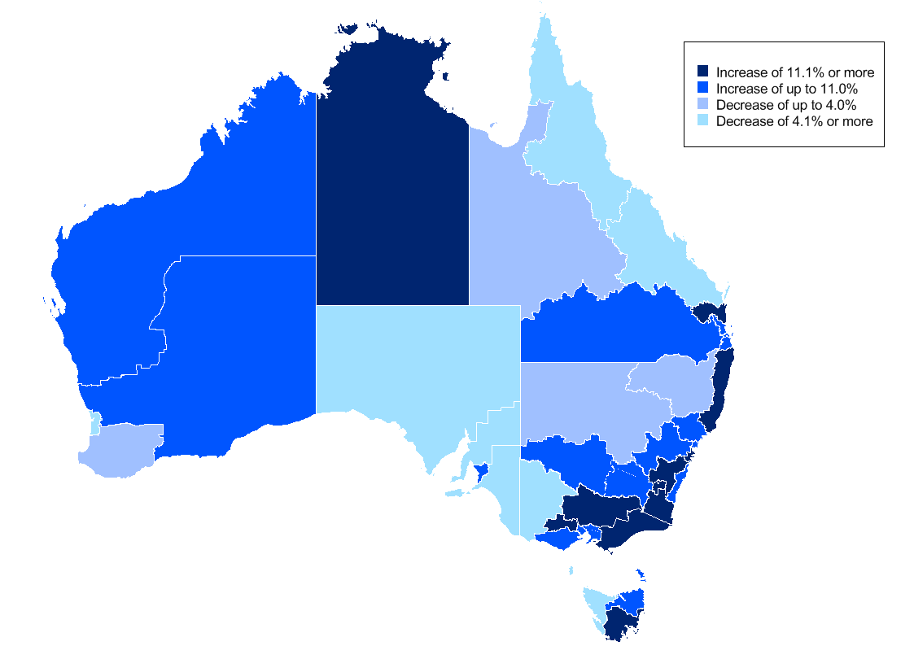
New South Wales continues to grow strongly, with this state recording the largest growth in job advertisements of all states and territories (except for the Australian Capital Territory) over the year to May 2016 (in trend terms). Gains were recorded in nearly all of the state’s regions, except for Dubbo & Western NSW (down by 0.9%) and a marginal fall in Tamworth & North West NSW (0.1%).

The rebalancing away from mining-related activity to service-based industries continues to adversely impact Western Australia, with job advertisements falling by 12.0% over the year. In addition, it was the only state or territory to record a fall across all occupational groups and skill levels over the year to May 2016.

Western Australia’s share of job advertisements has fallen from its peak of 15.6% in June 2012, to stand at 8.0% in May 2016, while Queensland has fallen from 24.2% in October 2008 to 17.5% in May 2016. By contrast, the share of job advertisements in New South Wales increased from a low of 29.7% in March 2012 to a record high of 39.5% in May 2016 (above the state’s share of total national employment, 32%).

Regional IVI – Three Month Moving Average
Regional IVI - May 2016 | Index  (May '10 = 100) | Yearly % change | Number of job advertisements
New South Wales
Blue Mountains, Bathurst & Central West NSW | 91.5 | 1.7 | 858
Dubbo & Western NSW | 103.5 | -0.9 | 562
Gosford & Central Coast | 131.8 | 6.3 | 1,098
Illawarra & South Coast | 131.9 | 10.8 | 1,363
NSW North Coast | 120.5 | 13.5 | 1,827
Newcastle & Hunter | 81.2 | 4.8 | 2,639
Riverina & Murray | 125.0 | 4.5 | 749
Southern Highlands & Snowy | 132.3 | 32.6 | 446
Sydney | 118.6 | 15.6 | 57,060
Tamworth & North West NSW | 75.6 | -0.1 | 615
Victoria
Ballarat & Central Highlands | 152.6 | 17.4 | 544
Bendigo & High Country | 120.4 | 28.2 | 1,372
Geelong & Surf Coast | 106.8 | 7.5 | 1,327
Gippsland | 192.6 | 22.0 | 1,067
Melbourne | 99.9 | 7.5 | 38,149
Wimmera & Western | 84.7 | -8.0 | 415
Queensland
Brisbane | 82.3 | 3.6 | 18,364
Central Queensland | 66.5 | -14.5 | 1,678
Far North Queensland | 85.0 | -10.8 | 2,941
Gold Coast | 103.4 | 10.3 | 3,682
Outback Queensland | 76.7 | -0.1 | 230
Sunshine Coast | 127.7 | 14.0 | 1,476
Toowoomba & South West QLD | 103.6 | 7.6 | 1,031
South Australia
Adelaide | 65.0 | 5.5 | 6,288
Fleurieu Peninsula & Murray Mallee | 95.2 | -8.9 | 387
Port Augusta & Eyre Peninsula | 69.6 | -8.8 | 187
Yorke Peninsula & Clare Valley | 69.6 | -15.3 | 98
Western Australia
Goldfields & Southern WA | 171.5 | 10.2 | 822
Perth | 63.5 | -16.4 | 10,596
Pilbara & Kimberley | 184.7 | 0.4 | 955
South West WA | 72.4 | -0.3 | 582
Tasmania
Hobart & Southeast Tasmania | 63.0 | 12.8 | 928
Launceston & Northeast Tasmania | 108.5 | 10.3 | 374
North West Tasmania | 115.8 | -14.1 | 238
Northern Territory
Darwin | 62.3 | -2.3 | 1,616
Regional Northern Territory | 50.3 | 22.8 | 454
Australian Capital Territory
Canberra & ACT | 117.0 | 19.4 | 5,298

State and Territory IVI – Trend
State IVI - May 2016 | Index  (Jan '06 = 100) | Monthly % change | Yearly % change | Number of job advertisements
Australia | 78.2 | 1.0 | 8.4 | 167,031
Managers | 107.5 | 0.6 | 8.9 | 22,533
Professionals | 95.1 | 0.8 | 9.2 | 45,624
Technicians and Trades Workers | 85.9 | 0.7 | 7.4 | 21,031
Community and Personal Service Workers | 102.4 | 0.7 | 5.2 | 13,124
Clerical and Administrative Workers | 71.2 | 1.1 | 8.5 | 29,490
Sales Workers | 71.0 | 0.8 | 5.3 | 16,673
Machinery Operators and Drivers | 60.3 | 0.7 | 15.7 | 7,702
Labourers | 38.4 | 0.7 | 6.7 | 11,173
New South Wales | 90.2 | 1.0 | 14.3 | 66,106
Managers | 111.0 | 0.5 | 13.6 | 9,867
Professionals | 95.7 | 0.7 | 11.6 | 18,545
Technicians and Trades Workers | 113.8 | 0.5 | 18.3 | 7,520
Community and Personal Service Workers | 118.7 | 1.2 | 12.8 | 4,592
Clerical and Administrative Workers | 79.0 | 1.4 | 14.6 | 12,385
Sales Workers | 75.2 | 1.5 | 11.9 | 6,464
Machinery Operators and Drivers | 85.8 | 0.6 | 25.4 | 2,731
Labourers | 57.6 | 1.1 | 18.5 | 3,966
Victoria | 85.4 | 1.3 | 9.8 | 42,852
Managers | 125.9 | 1.5 | 12.8 | 5,960
Professionals | 103.2 | 0.1 | 9.4 | 11,559
Technicians and Trades Workers | 98.8 | 1.9 | 13.7 | 5,177
Community and Personal Service Workers | 105.4 | 1.3 | -1.1 | 3,220
Clerical and Administrative Workers | 76.1 | 1.8 | 12.2 | 7,804
Sales Workers | 75.0 | 0.8 | 7.3 | 4,388
Machinery Operators and Drivers | 68.5 | 1.4 | 17.1 | 1,961
Labourers | 41.0 | 0.4 | 2.9 | 2,765
Queensland | 59.7 | -0.1 | 3.0 | 29,303
Managers | 87.6 | 0.4 | 6.9 | 3,353
Professionals | 80.1 | -0.2 | 7.6 | 7,664
Technicians and Trades Workers | 55.6 | -0.2 | -4.0 | 4,128
Community and Personal Service Workers | 83.2 | 0.5 | 2.0 | 2,746
Clerical and Administrative Workers | 55.1 | 0.8 | -1.3 | 4,667
Sales Workers | 59.7 | 0.1 | -1.3 | 2,955
Machinery Operators and Drivers | 40.0 | -0.4 | 8.1 | 1,452
Labourers | 28.4 | -0.1 | 3.6 | 2,338
South Australia | 52.1 | 0.6 | 7.1 | 6,865
Managers | 71.1 | -0.6 | 0.4 | 743
Professionals | 78.5 | 2.3 | 11.1 | 1,563
Technicians and Trades Workers | 52.0 | -0.9 | 9.9 | 961
Community and Personal Service Workers | 64.8 | 0.0 | 7.7 | 678
Clerical and Administrative Workers | 50.2 | 1.3 | 6.0 | 1,053
Sales Workers | 50.7 | 0.6 | 3.3 | 763
Machinery Operators and Drivers | 42.1 | 0.8 | 16.6 | 427
Labourers | 25.9 | -0.5 | 2.1 | 674
Western Australia | 72.7 | 0.8 | -12.0 | 13,328
Managers | 118.2 | 0.6 | -10.3 | 1,649
Professionals | 79.9 | 0.4 | -7.0 | 3,240
Technicians and Trades Workers | 96.3 | -0.1 | -13.1 | 2,213
Community and Personal Service Workers | 128.5 | -0.5 | -15.0 | 1,038
Clerical and Administrative Workers | 51.9 | -0.4 | -24.1 | 1,912
Sales Workers | 88.5 | 0.6 | -8.0 | 1,479
Machinery Operators and Drivers | 59.8 | 1.1 | -4.1 | 871
Labourers | 29.5 | -0.7 | -17.7 | 900
Tasmania | 54.4 | 0.8 | 7.9 | 1,562
Managers | 94.9 | 2.8 | 20.2 | 170
Professionals | 96.5 | 0.2 | 23.4 | 347
Technicians and Trades Workers | 53.4 | 0.1 | -8.8 | 199
Community and Personal Service Workers | 68.2 | -2.2 | -13.9 | 174
Clerical and Administrative Workers | 66.2 | 0.4 | 14.2 | 221
Sales Workers | 56.7 | 3.0 | 19.2 | 190
Machinery Operators and Drivers | 27.1 | -0.6 | -1.8 | 70
Labourers | 21.6 | 1.3 | -1.9 | 171
Northern Territory | 83.2 | 0.7 | 2.3 | 2,033
Managers | 107.1 | 0.8 | -2.8 | 227
Professionals | 161.1 | 2.0 | 16.9 | 557
Technicians and Trades Workers | 80.2 | 1.1 | 0.7 | 342
Community and Personal Service Workers | 88.4 | -0.9 | 5.3 | 211
Clerical and Administrative Workers | 90.6 | 0.1 | 1.0 | 320
Sales Workers | 57.9 | -1.9 | -24.0 | 131
Machinery Operators and Drivers | 50.4 | -3.7 | -17.1 | 94
Labourers | 31.8 | -0.7 | -1.7 | 146
Australian Capital Territory | 157.2 | 2.0 | 23.2 | 5,142
Managers | 161.2 | 2.3 | 22.1 | 711
Professionals | 153.4 | 2.4 | 16.7 | 2,004
Technicians and Trades Workers | 225.1 | 2.6 | 42.7 | 521
Community and Personal Service Workers | 262.9 | 0.9 | 25.4 | 374
Clerical and Administrative Workers | 138.8 | 1.2 | 19.8 | 886
Sales Workers | 119.0 | -0.8 | 18.9 | 318
Machinery Operators and Drivers | 108.0 | -0.1 | 23.9 | 68
Labourers | 109.2 | 0.8 | 36.9 | 215

Occupational IVI – Trend
Occupational IVI - May 2016 | Index  (Jan '06 = 100) | Monthly % change | Yearly % change | Number of job advertisements
Managers | 107.5 | 0.6 | 8.9 | 22,533
Chief Executives, Managing Directors & Legislators | 151.4 | -0.3 | 12.7 | 759
Farmers and Farm Managers | 72.1 | -0.1 | 2.7 | 87
Hospitality, Retail and Service Managers | 126.7 | 0.5 | 13.7 | 5,596
Corporate Managers | 106.7 | 0.3 | 7.0 | 9,829
Construction, Production and Distribution Managers | 100.6 | 1.0 | 10.1 | 4,943
Health, Education, ICT and Other Managers | 82.6 | 0.8 | 8.2 | 1,380
Professionals | 95.1 | 0.8 | 9.2 | 45,624
Arts and Media Professionals | 82.0 | 1.3 | 9.7 | 778
Education Professionals | 137.0 | 1.9 | 24.3 | 1,769
ICT Professionals | 85.7 | -0.1 | 3.8 | 9,989
Legal, Social and Welfare Professionals | 91.7 | -0.1 | 9.5 | 4,023
Business, Finance and Human Resource Professionals | 61.1 | -0.3 | 2.4 | 9,328
Information Professionals | 145.0 | 0.4 | 8.5 | 1,934
Sales, Marketing & Public Relations Professionals | 129.2 | 0.9 | 8.4 | 3,181
Transport and Design Professionals, and Architects | 163.6 | 2.0 | 19.2 | 2,826
Engineers | 57.1 | 2.1 | 13.1 | 2,635
Science Professionals and Veterinarians | 71.0 | 3.4 | 32.4 | 608
Health Diagnostic and Therapy Professionals | 204.9 | 0.0 | 16.1 | 2,750
Medical Practitioners and Nurses | 221.0 | -0.1 | 20.2 | 5,805
Technicians and Trades Workers | 85.9 | 0.7 | 7.4 | 21,031
Engineering, ICT and Science Technicians | 97.6 | 1.3 | 11.1 | 4,953
Automotive and Engineering Trades Workers | 73.1 | 1.0 | 13.5 | 4,572
Construction Trades Workers | 105.3 | 0.1 | 6.9 | 2,965
Electrotechnology and Telecommunications Trades Workers | 74.7 | 0.2 | -1.9 | 1,831
Food Trades Workers | 93.5 | 0.5 | 2.8 | 3,954
Skilled Animal and Horticultural Workers | 81.0 | 0.3 | 7.8 | 850
Hairdressers, Printing, Clothing and Wood Trades Workers | 80.6 | -0.4 | 2.5 | 1,442
Jewellers, Arts and Other Trades Workers | 98.0 | 0.3 | 26.2 | 519
Community and Personal Service Workers | 102.4 | 0.7 | 5.2 | 13,124
Health and Welfare Support Workers | 174.3 | -0.5 | 9.1 | 1,154
Carers and Aides | 149.8 | 1.0 | 17.3 | 6,098
Hospitality Workers | 62.3 | 0.4 | -14.8 | 3,186
Protective Service Workers | 54.7 | 1.5 | 10.5 | 687
Sports, Travel and Personal Service Workers | 107.5 | 0.6 | -0.3 | 1,917
Clerical and Administrative Workers | 71.2 | 1.1 | 8.5 | 29,490
Numerical Clerks | 58.3 | 0.8 | 6.0 | 6,081
Clerical and Office Support Workers | 72.5 | -1.0 | 5.3 | 708
Other Clerical and Administrative Workers | 91.0 | -0.1 | 5.8 | 4,015
Office Managers, Administrators and Secretaries | 78.5 | 1.9 | 12.5 | 5,404
General-Inquiry Clerks, Call Centre Workers, and Receptionists | 70.4 | 1.8 | 8.6 | 13,244
Sales Workers | 71.0 | 0.8 | 5.3 | 16,673
Sales Representatives and Agents | 78.7 | 0.9 | 5.4 | 5,677
Sales Assistants and Salespersons | 70.7 | 1.3 | 5.9 | 9,585
Sales Support Workers | 49.6 | -0.4 | 3.3 | 1,421
Machinery Operators and Drivers | 60.3 | 0.7 | 15.7 | 7,702
Machine and Stationary Plant Operators | 68.7 | 0.2 | 17.4 | 1,657
Mobile Plant Operators | 93.3 | 0.0 | 26.9 | 2,179
Drivers and Storepersons | 48.4 | 0.2 | 9.1 | 3,863
Labourers | 38.4 | 0.7 | 6.7 | 11,173
Cleaners and Laundry Workers | 44.0 | 2.4 | 9.1 | 2,021
Construction and Mining Labourers | 63.0 | -0.1 | 8.2 | 1,158
Factory Process Workers | 52.3 | 0.2 | 8.7 | 2,095
Farm, Forestry and Garden Workers | 26.0 | 0.6 | -0.1 | 614
Food Preparation Assistants | 31.9 | -2.5 | -6.5 | 790
Other Labourers | 32.9 | 0.1 | 8.5 | 4,494
Australian Total | 78.2 | 1.0 | 8.4 | 167,031

State and Territory Skill Level Internet Vacancy Index – Trend
Skill level by State/Territory – May 2016 | Index  (Jan '06 = 100) | Monthly % change | Yearly % change | Number of job advertisements
Australia | 78.2 | 1.0 | 8.4 | 167,031
Skill Level 1 - Bachelor degree or higher | 97.4 | 0.9 | 8.9 | 62,232
Skill Level 2 - Advanced Diploma or Diploma | 115.7 | 1.1 | 11.1 | 17,861
Skill Level 3 - Certificate IV or III* (Skilled VET) | 81.1 | 0.8 | 7.7 | 20,120
Skill Level 4 - Certificate II or III | 72.9 | 0.9 | 7.1 | 45,438
Skill Level 5 - Certificate I or secondary education | 47.2 | 1.1 | 7.8 | 21,812
New South Wales | 90.2 | 1.0 | 14.3 | 66,106
Skill Level 1 - Bachelor degree or higher | 99.5 | 0.6 | 11.9 | 26,191
Skill Level 2 - Advanced Diploma or Diploma | 129.8 | 1.0 | 18.4 | 6,872
Skill Level 3 - Certificate IV or III* (Skilled VET) | 97.8 | 0.3 | 17.6 | 7,340
Skill Level 4 - Certificate II or III | 84.9 | 1.3 | 15.7 | 17,961
Skill Level 5 - Certificate I or secondary education | 62.5 | 0.7 | 15.6 | 7,911
Victoria | 85.4 | 1.3 | 9.8 | 42,852
Skill Level 1 - Bachelor degree or higher | 107.5 | 0.6 | 10.1 | 15,998
Skill Level 2 - Advanced Diploma or Diploma | 140.0 | 1.6 | 16.3 | 4,588
Skill Level 3 - Certificate IV or III* (Skilled VET) | 87.5 | 2.0 | 12.3 | 4,972
Skill Level 4 - Certificate II or III | 78.3 | 1.5 | 8.3 | 11,796
Skill Level 5 - Certificate I or secondary education | 49.4 | 0.8 | 4.7 | 5,434
Queensland | 59.7 | -0.1 | 3.0 | 29,303
Skill Level 1 - Bachelor degree or higher | 80.3 | 0.0 | 6.1 | 9,962
Skill Level 2 - Advanced Diploma or Diploma | 83.3 | 0.7 | 3.5 | 3,182
Skill Level 3 - Certificate IV or III* (Skilled VET) | 56.4 | 0.7 | -2.3 | 3,786
Skill Level 4 - Certificate II or III | 56.0 | 0.2 | -1.0 | 7,983
Skill Level 5 - Certificate I or secondary education | 36.0 | -0.1 | 3.9 | 4,322
South Australia | 52.1 | 0.6 | 7.1 | 6,865
Skill Level 1 - Bachelor degree or higher | 73.5 | 1.0 | 7.7 | 2,035
Skill Level 2 - Advanced Diploma or Diploma | 79.8 | -0.5 | 4.3 | 721
Skill Level 3 - Certificate IV or III* (Skilled VET) | 48.5 | -1.0 | 5.5 | 853
Skill Level 4 - Certificate II or III | 50.3 | 1.1 | 11.2 | 1,999
Skill Level 5 - Certificate I or secondary education | 32.5 | 0.0 | 2.1 | 1,239
Western Australia | 72.7 | 0.8 | -12.0 | 13,328
Skill Level 1 - Bachelor degree or higher | 85.9 | 0.7 | -8.8 | 4,325
Skill Level 2 - Advanced Diploma or Diploma | 112.1 | 0.4 | -9.2 | 1,549
Skill Level 3 - Certificate IV or III* (Skilled VET) | 105.2 | 0.1 | -10.2 | 2,171
Skill Level 4 - Certificate II or III | 64.1 | 0.2 | -19.5 | 3,547
Skill Level 5 - Certificate I or secondary education | 40.3 | 0.9 | -12.7 | 1,704
Tasmania | 54.4 | 0.8 | 7.9 | 1,562
Skill Level 1 - Bachelor degree or higher | 92.1 | 0.6 | 19.0 | 453
Skill Level 2 - Advanced Diploma or Diploma | 95.3 | -0.2 | -1.5 | 166
Skill Level 3 - Certificate IV or III* (Skilled VET) | 45.0 | 1.6 | -15.1 | 154
Skill Level 4 - Certificate II or III | 52.9 | 0.0 | 3.7 | 434
Skill Level 5 - Certificate I or secondary education | 31.3 | 2.3 | 5.7 | 333
Northern Territory | 83.2 | 0.7 | 2.3 | 2,033
Skill Level 1 - Bachelor degree or higher | 141.3 | 2.1 | 11.8 | 699
Skill Level 2 - Advanced Diploma or Diploma | 121.1 | -0.3 | -1.2 | 248
Skill Level 3 - Certificate IV or III* (Skilled VET) | 79.9 | 1.1 | 0.9 | 310
Skill Level 4 - Certificate II or III | 70.8 | 0.5 | -5.9 | 513
Skill Level 5 - Certificate I or secondary education | 39.2 | -0.1 | -7.1 | 248
Australian Capital Territory | 157.2 | 2.0 | 23.2 | 5,142
Skill Level 1 - Bachelor degree or higher | 158.8 | 2.6 | 18.4 | 2,531
Skill Level 2 - Advanced Diploma or Diploma | 180.4 | 1.5 | 24.1 | 572
Skill Level 3 - Certificate IV or III* (Skilled VET) | 219.0 | 2.1 | 41.5 | 474
Skill Level 4 - Certificate II or III | 153.2 | 1.7 | 16.6 | 1,052
Skill Level 5 - Certificate I or secondary education | 101.2 | 0.9 | 32.6 | 452
The skill level is derived based on a classification used by the Australian Bureau of Statistics that measures skill level of occupations according to the level of educational attainment/experience commensurate with each occupation.
*Includes at least 2 years on-the-job training.

Explanatory Notes
- The monthly Internet Vacancy Index (IVI) is based on a count of online job advertisements newly lodged on SEEK, CareerOne and Australian JobSearch during the month. Duplicate advertisements are removed before the IVI job advertisements are coded by the Department of Employment to occupations based on the Australian and New Zealand Standard Classification of Occupations (ANZSCO). The data are seasonally adjusted and trended, and then indexed (January 2006 = 100).
- The IVI does not reflect the total number of job advertisements in the labour market as it does not include jobs advertised through other online job boards, employer websites, or in newspapers. Nor does it take account of vacancies filled using informal methods such as word of mouth. The IVI also does not take account of multiple positions being advertised in a single job advertisement. In addition, Department of Employment research indicates that one third of vacancies are not formally advertised.
- The Regional IVI was first published in September 2010 and back cast to May 2010. The Regional IVI concords job advertisements to 37 best fit regions across the states and territories from the three job boards. There were 38 regions until February 2016, after which the Blue Mountains region was amalgamated with the Bathurst and Central West NSW region to create the Blue Mountains, Bathurst and Central West Region NSW.
- Over the five months to August 2015, there was a reduction in the number of new job advertisements listed on the Australian JobSearch (AJS) website. This may have been as a result of the transition of employment services from Job Services Australia to jobactive, and had a relatively larger impact on the number of job advertisements advertised in some regional areas.
- For more information, please contact James Jordan (02 6240 2597) or email James.jordan@employment.gov.au. Media enquiries should be directed to the Department of Employment media unit (media@employment.gov.au).

Acknowledgements
The Department of Employment thanks the following job boards for their contribution to the Vacancy Report:

Forthcoming release dates (release time 11am):
For data covering: | Release date:
June 2016 | 20 July 2016
July 2016 | 24 August 2016
August 2016 | 21 September 2016
September 2016 | 19 October 2016
October 2016 | 23 November 2016
November 2016 | 21 December 2016
December 2016 | 25 January 2017

There were 38 regions until February 2016, after which the Blue Mountains region was amalgamated with the Bathurst and Central West NSW region to create the Blue Mountains, Bathurst and Central West Region NSW.
Over the five months to August 2015, there was a reduction in the number of new job advertisements listed on the Australian JobSearch (AJS) website that has had a relatively larger impact on the number of job advertisements advertised in some regional areas.
The only part of the Northern Territory that is visible on the map is Regional Northern Territory, in which job advertisements rose by 22.8%. Job advertisements in Darwin, which accounts for more than 75 per cent of total job advertisements in the Northern Territory, fell by 2.3 per cent in three month moving average terms over the year to May 2016, while job advertisements in the whole of the Northern Territory rose by 2.3% over the year in trend terms.

