
Key Points

Vacancy Report
November 2015
Release date: 16 December 2015

The Internet Vacancy Index (IVI) increased by 1.2% in trend terms in November 2015, and is 6.5% higher than the level recorded a year ago. Despite this increase, the level of vacancies remains 142,830 (or 46.6%) below the March 2008 peak.
Trend Summary  Annual Change  - Increased by 6.5% to 76.5 (Jan 2006 = 100).  - Increased in six of the eight occupational groups, with the strongest rises recorded for Professionals (up by 14.4%) and Managers (11.1%).  - Increased in the Australian Capital Territory (up by 25.1%), New South Wales (11.7%), Victoria (11.6%) and Queensland (3.9%).  Monthly Change  - Vacancies increased by 1.2% over the month.  - Increased in all eight occupational groups, with the strongest rises recorded for Labourers, Managers and Community and Personal Service Workers (all up by 1.6%).  - Increased in five states and the Australian Capital Territory, with the strongest rises recorded in New South Wales (up by 1.8%) and Victoria (1.5%).  (163,460 vacancies) | Seasonally Adjusted Summary  Annual Change  - Increased by 8.8% to 77.7 (Jan 2006 = 100).  - Increased in six of the eight occupational groups, with the strongest rises recorded for Managers (16.8%) and Professionals (up by 16.4%).  - Increased in the Australian Capital Territory (up by 25.4%), New South Wales (15.4%), Victoria (14.5%) and Queensland (6.3%).  Monthly Change  - Vacancies increased by 3.7% over the month.  - Increased in all eight occupational groups, with the strongest rises recorded for Professionals (up by 6.8%), Community and Personal Service Workers (6.0%) and Managers (5.3%).  - Increased in five states, with strongest rises recorded in New South Wales (up by 5.0%), Victoria (3.9%) and Queensland (3.5%).  (164,969 vacancies)

Internet Vacancies - seasonally adjusted and trend series
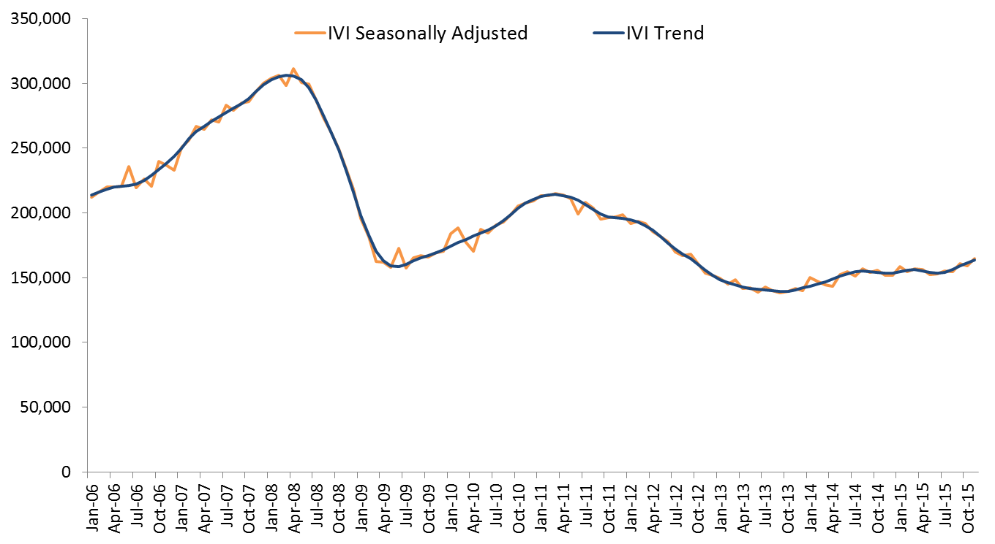

Internet Vacancy Index – Trend Series
In trend terms, the IVI rose by 1.2% in November 2015 with increases in all eight occupational groups, and in five states and the Australian Capital Territory.
Over the year to November 2015, vacancies increased by 6.5%. Vacancies rose in six of the eight occupational groups, with the strongest rises recorded for Professionals (up by 14.4%) and Managers (11.1%), while declines were recorded for Labourers (down by 11.1%) and Machinery Operators and Drivers (2.6%). Over the year to November 2015, the IVI increased in the Australian Capital Territory (up by 25.1%), New South Wales (11.7%), Victoria (11.6%) and Queensland (3.9%). The strongest declines were recorded in the Northern Territory (down by 17.2%) and Western Australia (13.3%). Around 163,460 newly lodged vacancies were advertised during November 2015.
IVI - Trend | Index (Jan '06 = 100) | Monthly  % change | Yearly  % change | Number of vacancies
Managers | 107.3 | 1.6 | 11.1 | 22,476
Professionals | 94.2 | 1.2 | 14.4 | 45,286
Technicians and Trades Workers | 82.7 | 0.3 | 3.2 | 20,237
Community and Personal Service Workers | 100.3 | 1.6 | 3.6 | 12,855
Clerical and Administrative Workers | 68.8 | 0.4 | 4.4 | 28,524
Sales Workers | 69.5 | 0.5 | 5.2 | 16,313
Machinery Operators and Drivers | 55.8 | 0.7 | -2.6 | 7,122
Labourers | 36.3 | 1.6 | -11.1 | 10,574
States and Territories
New South Wales | 86.0 | 1.8 | 11.7 | 62,922
Victoria | 82.2 | 1.5 | 11.6 | 41,269
Queensland | 59.9 | 0.4 | 3.9 | 29,559
South Australia | 48.9 | 0.8 | -9.0 | 6,450
Western Australia | 81.2 | -0.7 | -13.3 | 14,898
Tasmania | 51.3 | 0.1 | -7.3 | 1,471
Northern Territory | 76.9 | -1.3 | -17.2 | 1,881
Australian Capital Territory | 141.7 | 0.6 | 25.1 | 4,636
Australia | 76.5 | 1.2 | 6.5 | 163,460

Internet Vacancy Index – Seasonally Adjusted Series
In seasonally adjusted terms, the IVI increased by 3.7% in November 2015. Over the month, vacancies increased in all eight occupational groups, and in five states.

Over the year to November 2015, the IVI increased by 8.8%. Vacancies rose in six of the eight occupational groups, with the strongest rises recorded for Managers (up by 16.8%), Professionals (16.4%) and Community and Personal Service Workers (10.9%). Declines were recorded for Labourers (down by 7.5%) and Machinery Operators and Drivers (2.4%). Over the year, vacancies increased in the Australian Capital Territory (up by 25.4%), New South Wales (15.4%), Victoria (14.5%) and Queensland (6.3%). The strongest declines were recorded in the Northern Territory (down by 16.2%) and Western Australia (11.8%).
IVI - Seasonally Adjusted | Index (Jan '06 = 100) | Monthly % change | Yearly % change | Number of vacancies
Managers | 110.6 | 5.3 | 16.8 | 22,848
Professionals | 94.7 | 6.8 | 16.4 | 45,518
Technicians and Trades Workers | 85.0 | 1.2 | 5.0 | 20,373
Community and Personal Service Workers | 107.5 | 6.0 | 10.9 | 13,496
Clerical and Administrative Workers | 69.7 | 3.1 | 6.9 | 28,903
Sales Workers | 70.5 | 2.2 | 7.6 | 16,435
Machinery Operators and Drivers | 56.7 | 0.1 | -2.4 | 7,101
Labourers | 37.7 | 1.2 | -7.5 | 10,795
States and Territories
New South Wales | 87.5 | 5.0 | 15.4 | 63,789
Victoria | 84.5 | 3.9 | 14.5 | 41,726
Queensland | 60.5 | 3.5 | 6.3 | 30,091
South Australia | 49.8 | 1.0 | -6.8 | 6,511
Western Australia | 83.0 | 1.0 | -11.8 | 15,011
Tasmania | 51.0 | -2.3 | -5.0 | 1,470
Northern Territory | 74.3 | -0.1 | -16.2 | 1,907
Australian Capital Territory | 147.7 | -0.4 | 25.4 | 4,665
Australia | 77.7 | 3.7 | 8.8 | 164,969

Detailed Occupational Trend
Over the year to November 2015, the largest increases in vacancies at a more detailed occupational level were recorded for Medical Practitioners and Nurses (up by 1,082 vacancies), ICT Professionals (1,075 vacancies), Carers and Aides (737 vacancies) and Business, Finance and Human Resource Professionals (705 vacancies).
By contrast, over the year to November 2015 the largest declines in vacancies were recorded for Drivers and Storepersons (down by 524 vacancies), Other Labourers (514 vacancies), Hospitality Workers (509 vacancies) and Cleaners and Laundry Workers (325 vacancies).
Largest growing and declining detailed occupations - Trend | Index (Jan '06 = 100) | Yearly change | Yearly change (%) | Number of vacancies
Largest growing detailed occupations over the year
Medical Practitioners and Nurses | 207.0 | 1,082 | 24.8 | 5,444
ICT Professionals | 86.9 | 1,075 | 11.9 | 10,122
Carers and Aides | 145.3 | 737 | 14.2 | 5,917
Business, Finance and Human Resource Professionals | 64.1 | 705 | 7.8 | 9,786
Corporate Managers | 104.7 | 640 | 7.1 | 9,716
General-Inquiry Clerks, Call Centre, and Receptionists | 68.0 | 637 | 5.2 | 12,813
Hospitality, Retail and Service Managers | 124.0 | 568 | 11.6 | 5,476
Sales Assistants and Salespersons | 69.6 | 533 | 6.0 | 9,454
Transport and Design Professionals, and Architects | 148.7 | 448 | 21.2 | 2,564
Sales, Marketing & Public Relations Professionals | 129.8 | 387 | 13.8 | 3,200
Largest declining detailed occupations over the year
Farmers and Farm Managers | 65.9 | -6 | -7.0 | 80
Construction and Mining Labourers | 62.2 | -37 | -3.1 | 1,143
Factory Process Workers | 49.2 | -88 | -4.3 | 1,973
Automotive and Engineering Trades | 67.9 | -134 | -3.1 | 4,249
Farm, Forestry and Garden Workers | 25.0 | -140 | -19.2 | 591
Food Preparation Assistants | 30.3 | -286 | -27.6 | 751
Cleaners and Laundry Workers | 39.5 | -325 | -15.1 | 1,818
Hospitality Workers | 63.8 | -509 | -13.5 | 3,270
Other Labourers | 30.9 | -514 | -10.9 | 4,220
Drivers and Storepersons | 43.9 | -524 | -13.0 | 3,520

Skill Level Trend
Over the year to November 2015, vacancies increased for all but the lowest skill level, with the strongest rise recorded for skill level 1 occupations (commensurate with the attainment of a Bachelor degree or higher), up by 13.9%. By contrast, vacancies for skill level 5 occupations (commensurate with the attainment of a Certificate I or secondary education) declined by 2.6%.
Skill Level IVI - Trend | Index (Jan '06 = 100) | Monthly % change | Yearly % change | Number of vacancies
Skill Level 1 - Bachelor degree or higher | 97.2 | 1.3 | 13.9 | 62,092
Skill Level 2 - Advanced Diploma or Diploma | 112.0 | 1.4 | 10.6 | 17,270
Skill Level 3 - Certificate IV or III* (Skilled VET) | 77.0 | -0.1 | 2.7 | 19,102
Skill Level 4 - Certificate II or III | 71.1 | 1.0 | 2.3 | 44,287
Skill Level 5 - Certificate I or secondary education | 45.1 | 1.1 | -2.6 | 20,890
Australia | 76.5 | 1.2 | 6.5 | 163,460
The skill level is derived based on a classification used by the Australian Bureau of Statistics that measures the skill level of occupations according to the level of educational attainment/experience commensurate with each occupation contained in the Australian and New Zealand Standard Classification of Occupations (ANZSCO).
*Includes at least two years on-the-job training.

Regional Internet Vacancy Index
Over the year to November 2015, vacancies increased in 19 of the 38 IVI regions, with the strongest growth recorded for Canberra & ACT (up by 26.5%), Ballarat & Central Highlands VIC (23.6%), Bendigo & High Country VIC (16.8%), NSW North Coast (12.4%), Southern Highlands & Snowy VIC (11.6%), Sydney (11.1%), and Dubbo & Western NSW (11.0%). The strongest falls were recorded in Bathurst & Central West NSW (down by 50.6%, albeit from a low base), Port Augusta & Eyre Peninsula SA (24.4%), Darwin (17.1%), Yorke Peninsula & Clare Valley SA (17.0%), and Perth (16.3%).

Change in internet vacancies over the year to November 2015
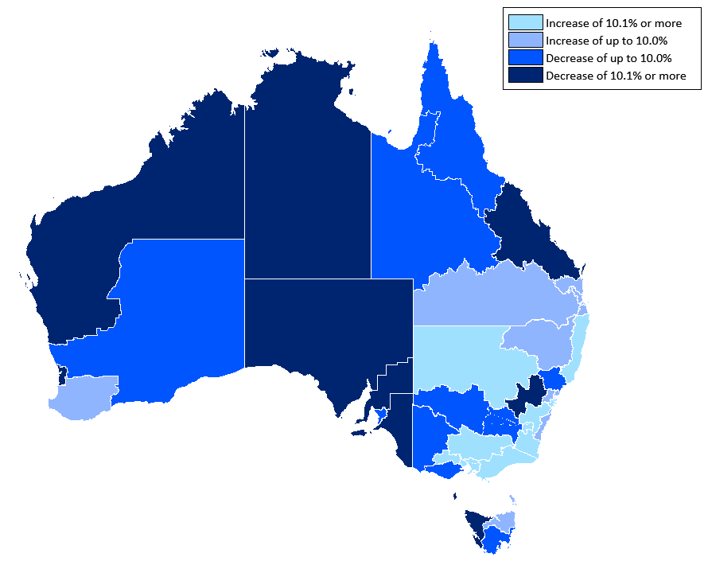
Against the backdrop of softening conditions in mining related activities, the number of vacancies in Western Australia and Queensland remains weak. Western Australia’s share of vacancies has fallen by 6.4 percentage points since the peak of 15.6% in June 2012, to stand at 9.1%. The share of vacancies in Queensland has fallen over this period by 4.2 percentage points to 18.1%. By contrast, the share of vacancies in New South Wales and Victoria have increased, driven by a rise of 8.1 percentage points in Sydney (to reach 31.9%) and 2.4 percentage points in Melbourne (to reach 22.1%).

Regional IVI – three month moving average
Regional IVI – November 2015 | Index (May '10 = 100) | Yearly  % change | Number of vacancies
New South Wales
Bathurst & Central West NSW | 22.1 | -50.6 | 133
Blue Mountains | 204.7 | 3.6 | 684
Dubbo & Western NSW | 124.0 | 11.0 | 674
Gosford & Central Coast | 128.9 | 3.0 | 1,074
Illawarra & South Coast | 136.5 | 0.9 | 1,411
NSW North Coast | 133.7 | 12.4 | 2,027
Newcastle & Hunter | 82.1 | -4.0 | 2,668
Riverina & Murray | 116.0 | -6.3 | 695
Southern Highlands & Snowy | 125.1 | 11.6 | 421
Sydney | 113.1 | 11.1 | 54,410
Tamworth & North West NSW | 82.0 | 3.8 | 667
Victoria
Ballarat & Central Highlands | 159.5 | 23.6 | 569
Bendigo & High Country | 122.3 | 16.8 | 1,394
Geelong & Surf Coast | 112.7 | -2.7 | 1,400
Gippsland | 211.6 | 10.2 | 1,172
Melbourne | 98.6 | 10.3 | 37,653
Wimmera & Western | 99.6 | -4.0 | 488
Queensland
Brisbane | 86.2 | 8.6 | 19,226
Central Queensland | 73.1 | -13.5 | 1,844
Far North Queensland | 102.5 | -4.4 | 3,547
Gold Coast | 108.9 | 8.9 | 3,878
Outback Queensland | 72.3 | -6.1 | 216
Sunshine Coast | 142.0 | 9.4 | 1,641
Toowoomba & South West QLD | 118.2 | 1.0 | 1,176
South Australia
Adelaide | 64.7 | -7.6 | 6,260
Fleurieu Peninsula & Murray Mallee | 104.6 | -10.2 | 426
Port Augusta & Eyre Peninsula | 79.3 | -24.4 | 213
Yorke Peninsula & Clare Valley | 81.9 | -17.0 | 115
Western Australia
Goldfields & Southern WA | 182.9 | -3.0 | 877
Perth | 77.3 | -16.3 | 12,906
Pilbara & Kimberley | 251.0 | -14.7 | 1,298
South West WA | 91.3 | 1.5 | 735
Tasmania
Hobart & Southeast Tasmania | 70.4 | -3.6 | 1,035
Launceston & Northeast Tasmania | 110.1 | 2.9 | 379
North West Tasmania | 125.7 | -15.3 | 258
Northern Territory
Darwin | 61.3 | -17.1 | 1,590
Regional Northern Territory | 46.2 | -10.5 | 417
Australian Capital Territory
Canberra & ACT | 104.7 | 26.5 | 4,739

State and Territory IV – trend
State IVI – November 2015 | Index (Jan '06 = 100) | Monthly  % change | Yearly  % change | Number of vacancies
Australia | 76.5 | 1.2 | 6.5 | 163,460
Managers | 107.3 | 1.6 | 11.1 | 22,476
Professionals | 94.2 | 1.2 | 14.4 | 45,286
Technicians and Trades Workers | 82.7 | 0.3 | 3.2 | 20,237
Community and Personal Service Workers | 100.3 | 1.6 | 3.6 | 12,855
Clerical and Administrative Workers | 68.8 | 0.4 | 4.4 | 28,524
Sales Workers | 69.5 | 0.5 | 5.2 | 16,313
Machinery Operators and Drivers | 55.8 | 0.7 | -2.6 | 7,122
Labourers | 36.3 | 1.6 | -11.1 | 10,574
New South Wales | 86.0 | 1.8 | 11.7 | 62,922
Managers | 109.3 | 2.3 | 16.0 | 9,698
Professionals | 94.7 | 2.5 | 14.6 | 18,351
Technicians and Trades Workers | 103.9 | 1.4 | 13.3 | 6,845
Community and Personal Service Workers | 111.8 | 1.9 | 7.7 | 4,326
Clerical and Administrative Workers | 75.0 | 1.0 | 11.7 | 11,744
Sales Workers | 71.3 | 0.1 | 11.3 | 6,132
Machinery Operators and Drivers | 74.4 | 0.2 | 10.8 | 2,368
Labourers | 51.1 | 2.0 | -4.8 | 3,519
Victoria | 82.2 | 1.5 | 11.6 | 41,269
Managers | 124.9 | 2.8 | 22.9 | 5,920
Professionals | 100.6 | 1.0 | 20.7 | 11,263
Technicians and Trades Workers | 90.1 | 0.0 | 7.7 | 4,717
Community and Personal Service Workers | 110.1 | 2.1 | 8.0 | 3,372
Clerical and Administrative Workers | 72.5 | 1.6 | 10.1 | 7,437
Sales Workers | 73.0 | 0.4 | 6.7 | 4,266
Machinery Operators and Drivers | 61.4 | 1.6 | 0.2 | 1,750
Labourers | 36.7 | 0.2 | -15.7 | 2,472
Queensland | 59.9 | 0.4 | 3.9 | 29,559
Managers | 87.2 | 0.2 | 6.7 | 3,345
Professionals | 79.9 | 0.3 | 11.6 | 7,643
Technicians and Trades Workers | 57.4 | -0.6 | 1.2 | 4,259
Community and Personal Service Workers | 82.4 | 0.9 | 2.2 | 2,708
Clerical and Administrative Workers | 56.7 | -0.7 | -2.0 | 4,769
Sales Workers | 62.6 | 0.0 | 7.3 | 3,105
Machinery Operators and Drivers | 39.6 | 1.8 | -2.0 | 1,438
Labourers | 28.0 | 1.8 | -7.7 | 2,302
South Australia | 48.9 | 0.8 | -9.0 | 6,450
Managers | 71.7 | 0.0 | -3.7 | 744
Professionals | 76.0 | 3.1 | 5.0 | 1,510
Technicians and Trades Workers | 48.7 | 1.6 | -10.6 | 899
Community and Personal Service Workers | 63.0 | 2.7 | -3.3 | 658
Clerical and Administrative Workers | 46.5 | -1.1 | -9.0 | 977
Sales Workers | 47.5 | 0.2 | -7.8 | 713
Machinery Operators and Drivers | 35.4 | 1.9 | -23.3 | 360
Labourers | 23.6 | 2.3 | -30.4 | 613
Western Australia | 81.2 | -0.7 | -13.3 | 14,898
Managers | 128.6 | -0.7 | -13.1 | 1,793
Professionals | 88.0 | 0.0 | -5.1 | 3,570
Technicians and Trades Workers | 111.1 | -0.8 | -14.9 | 2,555
Community and Personal Service Workers | 144.6 | -0.5 | -4.9 | 1,170
Clerical and Administrative Workers | 62.4 | -1.6 | -19.6 | 2,297
Sales Workers | 90.7 | -1.4 | -12.4 | 1,516
Machinery Operators and Drivers | 64.4 | 1.5 | -20.1 | 938
Labourers | 33.7 | 0.4 | -25.1 | 1,026
Tasmania | 51.3 | 0.1 | -7.3 | 1,471
Managers | 80.4 | 0.0 | -6.6 | 144
Professionals | 86.7 | -0.7 | 7.7 | 312
Technicians and Trades Workers | 56.0 | -0.5 | -15.9 | 209
Community and Personal Service Workers | 72.7 | 1.1 | -2.6 | 184
Clerical and Administrative Workers | 58.4 | 0.1 | -6.4 | 192
Sales Workers | 48.5 | -0.1 | -14.8 | 162
Machinery Operators and Drivers | 28.8 | 1.4 | -23.4 | 74
Labourers | 23.7 | 4.4 | -10.4 | 189
Northern Territory | 76.9 | -1.3 | -17.2 | 1,881
Managers | 103.6 | -1.1 | -15.8 | 220
Professionals | 148.6 | 1.5 | -3.4 | 510
Technicians and Trades Workers | 68.7 | -3.6 | -25.2 | 293
Community and Personal Service Workers | 81.9 | -0.3 | -9.4 | 196
Clerical and Administrative Workers | 82.1 | -1.8 | -26.7 | 290
Sales Workers | 68.4 | -1.6 | -15.0 | 154
Machinery Operators and Drivers | 53.1 | -2.3 | -34.9 | 100
Labourers | 32.1 | -2.0 | -14.4 | 147
Australian Capital Territory | 141.7 | 0.6 | 25.1 | 4,636
Managers | 159.6 | 2.5 | 34.6 | 704
Professionals | 138.1 | -1.1 | 21.1 | 1,796
Technicians and Trades Workers | 182.9 | 2.3 | 32.7 | 425
Community and Personal Service Workers | 235.2 | 3.6 | 16.2 | 334
Clerical and Administrative Workers | 135.8 | 2.3 | 40.5 | 866
Sales Workers | 108.1 | -0.2 | 23.3 | 289
Machinery Operators and Drivers | 79.6 | -2.6 | -1.7 | 51
Labourers | 90.7 | 1.0 | 18.7 | 178

Occupational IVI – trend
Occupational IVI – November 2015 | Index (Jan  '06 = 100) | Monthly % change | Yearly  % change | Number of vacancies
Managers | 107.3 | 1.6 | 11.1 | 22,476
Chief Executives, Managing Directors & Legislators | 156.8 | 3.0 | 18.7 | 785
Farmers and Farm Managers | 65.9 | 0.6 | -7.0 | 80
Hospitality, Retail and Service Managers | 124.0 | 2.3 | 11.6 | 5,476
Corporate Managers | 104.7 | 0.9 | 7.1 | 9,716
Construction, Production and Distribution Managers | 95.5 | 0.0 | 8.9 | 4,682
Health, Education, ICT and Other Managers | 91.1 | 2.1 | 25.8 | 1,525
Professionals | 94.2 | 1.2 | 14.4 | 45,286
Arts and Media Professionals | 79.7 | -0.3 | 9.8 | 754
Education Professionals | 117.5 | 1.1 | 13.7 | 1,527
ICT Professionals | 86.9 | 1.2 | 11.9 | 10,122
Legal, Social and Welfare Professionals | 86.9 | 0.3 | 7.2 | 3,814
Business, Finance and Human Resource Professionals | 64.1 | 0.8 | 7.8 | 9,786
Information Professionals | 140.1 | 0.1 | 10.5 | 1,872
Sales, Marketing & Public Relations Professionals | 129.8 | 0.2 | 13.8 | 3,200
Transport and Design Professionals, and Architects | 148.7 | 1.7 | 21.2 | 2,564
Engineers | 52.2 | 0.0 | 6.4 | 2,415
Science Professionals and Veterinarians | 61.8 | -1.2 | 13.8 | 530
Health Diagnostic and Therapy Professionals | 193.0 | 0.5 | 12.6 | 2,590
Medical Practitioners and Nurses | 207.0 | 2.1 | 24.8 | 5,444
Technicians and Trades Workers | 82.7 | 0.3 | 3.2 | 20,237
Engineering, ICT and Science Technicians | 88.5 | -1.2 | 5.5 | 4,496
Automotive and Engineering Trades | 67.9 | 0.5 | -3.1 | 4,249
Construction Trades | 97.2 | -0.2 | 2.8 | 2,733
Electrotechnology and Telecommunications Trades | 76.2 | -1.0 | 0.1 | 1,871
Food Trades | 94.6 | 1.9 | 2.9 | 4,042
Skilled Animal and Horticultural Workers | 76.1 | 0.4 | 7.6 | 799
Hairdressers, Printing, Clothing and Wood Trades | 77.6 | 0.5 | 1.9 | 1,385
Jewellers, Arts and Other Trades Workers | 86.2 | 0.6 | 13.9 | 457
Community and Personal Service Workers | 100.3 | 1.6 | 3.6 | 12,855
Health and Welfare Support Workers | 161.0 | 0.1 | 16.1 | 1,066
Carers and Aides | 145.3 | 2.6 | 14.2 | 5,917
Hospitality Workers | 63.8 | 0.7 | -13.5 | 3,270
Protective Service Workers | 52.2 | 0.8 | 1.5 | 657
Sports, Travel and Personal Service Workers | 115.3 | 1.8 | 8.0 | 2,048
Clerical and Administrative Workers | 68.8 | 0.4 | 4.4 | 28,524
Numerical Clerks | 57.9 | 1.1 | 0.0 | 6,037
Clerical and Office Support Workers | 72.6 | -0.7 | 11.1 | 710
Other Clerical and Administrative Workers | 92.8 | 0.4 | 8.8 | 4,097
Office Managers, Administrators and Secretaries | 72.2 | -0.4 | 7.0 | 4,969
General-Inquiry Clerks, Call Centre, and Receptionists | 68.0 | 0.6 | 5.2 | 12,813
Sales Workers | 69.5 | 0.5 | 5.2 | 16,313
Sales Representatives and Agents | 75.1 | -0.7 | 3.0 | 5,423
Sales Assistants and Salespersons | 69.6 | 1.1 | 6.0 | 9,454
Sales Support Workers | 50.5 | -0.1 | 6.8 | 1,449
Machinery Operators and Drivers | 55.8 | 0.7 | -2.6 | 7,122
Machine and Stationary Plant Operators | 65.3 | 0.9 | 4.9 | 1,577
Mobile Plant Operators | 85.8 | 2.0 | 12.4 | 2,001
Drivers and Storepersons | 43.9 | 0.7 | -13.0 | 3,520
Labourers | 36.3 | 1.6 | -11.1 | 10,574
Cleaners and Laundry Workers | 39.5 | 1.9 | -15.1 | 1,818
Construction and Mining Labourers | 62.2 | 1.1 | -3.1 | 1,143
Factory Process Workers | 49.2 | 1.3 | -4.3 | 1,973
Farm, Forestry and Garden Workers | 25.0 | 1.6 | -19.2 | 591
Food Preparation Assistants | 30.3 | 1.5 | -27.6 | 751
Other Labourers | 30.9 | 1.4 | -10.9 | 4,220
Australian Total | 76.5 | 1.2 | 6.5 | 163,460

State and Territory Skill Level Internet Vacancy Index – trend
Skill level by State/Territory – November 2015 | Index (Jan '06 = 100) | Monthly % change | Yearly % change | Number of vacancies
Australia | 76.5 | 1.2 | 6.5 | 163,460
Skill Level 1 - Bachelor degree or higher | 97.2 | 1.3 | 13.9 | 62,092
Skill Level 2 - Advanced Diploma or Diploma | 112.0 | 1.4 | 10.6 | 17,270
Skill Level 3 - Certificate IV or III* (Skilled VET) | 77.0 | -0.1 | 2.7 | 19,102
Skill Level 4 - Certificate II or III | 71.1 | 1.0 | 2.3 | 44,287
Skill Level 5 - Certificate I or secondary education | 45.1 | 1.1 | -2.6 | 20,890
New South Wales | 86.0 | 1.8 | 11.7 | 62,922
Skill Level 1 - Bachelor degree or higher | 98.9 | 2.5 | 14.8 | 26,050
Skill Level 2 - Advanced Diploma or Diploma | 118.5 | 2.0 | 15.2 | 6,278
Skill Level 3 - Certificate IV or III* (Skilled VET) | 88.8 | 0.7 | 12.8 | 6,673
Skill Level 4 - Certificate II or III | 79.1 | 1.5 | 9.8 | 16,703
Skill Level 5 - Certificate I or secondary education | 57.2 | 1.2 | 2.0 | 7,251
Victoria | 82.2 | 1.5 | 11.6 | 41,269
Skill Level 1 - Bachelor degree or higher | 104.7 | 1.3 | 19.7 | 15,592
Skill Level 2 - Advanced Diploma or Diploma | 138.1 | 2.7 | 23.3 | 4,528
Skill Level 3 - Certificate IV or III* (Skilled VET) | 77.2 | 0.0 | 5.0 | 4,482
Skill Level 4 - Certificate II or III | 76.8 | 2.0 | 6.9 | 11,569
Skill Level 5 - Certificate I or secondary education | 46.9 | 0.4 | -4.2 | 5,162
Queensland | 59.9 | 0.4 | 3.9 | 29,559
Skill Level 1 - Bachelor degree or higher | 80.4 | 0.3 | 10.8 | 9,979
Skill Level 2 - Advanced Diploma or Diploma | 81.2 | -0.7 | 4.2 | 3,100
Skill Level 3 - Certificate IV or III* (Skilled VET) | 57.9 | -0.6 | 1.2 | 3,895
Skill Level 4 - Certificate II or III | 56.8 | 0.2 | -2.9 | 8,109
Skill Level 5 - Certificate I or secondary education | 37.6 | 1.6 | 3.1 | 4,512
South Australia | 48.9 | 0.8 | -9.0 | 6,450
Skill Level 1 - Bachelor degree or higher | 71.4 | 1.6 | 0.9 | 1,978
Skill Level 2 - Advanced Diploma or Diploma | 78.8 | 0.7 | 0.0 | 710
Skill Level 3 - Certificate IV or III* (Skilled VET) | 45.7 | 1.0 | -11.5 | 800
Skill Level 4 - Certificate II or III | 46.5 | 1.0 | -9.6 | 1,852
Skill Level 5 - Certificate I or secondary education | 29.0 | 0.9 | -24.8 | 1,107
Western Australia | 81.2 | -0.7 | -13.3 | 14,898
Skill Level 1 - Bachelor degree or higher | 94.1 | -0.4 | -8.6 | 4,739
Skill Level 2 - Advanced Diploma or Diploma | 120.0 | -0.4 | -13.3 | 1,661
Skill Level 3 - Certificate IV or III* (Skilled VET) | 122.7 | 0.3 | -10.0 | 2,536
Skill Level 4 - Certificate II or III | 75.3 | -0.6 | -15.6 | 4,174
Skill Level 5 - Certificate I or secondary education | 42.3 | -0.5 | -22.5 | 1,788
Tasmania | 51.3 | 0.1 | -7.3 | 1,471
Skill Level 1 - Bachelor degree or higher | 83.7 | -1.1 | 6.5 | 411
Skill Level 2 - Advanced Diploma or Diploma | 96.0 | 0.8 | -5.2 | 168
Skill Level 3 - Certificate IV or III* (Skilled VET) | 46.1 | -1.7 | -18.4 | 158
Skill Level 4 - Certificate II or III | 51.5 | 0.4 | -9.3 | 419
Skill Level 5 - Certificate I or secondary education | 29.2 | 2.5 | -18.6 | 311
Northern Territory | 76.9 | -1.3 | -17.2 | 1,881
Skill Level 1 - Bachelor degree or higher | 129.5 | 0.1 | -7.3 | 643
Skill Level 2 - Advanced Diploma or Diploma | 115.9 | -0.7 | -16.0 | 233
Skill Level 3 - Certificate IV or III* (Skilled VET) | 69.2 | -2.9 | -25.3 | 270
Skill Level 4 - Certificate II or III | 69.9 | -2.0 | -23.5 | 505
Skill Level 5 - Certificate I or secondary education | 39.7 | -0.6 | -11.9 | 253
Australian Capital Territory | 141.7 | 0.6 | 25.1 | 4,636
Skill Level 1 - Bachelor degree or higher | 143.9 | -0.5 | 22.8 | 2,296
Skill Level 2 - Advanced Diploma or Diploma | 187.8 | 4.8 | 49.1 | 592
Skill Level 3 - Certificate IV or III* (Skilled VET) | 185.3 | 2.8 | 45.0 | 400
Skill Level 4 - Certificate II or III | 141.3 | 0.3 | 17.9 | 964
Skill Level 5 - Certificate I or secondary education | 88.8 | 2.1 | 23.9 | 399
The skill level is derived based on a classification used by the Australian Bureau of Statistics that measures skill level of occupations according to the level of educational attainment/experience commensurate with each occupation.
*Includes at least 2 years on-the-job training.

Explanatory Notes
- Over the five months to August 2015, there was a reduction in the number of new job advertisements listed on the Australian JobSearch (AJS) website. This may have been as a result of the transition of employment services from Job Services Australia to jobactive. The number of job advertisements listed on AJS began to recover in September; however, the data in this report should be used with caution.
- The monthly Internet Vacancy Index (IVI) is based on a count of online job advertisements newly lodged on SEEK, CareerOne and Australian JobSearch during the month. Duplicate advertisements are removed before the IVI vacancies are coded by the Department of Employment to occupations based on the Australian and New Zealand Standard Classification of Occupations (ANZSCO). The data are seasonally adjusted and trended, and then indexed (January 2006 = 100).
- The IVI does not reflect the total number of job advertisements in the labour market as it does not include jobs advertised through other online job boards, employer websites, word of mouth, in newspapers, and advertisements in shop windows. The IVI also does not take account of multiple positions being advertised in a single job advertisement.
- The Regional IVI was first published in September 2010 and back cast to May 2010. The Regional IVI concords vacancies to 38 best fit regions across the states and territories from the three job boards.
- The Skill level IVI was first published in June 2015 and is based on the skill level classification contained in the ANZSCO. This classification measures skill level according to the level of educational attainment/experience commensurate with each occupation.
- For more information, please contact Michael Gray (02 6121 6012) or email Michael.Gray@employment.gov.au. Media enquiries should be directed to the Department of Employment media unit (media@employment.gov.au).

Acknowledgements
The Department of Employment thanks the following job boards for their contribution to the Vacancy Report:


Forthcoming release dates (release time 11am):
For data covering: | Release date:
December 2015 | 27 January 2016
January 2016 | 24 February 2016
February 2016 | 23 March 2016
March 2016 | 20 April 2016
April 2016 | 25 May 2016
May 2016  June 201 | 22 June 2016
June 2016 | 20 July 2016
July 2016 | 24 August 2016
August 2016 | 21 September 2016
September 2016 | 19 October 2016
October 2016 | 23 November 2016
November 2016 | 21 December 2016
December 2016 | 25 January 2017

Other Labourers includes Labourers not elsewhere classified, such as Freight Handlers and Shelf Fillers.

