Key Points

Vacancy Report
September 2015
Release date: 21 October 2015

Over the five months to August 2015, there was a reduction in the number of new job advertisements listed on the Australian JobSearch (AJS) website. This may have been as a result of the transition of employment services from Job Services Australia to jobactive. The number of job advertisements listed on AJS has begun to recover this month, however, the data in this report should be used with caution.
The Internet Vacancy Index (IVI) increased by 1.8% in trend terms in September 2015, and is 3.4% higher than the level recorded a year ago. Despite this increase, the level of vacancies remains 146,400 (or 47.9%) below the March 2008 peak.
Trend Summary  Annual Change  - Increased by 3.4% to 74.6 (Jan 2006 = 100).  - Increased in five of the eight occupational groups, with the strongest rises recorded for Professionals (up by 10.5%) and Managers (8.7%).  - Increased in the Australian Capital Territory (up by 24.9%), Victoria (7.1%), New South Wales (6.5%) and Queensland (4.4%).  Monthly Change  - Vacancies increased by 1.8% over the month.  - Increased in seven of the eight occupational groups, with the strongest rise recorded for Managers (up by 2.2%).  - Increased in five states and the Australian Capital Territory, with the strongest rises recorded in New South Wales (up by 1.8%) and the Australian Capital Territory (1.6%).  (159,500 vacancies) | Seasonally Adjusted Summary  Annual Change  - Increased by 4.5% to 75.8 (Jan 2006 = 100).  - Increased in five of the eight occupational groups, with the strongest rises recorded for Managers (up by 10.5%) and Professionals (10.4%).  - Increased in three states and the Australian Capital Territory, which recorded the strongest rise (up by 26.3 per cent).  Monthly Change  - Vacancies increased by 4.2% over the month.  - Increased in all of the eight occupational groups, with the strongest rise recorded for Labourers (up by 19.5%).  - Increased in five states and the Australian Capital Territory, with strongest rises recorded in Tasmania (up by 17.4%) and South Australia (7.7%).  (160,900 vacancies)

Internet Vacancies - seasonally adjusted and trend series
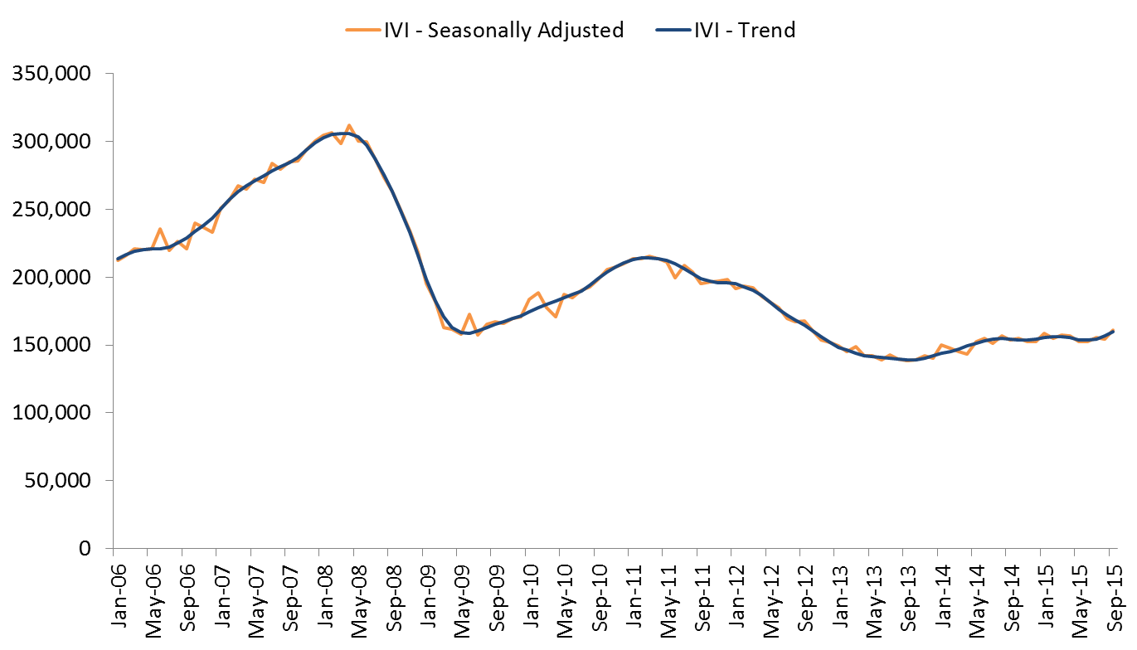

Internet Vacancy Index – Trend Series
In trend terms, the IVI rose by 1.8% in September 2015 with increases in seven of the eight occupational groups, and in five states and the Australian Capital Territory.
Over the year to September 2015, vacancies increased by 3.4%. Vacancies rose in five of the eight occupational groups, with the strongest rises recorded for Professionals (up by 10.5%) and Managers (8.7%), and the strongest declines recorded for Labourers (down by 21.4%) and Machinery Operators and Drivers (10.1%). Over the year to September 2015, the IVI increased in the Australian Capital Territory (up by 24.9%), Victoria (7.1%), New South Wales (6.5%) and Queensland (4.4%). The strongest declines were recorded in the Northern Territory (down by 16.5%) and South Australia (15.0%). Around 159,500 newly lodged vacancies were advertised during September 2015.
IVI - Trend | Index (Jan '06 = 100) | Monthly  % change | Yearly  % change | Number of vacancies
Managers | 105.4 | 2.2 | 8.7 | 21,918
Professionals | 91.7 | 1.8 | 10.5 | 44,022
Technicians and Trades Workers | 81.7 | 1.3 | 0.6 | 19,992
Community and Personal Service Workers | 94.9 | 0.1 | -1.4 | 12,158
Clerical and Administrative Workers | 68.1 | 1.1 | 4.0 | 28,250
Sales Workers | 70.3 | 1.7 | 6.5 | 16,494
Machinery Operators and Drivers | 52.3 | 2.0 | -10.1 | 6,678
Labourers | 33.0 | -0.4 | -21.4 | 9,585
States and Territories
New South Wales | 82.3 | 1.8 | 6.5 | 60,281
Victoria | 78.9 | 1.5 | 7.1 | 39,610
Queensland | 59.8 | 1.5 | 4.4 | 29,573
South Australia | 46.2 | 0.3 | -15.0 | 6,103
Western Australia | 82.9 | -0.1 | -13.4 | 15,213
Tasmania | 49.7 | 0.2 | -11.6 | 1,426
Northern Territory | 78.7 | -0.7 | -16.5 | 1,925
Australian Capital Territory | 137.7 | 1.6 | 24.9 | 4,506
Australia | 74.6 | 1.8 | 3.4 | 159,501

Internet Vacancy Index – Seasonally Adjusted Series
In seasonally adjusted terms, the IVI increased by 4.2% in September 2015. Over the month, vacancies increased in all of the eight occupational groups, and in five states and the Australian Capital Territory.

Over the year to September 2015, the IVI increased by 4.5%. Vacancies rose in five of the eight occupational groups, with the strongest rises recorded for Managers (up by 10.5%) and Professionals (10.4%). The strongest decline was recorded for Labourers (down by 14.8%). Over the year, vacancies increased in three states and in the Australian Capital Territory, which recorded the strongest rise (up by 26.3%). The strongest declines were recorded in the Northern Territory (down by 16.0%) and Western Australia (14.5%).
IVI - Seasonally Adjusted | Index (Jan '06 = 100) | Monthly % change | Yearly % change | Number of vacancies
Managers | 108.7 | 6.1 | 10.5 | 22,282
Professionals | 92.0 | 2.9 | 10.4 | 44,131
Technicians and Trades Workers | 83.4 | 1.7 | 0.6 | 20,008
Community and Personal Service Workers | 97.2 | 3.8 | -0.1 | 12,235
Clerical and Administrative Workers | 68.3 | 2.4 | 5.4 | 28,349
Sales Workers | 72.1 | 4.8 | 8.6 | 16,802
Machinery Operators and Drivers | 56.5 | 9.9 | -3.4 | 7,086
Labourers | 36.0 | 19.5 | -14.8 | 10,317
States and Territories
New South Wales | 83.5 | 5.1 | 8.7 | 60,989
Victoria | 81.0 | 3.9 | 8.1 | 40,032
Queensland | 60.2 | 4.5 | 7.0 | 30,013
South Australia | 48.8 | 7.7 | -12.5 | 6,384
Western Australia | 83.7 | -0.1 | -14.5 | 15,136
Tasmania | 52.4 | 17.4 | -9.9 | 1,510
Northern Territory | 73.8 | -4.0 | -16.0 | 1,894
Australian Capital Territory | 143.7 | 1.6 | 26.3 | 4,540
Australia | 75.8 | 4.2 | 4.5 | 160,878

Detailed Occupational Trend
Over the year to September 2015, the largest increases in vacancies at a more detailed occupational level were recorded for ICT Professionals (up by 1,013 vacancies), Medical Practitioners and Nurses (875 vacancies), Corporate Managers (660 vacancies) and Sales Assistants and Salespersons (574 vacancies).
By contrast, over the year to September 2015 the largest declines in vacancies were recorded for Other Labourers (down by 1,073 vacancies), Drivers and Storepersons (806 vacancies), Hospitality Workers (532 vacancies) and Cleaners and Laundry Workers (505 vacancies).
Largest growing and declining detailed occupations - Trend | Index (Jan '06 = 100) | Yearly change | Yearly change (%) | Number of vacancies
Largest growing detailed occupations over the year
ICT Professionals | 85.4 | 1,013 | 11.3 | 9,948
Medical Practitioners and Nurses | 193.4 | 875 | 20.8 | 5,089
Corporate Managers | 106.5 | 660 | 7.2 | 9,817
Sales Assistants and Salespersons | 69.6 | 574 | 6.5 | 9,458
General-Inquiry Clerks, Call Centre, and Receptionists | 66.6 | 570 | 4.8 | 12,552
Transport and Design Professionals, and Architects | 146.8 | 490 | 24.0 | 2,531
Office Managers, Administrators and Secretaries | 73.5 | 488 | 10.7 | 5,059
Construction, Production and Distribution Managers | 97.1 | 422 | 9.9 | 4,673
Engineering, ICT and Science Technicians | 91.7 | 421 | 9.9 | 4,654
Sales, Marketing & Public Relations Professionals | 130.9 | 378 | 13.3 | 3,225
Largest declining detailed occupations over the year
Farm, Forestry and Garden Workers | 23.2 | -189 | -25.7 | 548
Food Trades | 88.4 | -190 | -4.8 | 3,768
Factory Process Workers | 45.8 | -239 | -11.5 | 1,835
Numerical Clerks | 55.8 | -324 | -5.3 | 5,822
Food Preparation Assistants | 27.5 | -379 | -35.8 | 680
Automotive and Engineering Trades | 65.8 | -431 | -9.5 | 4,122
Cleaners and Laundry Workers | 36.4 | -505 | -23.2 | 1,670
Hospitality Workers | 61.6 | -532 | -14.4 | 3,159
Drivers and Storepersons | 41.7 | -806 | -19.5 | 3,324
Other Labourers | 27.9 | -1,073 | -22.0 | 3,811

Skill Level Trend
Over the year to September 2015, vacancies increased for the highest three skill levels, with the strongest rise recorded for skill level 1 occupations (commensurate with the attainment of a Bachelor degree or higher), up by 10.4%. By contrast, vacancies for occupations with the lowest two skill levels declined over the year, with the strongest decline in vacancies recorded for skill level 5 occupations (commensurate with the attainment of a Certificate I or secondary education), down by 8.6%.
Skill Level IVI - Trend | Index (Jan '06 = 100) | Monthly % change | Yearly % change | Number of vacancies
Skill Level 1 - Bachelor degree or higher | 95.0 | 2.0 | 10.4 | 60,611
Skill Level 2 - Advanced Diploma or Diploma | 109.2 | 1.9 | 8.4 | 16,841
Skill Level 3 - Certificate IV or III* (Skilled VET) | 77.0 | 0.6 | 1.4 | 19,103
Skill Level 4 - Certificate II or III | 68.9 | 1.0 | -1.0 | 42,907
Skill Level 5 - Certificate I or secondary education | 43.2 | 2.0 | -8.6 | 20,017
Australia | 74.6 | 1.8 | 3.4 | 159,501
The skill level is derived based on a classification used by the Australian Bureau of Statistics that measures the skill level of occupations according to the level of educational attainment/experience commensurate with each occupation.
*Includes at least two years on-the-job training.

Regional Internet Vacancy Index
Over the year to September 2015, vacancies increased in 8 of the 38 IVI regions, with the strongest growth recorded for Canberra & ACT (up by 25.6%), Sunshine Coast (8.3%) and Sydney (7.8%). The strongest falls were recorded in Bathurst & Central West NSW (down by 65.7%, albeit from a low base), Port Augusta & Eyre Peninsula SA (39.2%), Fleurieu Peninsula & Murray Mallee SA (33.9%), and Regional Northern Territory (33.6%).

Change in internet vacancies over the year to September 2015
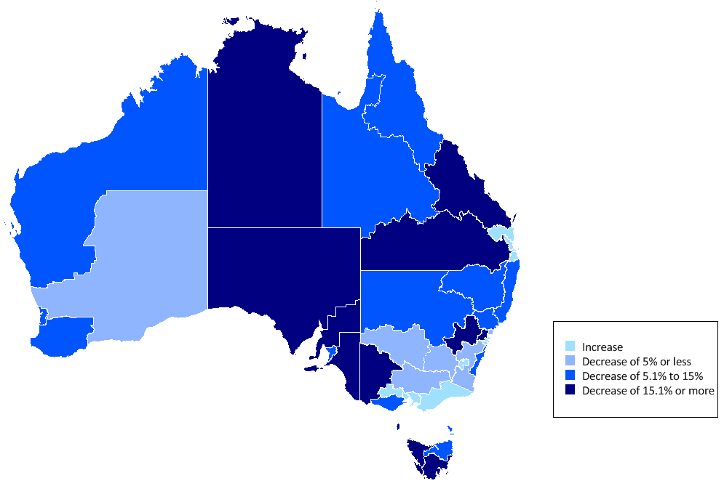
Against the backdrop of softening conditions in mining related activities, the number of vacancies in Western Australia and Queensland remains weak. Western Australia’s share of vacancies has fallen by 6.0 percentage points since the peak of 15.5% in June 2012, to stand at 9.6%. The share of vacancies in Queensland has fallen over this period by 3.7 percentage points to 18.6%. By contrast, the share of vacancies in New South Wales and Victoria have increased, driven by a rise of 8.8 percentage points in Sydney (to reach 32.6%) and 2.8 percentage points in Melbourne (to reach 22.4%).

Regional IVI – three month moving average
Regional IVI – September 2015 | Index (May '10 = 100) | Yearly  % change | Number of vacancies
New South Wales
Bathurst & Central West NSW | 14.4 | -65.7 | 87
Blue Mountains | 174.4 | -19.0 | 583
Dubbo & Western NSW | 99.6 | -12.2 | 541
Gosford & Central Coast | 128.9 | -4.6 | 1,074
Illawarra & South Coast | 125.2 | -10.6 | 1,294
NSW North Coast | 105.0 | -12.7 | 1,592
Newcastle & Hunter | 79.4 | -7.4 | 2,580
Riverina & Murray | 119.1 | -3.3 | 714
Southern Highlands & Snowy | 101.6 | -4.0 | 342
Sydney | 114.8 | 7.8 | 55,211
Tamworth & North West NSW | 70.4 | -12.9 | 573
Victoria
Ballarat & Central Highlands | 143.9 | 4.0 | 513
Bendigo & High Country | 97.1 | -3.7 | 1,107
Geelong & Surf Coast | 102.9 | -12.8 | 1,278
Gippsland | 171.4 | 1.7 | 950
Melbourne | 99.4 | 7.7 | 37,969
Wimmera & Western | 81.6 | -23.2 | 400
Queensland
Brisbane | 87.4 | 6.3 | 19,508
Central Queensland | 69.2 | -21.3 | 1,746
Far North Queensland | 101.7 | -5.7 | 3,520
Gold Coast | 102.8 | 2.0 | 3,659
Outback Queensland | 76.0 | -8.8 | 228
Sunshine Coast | 132.3 | 8.3 | 1,529
Toowoomba & South West QLD | 100.9 | -18.1 | 1,003
South Australia
Adelaide | 61.2 | -14.6 | 5,927
Fleurieu Peninsula & Murray Mallee | 76.0 | -33.9 | 309
Port Augusta & Eyre Peninsula | 62.3 | -39.2 | 167
Yorke Peninsula & Clare Valley | 65.6 | -33.1 | 92
Western Australia
Goldfields & Southern WA | 174.5 | -3.9 | 837
Perth | 79.6 | -14.7 | 13,290
Pilbara & Kimberley | 255.8 | -10.8 | 1,323
South West WA | 72.1 | -7.8 | 580
Tasmania
Hobart & Southeast Tasmania | 62.5 | -16.1 | 919
Launceston & Northeast Tasmania | 93.8 | -14.2 | 323
North West Tasmania | 113.3 | -19.1 | 233
Northern Territory
Darwin | 64.3 | -15.0 | 1,667
Regional Northern Territory | 46.9 | -33.6 | 422
Australian Capital Territory
Canberra & ACT | 104.9 | 25.6 | 4,751

State and Territory IV – trend
State IVI – September 2015 | Index (Jan '06 = 100) | Monthly  % change | Yearly  % change | Number of vacancies
Australia | 74.6 | 1.8 | 3.4 | 159,501
Managers | 105.4 | 2.2 | 8.7 | 21,918
Professionals | 91.7 | 1.8 | 10.5 | 44,022
Technicians and Trades Workers | 81.7 | 1.3 | 0.6 | 19,992
Community and Personal Service Workers | 94.9 | 0.1 | -1.4 | 12,158
Clerical and Administrative Workers | 68.1 | 1.1 | 4.0 | 28,250
Sales Workers | 70.3 | 1.7 | 6.5 | 16,494
Machinery Operators and Drivers | 52.3 | 2.0 | -10.1 | 6,678
Labourers | 33.0 | -0.4 | -21.4 | 9,585
New South Wales | 82.3 | 1.8 | 6.5 | 60,281
Managers | 104.4 | 2.6 | 10.6 | 9,268
Professionals | 90.2 | 2.1 | 8.0 | 17,483
Technicians and Trades Workers | 99.7 | 0.8 | 8.4 | 6,569
Community and Personal Service Workers | 101.2 | -0.5 | -2.3 | 3,916
Clerical and Administrative Workers | 73.0 | 1.6 | 8.0 | 11,439
Sales Workers | 71.4 | 1.3 | 12.0 | 6,133
Machinery Operators and Drivers | 73.7 | 2.7 | 9.1 | 2,346
Labourers | 45.2 | 0.4 | -18.4 | 3,106
Victoria | 78.9 | 1.5 | 7.1 | 39,610
Managers | 117.3 | 2.0 | 14.0 | 5,558
Professionals | 98.0 | 1.0 | 18.5 | 10,981
Technicians and Trades Workers | 89.3 | 1.9 | 6.7 | 4,675
Community and Personal Service Workers | 101.0 | 0.0 | 0.8 | 3,096
Clerical and Administrative Workers | 67.8 | 0.0 | 4.1 | 6,961
Sales Workers | 72.0 | 1.1 | 5.8 | 4,196
Machinery Operators and Drivers | 57.0 | 0.4 | -7.6 | 1,626
Labourers | 36.0 | -1.0 | -17.2 | 2,438
Queensland | 59.8 | 1.5 | 4.4 | 29,573
Managers | 88.1 | 2.1 | 6.9 | 3,381
Professionals | 79.6 | 2.3 | 14.3 | 7,689
Technicians and Trades Workers | 58.3 | 0.7 | 2.4 | 4,326
Community and Personal Service Workers | 81.0 | 0.4 | 3.0 | 2,670
Clerical and Administrative Workers | 58.9 | 0.7 | 4.5 | 4,972
Sales Workers | 64.2 | 2.3 | 10.4 | 3,182
Machinery Operators and Drivers | 35.5 | -0.4 | -12.8 | 1,286
Labourers | 24.8 | -0.9 | -18.7 | 2,037
South Australia | 46.2 | 0.3 | -15.0 | 6,103
Managers | 74.2 | 1.7 | 0.4 | 770
Professionals | 70.2 | 1.1 | -7.2 | 1,397
Technicians and Trades Workers | 45.7 | 0.1 | -18.9 | 844
Community and Personal Service Workers | 55.6 | -0.1 | -14.0 | 582
Clerical and Administrative Workers | 48.1 | 1.1 | -6.2 | 1,009
Sales Workers | 46.5 | -0.7 | -11.0 | 698
Machinery Operators and Drivers | 30.2 | -1.9 | -35.7 | 307
Labourers | 20.5 | -2.7 | -41.2 | 532
Western Australia | 82.9 | -0.1 | -13.4 | 15,213
Managers | 135.6 | 0.8 | -9.3 | 1,891
Professionals | 88.4 | -0.3 | -6.4 | 3,587
Technicians and Trades Workers | 111.7 | 0.2 | -19.7 | 2,567
Community and Personal Service Workers | 147.3 | -0.5 | -0.1 | 1,191
Clerical and Administrative Workers | 65.2 | -1.3 | -15.8 | 2,400
Sales Workers | 95.3 | 0.7 | -8.9 | 1,594
Machinery Operators and Drivers | 63.2 | 2.7 | -27.0 | 921
Labourers | 32.9 | -1.1 | -29.7 | 1,003
Tasmania | 49.7 | 0.2 | -11.6 | 1,426
Managers | 83.2 | 1.5 | -2.6 | 149
Professionals | 88.4 | 1.4 | 11.3 | 319
Technicians and Trades Workers | 58.6 | 1.0 | -12.4 | 219
Community and Personal Service Workers | 73.6 | -2.4 | -5.9 | 186
Clerical and Administrative Workers | 57.8 | 0.1 | -8.0 | 191
Sales Workers | 45.0 | -0.2 | -24.8 | 151
Machinery Operators and Drivers | 24.5 | 1.4 | -38.5 | 63
Labourers | 18.7 | 0.1 | -34.2 | 149
Northern Territory | 78.7 | -0.7 | -16.5 | 1,925
Managers | 107.3 | 0.4 | -15.7 | 228
Professionals | 139.6 | -0.4 | -7.5 | 479
Technicians and Trades Workers | 76.9 | -2.0 | -17.5 | 328
Community and Personal Service Workers | 81.7 | -1.0 | -10.5 | 196
Clerical and Administrative Workers | 87.9 | -0.6 | -23.6 | 311
Sales Workers | 70.6 | -1.4 | -15.5 | 159
Machinery Operators and Drivers | 55.9 | -1.3 | -35.3 | 105
Labourers | 33.2 | 0.0 | -15.2 | 153
Australian Capital Territory | 137.7 | 1.6 | 24.9 | 4,506
Managers | 143.6 | 3.7 | 25.9 | 634
Professionals | 142.4 | 1.5 | 29.6 | 1,862
Technicians and Trades Workers | 166.0 | 1.2 | 21.5 | 385
Community and Personal Service Workers | 201.4 | -0.7 | -6.6 | 286
Clerical and Administrative Workers | 125.3 | 1.3 | 40.0 | 800
Sales Workers | 107.7 | 0.4 | 20.0 | 288
Machinery Operators and Drivers | 85.4 | -0.3 | 1.0 | 54
Labourers | 83.4 | 0.1 | 6.3 | 164

Occupational IVI – trend
Occupational IVI – September 2015 | Index (Jan  '06 = 100) | Monthly % change | Yearly  % change | Number of vacancies
Managers | 105.4 | 2.2 | 8.7 | 21,918
Chief Executives, Managing Directors & Legislators | 139.7 | 1.5 | 1.3 | 701
Farmers and Farm Managers | 63.0 | -1.9 | -4.9 | 77
Hospitality, Retail and Service Managers | 117.8 | 2.1 | 7.3 | 5,211
Corporate Managers | 106.5 | 2.5 | 7.2 | 9,817
Construction, Production and Distribution Managers | 97.1 | 1.1 | 9.9 | 4,673
Health, Education, ICT and Other Managers | 84.2 | 2.4 | 19.2 | 1,414
Professionals | 91.7 | 1.8 | 10.5 | 44,022
Arts and Media Professionals | 79.5 | 1.0 | 10.5 | 752
Education Professionals | 116.3 | 1.8 | 8.9 | 1,513
ICT Professionals | 85.4 | 1.5 | 11.3 | 9,948
Legal, Social and Welfare Professionals | 86.3 | 1.3 | 7.0 | 3,788
Business, Finance and Human Resource Professionals | 62.1 | 1.1 | 2.7 | 9,484
Information Professionals | 140.6 | 0.9 | 10.2 | 1,880
Sales, Marketing & Public Relations Professionals | 130.9 | 2.7 | 13.3 | 3,225
Transport and Design Professionals, and Architects | 146.8 | 2.8 | 24.0 | 2,531
Engineers | 52.7 | 1.5 | 3.6 | 2,440
Science Professionals and Veterinarians | 63.4 | 2.6 | 18.3 | 545
Health Diagnostic and Therapy Professionals | 190.8 | 1.6 | 11.7 | 2,560
Medical Practitioners and Nurses | 193.4 | 1.3 | 20.8 | 5,089
Technicians and Trades Workers | 81.7 | 1.3 | 0.6 | 19,992
Engineering, ICT and Science Technicians | 91.7 | 1.2 | 9.9 | 4,654
Automotive and Engineering Trades | 65.8 | 0.7 | -9.5 | 4,122
Construction Trades | 99.0 | 0.0 | 4.5 | 2,783
Electrotechnology and Telecommunications Trades | 77.6 | -0.2 | 2.1 | 1,905
Food Trades | 88.4 | 0.9 | -4.8 | 3,768
Skilled Animal and Horticultural Workers | 73.9 | 0.3 | 2.4 | 777
Hairdressers, Printing, Clothing and Wood Trades | 77.4 | 0.1 | 0.2 | 1,381
Jewellers, Arts and Other Trades Workers | 86.7 | 3.3 | 17.4 | 459
Community and Personal Service Workers | 94.9 | 0.1 | -1.4 | 12,158
Health and Welfare Support Workers | 162.9 | 0.1 | 21.3 | 1,079
Carers and Aides | 134.2 | 1.4 | 5.2 | 5,470
Hospitality Workers | 61.6 | -2.8 | -14.4 | 3,159
Protective Service Workers | 50.1 | 1.2 | -0.3 | 631
Sports, Travel and Personal Service Workers | 105.5 | -0.3 | 0.5 | 1,876
Clerical and Administrative Workers | 68.1 | 1.1 | 4.0 | 28,250
Numerical Clerks | 55.8 | 0.9 | -5.3 | 5,822
Clerical and Office Support Workers, Couriers | 75.2 | 1.9 | 15.0 | 736
Other Clerical and Administrative Workers | 93.1 | 1.9 | 9.8 | 4,111
Office Managers, Administrators and Secretaries | 73.5 | 1.0 | 10.7 | 5,059
General-Inquiry Clerks, Call Centre, and Receptionists | 66.6 | 0.9 | 4.8 | 12,552
Sales Workers | 70.3 | 1.7 | 6.5 | 16,494
Sales Representatives and Agents | 76.7 | 0.2 | 5.7 | 5,544
Sales Assistants and Salespersons | 69.6 | 2.3 | 6.5 | 9,458
Sales Support Workers | 53.2 | 3.3 | 11.9 | 1,526
Machinery Operators and Drivers | 52.3 | 2.0 | -10.1 | 6,678
Machine and Stationary Plant Operators | 62.9 | 2.1 | 0.1 | 1,520
Mobile Plant Operators | 77.3 | 1.7 | 0.5 | 1,803
Drivers and Storepersons | 41.7 | -0.1 | -19.5 | 3,324
Labourers | 33.0 | -0.4 | -21.4 | 9,585
Cleaners and Laundry Workers | 36.4 | -0.7 | -23.2 | 1,670
Construction and Mining Labourers | 58.7 | 0.4 | -12.3 | 1,080
Factory Process Workers | 45.8 | -0.3 | -11.5 | 1,835
Farm, Forestry and Garden Workers | 23.2 | -0.6 | -25.7 | 548
Food Preparation Assistants | 27.5 | -2.8 | -35.8 | 680
Other Labourers | 27.9 | -0.3 | -22.0 | 3,811
Australian Total | 74.6 | 1.8 | 3.4 | 159,501

State and Territory Skill Level Internet Vacancy Index – trend
Skill level by State/Territory – September 2015 | Index (Jan '06 = 100) | Monthly % change | Yearly % change | Number of vacancies
Australia | 74.6 | 1.8 | 3.4 | 159,501
Skill Level 1 - Bachelor degree or higher | 95.0 | 2.0 | 10.4 | 60,611
Skill Level 2 - Advanced Diploma or Diploma | 109.2 | 1.9 | 8.4 | 16,841
Skill Level 3 - Certificate IV or III* (Skilled VET) | 77.0 | 0.6 | 1.4 | 19,103
Skill Level 4 - Certificate II or III | 68.9 | 1.0 | -1.0 | 42,907
Skill Level 5 - Certificate I or secondary education | 43.2 | 2.0 | -8.6 | 20,017
New South Wales | 82.3 | 1.8 | 6.5 | 60,281
Skill Level 1 - Bachelor degree or higher | 94.3 | 2.5 | 9.2 | 24,844
Skill Level 2 - Advanced Diploma or Diploma | 113.9 | 1.5 | 11.9 | 6,043
Skill Level 3 - Certificate IV or III* (Skilled VET) | 86.9 | 0.9 | 8.5 | 6,527
Skill Level 4 - Certificate II or III | 75.6 | 0.9 | 4.9 | 15,983
Skill Level 5 - Certificate I or secondary education | 54.3 | 1.1 | -4.3 | 6,870
Victoria | 78.9 | 1.5 | 7.1 | 39,610
Skill Level 1 - Bachelor degree or higher | 101.5 | 1.1 | 17.3 | 15,122
Skill Level 2 - Advanced Diploma or Diploma | 125.7 | 2.6 | 13.4 | 4,127
Skill Level 3 - Certificate IV or III* (Skilled VET) | 76.7 | 1.1 | 5.7 | 4,498
Skill Level 4 - Certificate II or III | 71.4 | 1.1 | -0.5 | 10,752
Skill Level 5 - Certificate I or secondary education | 46.0 | 0.5 | -5.8 | 5,057
Queensland | 59.8 | 1.5 | 4.4 | 29,573
Skill Level 1 - Bachelor degree or higher | 80.6 | 2.4 | 13.0 | 10,100
Skill Level 2 - Advanced Diploma or Diploma | 84.6 | 1.9 | 9.2 | 3,230
Skill Level 3 - Certificate IV or III* (Skilled VET) | 58.6 | 0.9 | 2.6 | 3,942
Skill Level 4 - Certificate II or III | 56.4 | 0.1 | -1.7 | 8,049
Skill Level 5 - Certificate I or secondary education | 35.3 | 1.6 | -3.9 | 4,240
South Australia | 46.2 | 0.3 | -15.0 | 6,103
Skill Level 1 - Bachelor degree or higher | 68.3 | 0.7 | -5.0 | 1,891
Skill Level 2 - Advanced Diploma or Diploma | 79.1 | 1.3 | 0.4 | 714
Skill Level 3 - Certificate IV or III* (Skilled VET) | 43.0 | -0.6 | -18.1 | 756
Skill Level 4 - Certificate II or III | 43.8 | 0.8 | -16.0 | 1,743
Skill Level 5 - Certificate I or secondary education | 27.0 | -1.9 | -31.4 | 1,028
Western Australia | 82.9 | -0.1 | -13.4 | 15,213
Skill Level 1 - Bachelor degree or higher | 95.8 | -0.6 | -8.7 | 4,827
Skill Level 2 - Advanced Diploma or Diploma | 127.0 | 2.1 | -9.5 | 1,757
Skill Level 3 - Certificate IV or III* (Skilled VET) | 119.7 | 0.3 | -17.0 | 2,474
Skill Level 4 - Certificate II or III | 76.6 | -0.9 | -15.7 | 4,248
Skill Level 5 - Certificate I or secondary education | 43.8 | 1.0 | -22.6 | 1,851
Tasmania | 49.7 | 0.2 | -11.6 | 1,426
Skill Level 1 - Bachelor degree or higher | 87.2 | 1.6 | 11.4 | 429
Skill Level 2 - Advanced Diploma or Diploma | 96.4 | 0.7 | -3.6 | 168
Skill Level 3 - Certificate IV or III* (Skilled VET) | 50.1 | -0.7 | -11.9 | 171
Skill Level 4 - Certificate II or III | 49.8 | -0.1 | -15.4 | 405
Skill Level 5 - Certificate I or secondary education | 27.8 | 1.0 | -25.4 | 295
Northern Territory | 78.7 | -0.7 | -16.5 | 1,925
Skill Level 1 - Bachelor degree or higher | 128.1 | 0.4 | -8.6 | 637
Skill Level 2 - Advanced Diploma or Diploma | 119.1 | -1.2 | -14.2 | 239
Skill Level 3 - Certificate IV or III* (Skilled VET) | 73.9 | -3.0 | -23.4 | 288
Skill Level 4 - Certificate II or III | 74.2 | 0.3 | -20.0 | 535
Skill Level 5 - Certificate I or secondary education | 39.9 | -0.9 | -17.7 | 254
Australian Capital Territory | 137.7 | 1.6 | 24.9 | 4,506
Skill Level 1 - Bachelor degree or higher | 146.1 | 2.1 | 29.5 | 2,327
Skill Level 2 - Advanced Diploma or Diploma | 160.5 | 2.3 | 26.2 | 506
Skill Level 3 - Certificate IV or III* (Skilled VET) | 164.7 | 1.3 | 34.5 | 355
Skill Level 4 - Certificate II or III | 139.2 | 0.5 | 18.9 | 950
Skill Level 5 - Certificate I or secondary education | 80.6 | 0.5 | 10.9 | 360
The skill level is derived based on a classification used by the Australian Bureau of Statistics that measures skill level of occupations according to the level of educational attainment/experience commensurate with each occupation.
*Includes at least 2 years on-the-job training.

Explanatory Notes
- Over the five months to August 2015, there was a reduction in the number of new job advertisements listed on the Australian JobSearch (AJS) website. This may have been as a result of the transition of employment services from Job Services Australia to jobactive. The number of job advertisements listed on AJS has begun to recover this month, however, the data in this report should be used with caution.
- The monthly Internet Vacancy Index (IVI) is based on a count of online job advertisements newly lodged on SEEK, CareerOne and Australian JobSearch during the month. Duplicate advertisements are removed before the IVI vacancies are coded by the Department of Employment to occupations based on the Australian and New Zealand Standard Classification of Occupations (ANZSCO). The data are seasonally adjusted and trended, and then indexed (January 2006 = 100).
- The IVI does not reflect the total number of job advertisements in the labour market as it does not include jobs advertised through other online job boards, employer websites, word of mouth, in newspapers, and advertisements in shop windows. The IVI also does not take account of multiple positions being advertised in a single job advertisement.
- The Regional IVI was first published in September 2010 and back cast to May 2010. The Regional IVI concords vacancies to 38 best fit regions across the states and territories from the three job boards.
- The Skill level IVI was first published in June 2015 and is based on the skill level classification contained in the Australian and New Zealand Standard Classification of Occupations. This classification measures skill level according to the level of educational attainment/experience commensurate with each occupation.
- For more information, please contact James Jordan (02 6240 2597) or email james.jordan@employment.gov.au. Media enquiries should be directed to the Department of Employment media unit (media@employment.gov.au).

Acknowledgements
The Department of Employment thanks the following job boards for their contribution to the Vacancy Report:

Forthcoming release dates (release time 11am):
For data covering: | Release date:
October 2015 | 25 November 2015
November 2015 | 16 December 2015
December 2015 | 27 January 2015

Other Labourers includes Labourers not elsewhere classified, such as Freight Handlers and Shelf Fillers.

