Key Points

Vacancy Report
March 2015
Release date: 22 April 2015

The Internet Vacancy Index (IVI) rose by 0.4 per cent in trend terms in March 2015. In line with other vacancy measures, the IVI is now 7.7 per cent (or 11,300 vacancies) higher than the level recorded a year ago, suggesting that demand for labour has improved. However, vacancies remain 150,300 (or 48.8 per cent) below the March 2008 peak indicating that labour market conditions are likely to remain relatively subdued, at least in the near term.
Trend Summary  Annual Change  - Increased by 7.7% to 74.1 (Jan 2006 = 100).  - Increased in all eight occupational groups, with the strongest rise recorded for Community and Personal Service Workers (up by 12.3%).  - Increased in four states and the Australian Capital Territory, with vacancies declining in the Northern Territory (down by 11.7%), Western Australia (5.5%) and Tasmania (1.0%).  Monthly Change  - Vacancies rose by 0.4% over the month.  - Increased in seven of the eight occupational groups, with the strongest rise recorded for Professionals (up by 1.2%) and Machinery Operators and Drivers (1.1%).  - Increased in three states and the Australian Capital Territory, with Victoria recording the strongest rise (up by 1.7%).  (157,600 vacancies) | Seasonally Adjusted Summary  Annual Change  - Increased by 9.0% to 74.6 (Jan 2006 = 100).  - Increased in all eight occupational groups, with the strongest rise recorded for Community and Personal Service Workers (up by 18.2%).  - Increased in four states and the Australian Capital Territory, which recorded the strongest rise of 25.2%.  Monthly Change  - Vacancies increased by 1.9% over the month.  - Increased in seven of the eight occupational groups, with the strongest rise recorded for Machinery Operators and Drivers (up by 5.1%). Remained unchanged for Clerical and Administrative Workers.  - Increased in four states and the Australian Capital Territory, with declines recorded in Northern Territory (down by 11.1%), Western Australia (2.7%) and Tasmania (2.7%).  (158,200 vacancies)

Internet Vacancy Index and Skilled Internet Vacancy Index (January 2006 = 100)
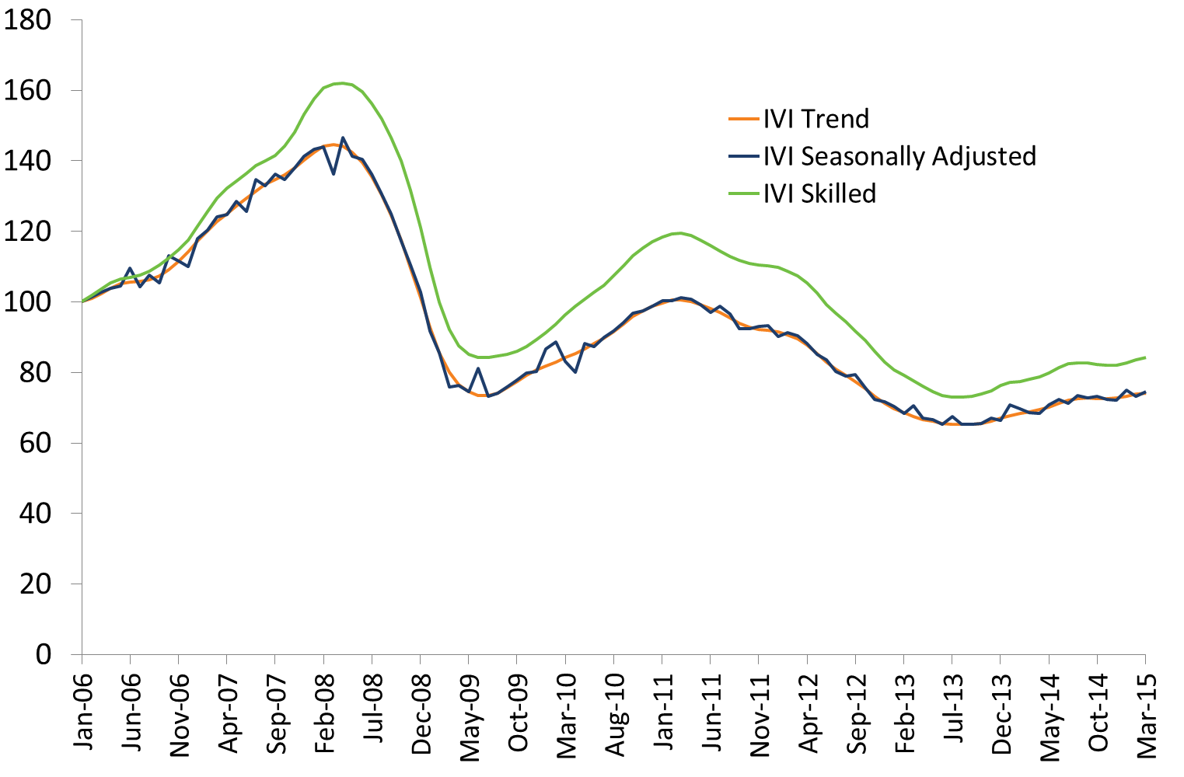

Internet Vacancy Index – Trend Series
In trend terms, the IVI rose by 0.4% in March 2015. Over the month, vacancies increased in seven of the eight occupational groups, and in three states and the Australian Capital Territory.
Over the year to March 2015, vacancies increased by 7.7%. The IVI increased in four states and the Australian Capital Territory, with vacancies declining in the Northern Territory (down by 11.7%), Western Australia (5.5%) and Tasmania (1.0%). The strongest rises were recorded in the Australian Capital Territory (up by 21.7%, driven primarily by ICT occupations, including Software and Applications Programmers and ICT Support Technicians), Victoria (12.3%) and New South Wales (11.7%). Vacancies rose in all eight occupational groups, with the strongest rises recorded for Community and Personal Service Workers (up by 12.3%) and Clerical and Administrative Workers (10.0%). Around 157,600 newly lodged vacancies were advertised during March 2015.
IVI - Trend | Index (Jan '06 = 100) | Monthly  % change | Yearly  % change | Number of vacancies
Managers | 101.0 | 0.1 | 6.9 | 20,702
Professionals | 86.3 | 1.2 | 9.6 | 41,313
Technicians and Trades Workers | 80.6 | -0.1 | 3.1 | 19,644
Community and Personal Service Workers | 100.0 | 0.5 | 12.3 | 12,812
Clerical and Administrative Workers | 67.0 | 0.3 | 10.0 | 27,728
Sales Workers | 67.3 | 0.4 | 4.0 | 15,785
Machinery Operators and Drivers | 58.3 | 1.1 | 1.0 | 7,444
Labourers | 41.1 | 0.5 | 2.8 | 11,921
States and Territories
New South Wales | 79.7 | 0.6 | 11.7 | 58,289
Victoria | 78.9 | 1.7 | 12.3 | 39,493
Queensland | 58.8 | 0.1 | 2.9 | 29,019
South Australia | 53.4 | -0.1 | 0.7 | 7,041
Western Australia | 86.3 | -1.3 | -5.5 | 15,844
Tasmania | 53.2 | -1.1 | -1.0 | 1,522
Northern Territory | 88.8 | -2.0 | -11.7 | 2,170
Australian Capital Territory | 121.5 | 1.4 | 21.7 | 3,958
Australia | 74.1 | 0.4 | 7.7 | 157,562

Internet Vacancy Index – Seasonally Adjusted Series
In seasonally adjusted terms, the IVI increased by 1.9% in March 2015. Over the month, vacancies increased in seven of the eight occupational groups (and remained unchanged for Clerical and Administrative Workers), and in four states and the Australian Capital Territory.
Over the year to March 2015, the IVI increased by 9.0%. Vacancies rose in all eight occupational groups, with the strongest increases recorded for Community and Personal Service Workers (up by 18.2%) and Professionals (13.5%). Over the year, vacancies rose in four states and the Australian Capital Territory, which recorded the strongest increase of 25.2%.
IVI - Seasonally Adjusted | Index (Jan '06 = 100) | Monthly % change | Yearly % change | Number of vacancies
Managers | 102.3 | 2.1 | 9.5 | 20,882
Professionals | 85.8 | 1.3 | 13.5 | 41,153
Technicians and Trades Workers | 82.1 | 1.3 | 3.4 | 19,665
Community and Personal Service Workers | 101.7 | 1.2 | 18.2 | 12,797
Clerical and Administrative Workers | 66.4 | 0.0 | 9.0 | 27,565
Sales Workers | 68.1 | 1.0 | 4.9 | 15,831
Machinery Operators and Drivers | 60.1 | 5.1 | 2.7 | 7,537
Labourers | 41.6 | 1.3 | 2.7 | 11,933
States and Territories
New South Wales | 79.6 | 1.0 | 15.7 | 58,037
Victoria | 80.7 | 3.0 | 13.8 | 39,737
Queensland | 58.1 | 1.0 | 2.9 | 28,879
South Australia | 54.4 | 2.0 | 3.1 | 7,094
Western Australia | 86.7 | -2.7 | -6.5 | 15,697
Tasmania | 52.0 | -2.7 | -5.2 | 1,492
Northern Territory | 77.9 | -11.1 | -18.6 | 2,003
Australian Capital Territory | 128.7 | 7.8 | 25.2 | 4,052
Australia | 74.6 | 1.9 | 9.0 | 158,189

Skilled Internet Vacancy Index
The Skilled IVI increased by 0.7% in March 2015, with vacancies rising in 14 of the 20 Skilled IVI occupational groups over the month. The strongest increases were recorded Science Professionals and Veterinarians (up by 2.8%), albeit from a low base and Skilled Animal and Horticulture Workers (2.5%), while the strongest declines were recorded for Automotive and Engineering Trades (down by 0.7%) and Electrotechnology and Telecommunications Trades (0.5%). Vacancies remained unchanged for Engineering, ICT and Science Technicians over the month.
Over the year to March 2015, the Skilled IVI has risen by 8.0%, with vacancies increasing in 15 of the 20 occupational groups. The strongest increases were recorded for Medical Practitioners and Nurses (up by 26.5%), followed by Skilled Animal and Horticultural Workers (25.6%). By contrast, in line with the softening conditions in Mining, a strong decline in vacancies was recorded for Engineers (6.3%), with the series now more than 80 per cent below its peak in 2008. Vacancies for Automotive and Engineering Trades also declined by 10.6% over the year to March 2015. Vacancies remained unchanged for Business, Finance and Human Resource Professionals over the month.
Skilled IVI – March 2015 | Index (Jan '06 = 100) | Monthly % change | Yearly  % change | Number of vacancies
Professionals | 86.3 | 1.2 | 9.6 | 41,313
Arts and Media Professionals | 73.3 | -0.2 | 3.2 | 698
Education Professionals | 105.6 | 1.3 | -1.0 | 1,367
ICT Professionals | 82.1 | 0.7 | 14.9 | 9,565
Legal, Social and Welfare Professionals | 84.4 | 0.9 | 14.9 | 3,707
Business, Finance and Human Resource Professionals | 61.0 | 0.9 | 0.0 | 9,110
Information Professionals | 139.8 | 2.4 | 14.1 | 1,842
Sales, Marketing & Public Relations Professionals | 121.0 | 2.1 | 10.6 | 2,988
Transport and Design Professionals, and Architects | 131.2 | 0.9 | 19.3 | 2,257
Engineers | 49.0 | -0.2 | -6.3 | 2,268
Science Professionals and Veterinarians | 58.7 | 2.8 | 4.0 | 503
Health Diagnostic and Therapy Professionals | 174.8 | -0.2 | 3.1 | 2,326
Medical Practitioners and Nurses | 179.5 | 1.7 | 26.5 | 4,708
Technicians and Trades Workers | 80.6 | -0.1 | 3.1 | 19,644
Engineering, ICT and Science Technicians | 85.8 | 0.0 | 6.5 | 4,337
Automotive and Engineering Trades | 66.3 | -0.7 | -10.6 | 4,159
Construction Trades | 96.8 | 1.3 | 17.0 | 2,705
Electrotechnology and Telecommunications Trades | 73.0 | -0.5 | -1.1 | 1,791
Food Trades | 93.3 | 0.1 | 3.3 | 3,974
Skilled Animal and Horticultural Workers | 77.2 | 2.5 | 25.6 | 812
Hairdressers, Printing, Clothing and Wood Trades | 78.2 | 1.1 | 5.1 | 1,389
Jewellers, Arts and Other Trades Workers | 80.8 | 1.3 | 15.0 | 430
Skilled IVI Total | 84.2 | 0.7 | 8.0 | 61,068

Regional Internet Vacancy Index
Over the year to March 2015, vacancies increased in 18 of the 38 IVI regions. The strongest increases were recorded in Ballarat & Central Highlands (up by 19.9%), Canberra & ACT (18.7%) and Illawarra & South Coast (14.7%), while the strongest falls were in Pilbara & Kimberley (down by 30.0%), Toowoomba & South West QLD (27.2%) and Port Augusta & Eyre Peninsula (22.7%).

Change in internet vacancies over the year to March 2015
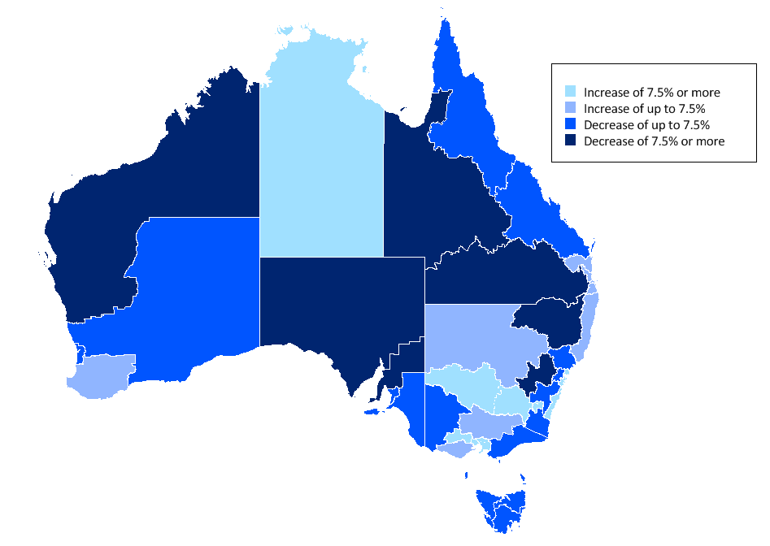

Against the backdrop of softening conditions in mining related activities, the number of vacancies in regional areas of Western Australia and Queensland continues to decline. For instance, over the past three years, Western Australia’s share of vacancies has fallen by 5.0 percentage points to stand at 10.1% in March 2015, while the share of vacancies in Queensland has fallen by 4.2 percentage points to stand at 18.4%. By contrast, the share of vacancies in New South Wales has increased by 7.3 percentage points over the same period, to stand at 37.0% in March 2015.

Regional IVI – March 2015 – three month moving average
Regional IVI – March 2015 | Index (May '10 = 100) | Yearly  % change | Number of vacancies
New South Wales
Bathurst & Central West NSW | 34.3 | -12.9 | 207
Blue Mountains | 188.7 | -1.0 | 631
Dubbo & Western NSW | 105.8 | 4.0 | 575
Gosford & Central Coast | 123.4 | 9.7 | 1,028
Illawarra & South Coast | 122.7 | 14.7 | 1,268
NSW North Coast | 112.8 | 2.7 | 1,710
Newcastle & Hunter | 79.3 | -5.9 | 2,577
Riverina & Murray | 124.7 | 10.6 | 748
Southern Highlands & Snowy | 101.3 | -3.2 | 341
Sydney | 100.2 | 14.3 | 48,196
Tamworth & North West NSW | 77.7 | -11.8 | 632
Victoria
Ballarat & Central Highlands | 135.0 | 19.9 | 481
Bendigo & High Country | 101.3 | 3.8 | 1,154
Geelong & Surf Coast | 103.7 | 1.9 | 1,288
Gippsland | 169.9 | -0.4 | 941
Melbourne | 90.8 | 9.8 | 34,678
Wimmera & Western | 102.9 | -5.2 | 505
Queensland
Brisbane | 80.7 | 5.5 | 18,003
Central Queensland | 79.4 | -6.5 | 2,004
Far North Queensland | 98.1 | -1.3 | 3,395
Gold Coast | 95.9 | 4.1 | 3,415
Outback Queensland | 84.8 | -10.2 | 254
Sunshine Coast | 117.7 | 6.1 | 1,360
Toowoomba & South West QLD | 104.4 | -27.2 | 1,039
South Australia
Adelaide | 64.7 | 0.9 | 6,261
Fleurieu Peninsula & Murray Mallee | 110.8 | -3.4 | 451
Port Augusta & Eyre Peninsula | 82.7 | -22.7 | 222
Yorke Peninsula & Clare Valley | 85.0 | -10.9 | 120
Western Australia
Goldfields & Southern WA | 166.7 | -6.1 | 799
Perth | 82.5 | -3.3 | 13,780
Pilbara & Kimberley | 225.3 | -30.0 | 1,165
South West WA | 82.7 | 6.6 | 665
Tasmania
Hobart & Southeast Tasmania | 67.1 | 0.4 | 987
Launceston & Northeast Tasmania | 102.4 | -1.9 | 353
North West Tasmania | 127.3 | -3.1 | 261
Northern Territory
Darwin | 65.5 | -16.0 | 1,697
Regional Northern Territory | 49.6 | 8.4 | 447
Australian Capital Territory
Canberra & ACT | 86.4 | 18.7 | 3,911

State and Territory IVI – March 2015 – trend
State IVI – March 2015 | Index (Jan '06 = 100) | Monthly  % change | Yearly  % change | Number of vacancies
Australia | 74.1 | 0.4 | 7.7 | 157,562
Managers | 101.0 | 0.1 | 6.9 | 20,702
Professionals | 86.3 | 1.2 | 9.6 | 41,313
Technicians and Trades Workers | 80.6 | -0.1 | 3.1 | 19,644
Community and Personal Service Workers | 100.0 | 0.5 | 12.3 | 12,812
Clerical and Administrative Workers | 67.0 | 0.3 | 10.0 | 27,728
Sales Workers | 67.3 | 0.4 | 4.0 | 15,785
Machinery Operators and Drivers | 58.3 | 1.1 | 1.0 | 7,444
Labourers | 41.1 | 0.5 | 2.8 | 11,921
New South Wales | 79.7 | 0.6 | 11.7 | 58,289
Managers | 98.4 | 0.9 | 12.3 | 8,727
Professionals | 86.2 | 1.3 | 12.6 | 16,690
Technicians and Trades Workers | 94.3 | 0.4 | 9.7 | 6,180
Community and Personal Service Workers | 106.7 | 0.5 | 10.6 | 4,116
Clerical and Administrative Workers | 70.1 | 1.2 | 16.2 | 10,938
Sales Workers | 65.7 | 0.7 | 8.0 | 5,642
Machinery Operators and Drivers | 73.2 | 2.5 | 13.7 | 2,331
Labourers | 54.1 | 0.0 | 3.7 | 3,724
Victoria | 78.9 | 1.7 | 12.3 | 39,493
Managers | 108.3 | 0.5 | 6.4 | 5,124
Professionals | 90.7 | 1.9 | 12.7 | 10,138
Technicians and Trades Workers | 88.9 | 1.6 | 15.4 | 4,648
Community and Personal Service Workers | 111.5 | 1.9 | 18.6 | 3,419
Clerical and Administrative Workers | 69.4 | 1.5 | 12.6 | 7,111
Sales Workers | 71.0 | 0.7 | 5.7 | 4,136
Machinery Operators and Drivers | 62.5 | 1.1 | 13.8 | 1,781
Labourers | 44.0 | 0.8 | 12.1 | 3,001
Queensland | 58.8 | 0.1 | 2.9 | 29,019
Managers | 81.9 | -0.2 | 1.7 | 3,144
Professionals | 74.0 | 0.2 | 6.2 | 7,095
Technicians and Trades Workers | 57.6 | 0.7 | -0.1 | 4,268
Community and Personal Service Workers | 82.8 | -0.1 | 13.5 | 2,734
Clerical and Administrative Workers | 55.7 | -1.7 | 2.4 | 4,695
Sales Workers | 60.3 | 0.3 | -1.1 | 2,971
Machinery Operators and Drivers | 41.6 | 0.0 | -4.1 | 1,513
Labourers | 31.0 | -0.1 | -2.8 | 2,561
South Australia | 53.4 | -0.1 | 0.7 | 7,041
Managers | 73.5 | -0.4 | 4.9 | 766
Professionals | 73.3 | 1.3 | 3.1 | 1,455
Technicians and Trades Workers | 50.9 | -2.1 | -11.7 | 938
Community and Personal Service Workers | 68.3 | 0.3 | 13.5 | 714
Clerical and Administrative Workers | 52.1 | -0.3 | 4.4 | 1,095
Sales Workers | 52.6 | 0.7 | 7.2 | 786
Machinery Operators and Drivers | 44.5 | -1.3 | -5.1 | 453
Labourers | 33.1 | -1.0 | -3.4 | 861
Western Australia | 86.3 | -1.3 | -5.5 | 15,844
Managers | 139.4 | -1.4 | -5.7 | 1,944
Professionals | 88.5 | -0.6 | -2.9 | 3,587
Technicians and Trades Workers | 115.6 | -2.3 | -13.9 | 2,660
Community and Personal Service Workers | 153.0 | 0.1 | 17.1 | 1,235
Clerical and Administrative Workers | 71.8 | -2.5 | -4.9 | 2,640
Sales Workers | 100.1 | -1.0 | -1.9 | 1,668
Machinery Operators and Drivers | 72.2 | -1.9 | -17.5 | 1,048
Labourers | 39.5 | -3.2 | -6.2 | 1,206
Tasmania | 53.2 | -1.1 | -1.0 | 1,522
Managers | 85.5 | -0.5 | 2.0 | 152
Professionals | 77.1 | -1.1 | -1.2 | 276
Technicians and Trades Workers | 66.9 | -0.7 | 14.4 | 250
Community and Personal Service Workers | 70.9 | -0.8 | -8.8 | 178
Clerical and Administrative Workers | 63.8 | -0.3 | 0.0 | 208
Sales Workers | 53.7 | -1.0 | -11.7 | 179
Machinery Operators and Drivers | 35.1 | -2.3 | -1.2 | 91
Labourers | 25.4 | -0.6 | 4.0 | 206
Northern Territory | 88.8 | -2.0 | -11.7 | 2,170
Managers | 122.1 | 0.2 | -3.1 | 263
Professionals | 153.0 | -1.7 | -2.1 | 516
Technicians and Trades Workers | 85.4 | -1.5 | -17.5 | 364
Community and Personal Service Workers | 84.3 | -1.3 | -9.3 | 202
Clerical and Administrative Workers | 101.3 | -2.3 | -8.0 | 358
Sales Workers | 74.9 | -1.1 | -19.3 | 169
Machinery Operators and Drivers | 71.2 | -3.5 | -32.5 | 133
Labourers | 34.5 | -2.9 | -23.6 | 159
Australian Capital Territory | 121.5 | 1.4 | 21.7 | 3,958
Managers | 134.6 | 2.0 | 35.6 | 593
Professionals | 121.3 | 1.9 | 21.3 | 1,601
Technicians and Trades Workers | 145.5 | 1.5 | 21.5 | 336
Community and Personal Service Workers | 201.5 | 0.8 | -0.5 | 286
Clerical and Administrative Workers | 106.6 | 1.0 | 40.3 | 680
Sales Workers | 87.7 | 0.7 | -8.2 | 235
Machinery Operators and Drivers | 98.7 | 6.7 | 26.7 | 62
Labourers | 73.5 | -0.2 | -4.3 | 144

Occupational IVI – March 2015 – trend
Occupational IVI – March 2015 | Index (Jan  '06 = 100) | Monthly % change | Yearly  % change | Number of vacancies
Managers | 101.0 | 0.1 | 6.9 | 20,702
Chief Executives, Managing Directors & Legislators | 132.0 | -0.1 | 2.9 | 656
Farmers and Farm Managers | 79.1 | 1.4 | 47.5 | 96
Hospitality, Retail and Service Managers | 114.1 | 0.5 | 10.7 | 5,035
Corporate Managers | 100.1 | 0.1 | 4.5 | 9,190
Construction, Production and Distribution Managers | 94.1 | 1.1 | 11.7 | 4,545
Health, Education, ICT and Other Managers | 72.8 | -0.2 | 7.1 | 1,223
Professionals | 86.3 | 1.2 | 9.6 | 41,313
Arts and Media Professionals | 73.3 | -0.2 | 3.2 | 698
Education Professionals | 105.6 | 1.3 | -1.0 | 1,367
ICT Professionals | 82.1 | 0.7 | 14.9 | 9,565
Legal, Social and Welfare Professionals | 84.4 | 0.9 | 14.9 | 3,707
Business, Finance and Human Resource Professionals | 61.0 | 0.9 | 0.0 | 9,110
Information Professionals | 139.8 | 2.4 | 14.1 | 1,842
Sales, Marketing & Public Relations Professionals | 121.0 | 2.1 | 10.6 | 2,988
Transport and Design Professionals, and Architects | 131.2 | 0.9 | 19.3 | 2,257
Engineers | 49.0 | -0.2 | -6.3 | 2,268
Science Professionals and Veterinarians | 58.7 | 2.8 | 4.0 | 503
Health Diagnostic and Therapy Professionals | 174.8 | -0.2 | 3.1 | 2,326
Medical Practitioners and Nurses | 179.5 | 1.7 | 26.5 | 4,708
Technicians and Trades Workers | 80.6 | -0.1 | 3.1 | 19,644
Engineering, ICT and Science Technicians | 85.8 | 0.0 | 6.5 | 4,337
Automotive and Engineering Trades | 66.3 | -0.7 | -10.6 | 4,159
Construction Trades | 96.8 | 1.3 | 17.0 | 2,705
Electrotechnology and Telecommunications Trades | 73.0 | -0.5 | -1.1 | 1,791
Food Trades | 93.3 | 0.1 | 3.3 | 3,974
Skilled Animal and Horticultural Workers | 77.2 | 2.5 | 25.6 | 812
Hairdressers, Printing, Clothing and Wood Trades | 78.2 | 1.1 | 5.1 | 1,389
Jewellers, Arts and Other Trades Workers | 80.8 | 1.3 | 15.0 | 430
Community and Personal Service Workers | 100.0 | 0.5 | 12.3 | 12,812
Health and Welfare Support Workers | 153.1 | 2.0 | 16.3 | 1,009
Carers and Aides | 127.9 | 0.2 | 4.8 | 5,226
Hospitality Workers | 78.3 | 1.3 | 25.9 | 4,022
Protective Service Workers | 54.0 | 0.7 | 19.5 | 678
Sports, Travel and Personal Service Workers | 109.3 | 0.2 | 10.2 | 1,936
Clerical and Administrative Workers | 67.0 | 0.3 | 10.0 | 27,728
Numerical Clerks | 57.9 | 0.7 | 7.0 | 6,043
Clerical and Office Support Workers, Couriers | 67.3 | 1.2 | 2.9 | 658
Other Clerical and Administrative Workers | 87.2 | -0.4 | 8.4 | 3,842
Office Managers, Administrators and Secretaries | 68.6 | 0.9 | 11.0 | 4,725
General-Inquiry Clerks, Call Centre, Receptionists | 65.8 | 0.0 | 11.0 | 12,397
Sales Workers | 67.3 | 0.4 | 4.0 | 15,785
Sales Representatives and Agents | 73.9 | 0.6 | 1.8 | 5,321
Sales Assistants and Salespersons | 67.5 | 0.3 | 8.1 | 9,168
Sales Support Workers | 47.1 | -0.1 | -6.1 | 1,362
Machinery Operators and Drivers | 58.3 | 1.1 | 1.0 | 7,444
Machine and Stationary Plant Operators | 63.6 | 0.5 | -0.2 | 1,541
Mobile Plant Operators | 76.6 | 0.1 | -1.8 | 1,789
Drivers and Storepersons | 50.8 | 0.6 | 2.6 | 4,084
Labourers | 41.1 | 0.5 | 2.8 | 11,921
Cleaners and Laundry Workers | 47.0 | 0.0 | 1.8 | 2,165
Construction and Mining Labourers | 60.7 | -0.5 | -6.5 | 1,114
Factory Process Workers | 51.8 | 0.0 | 4.1 | 2,061
Farm, Forestry and Garden Workers | 30.0 | -1.7 | 2.7 | 709
Food Preparation Assistants | 41.4 | -0.4 | -2.9 | 1,035
Other Labourers | 35.0 | 0.7 | 4.1 | 4,786
Australian Total | 74.1 | 0.4 | 7.7 | 157,562

Explanatory Notes
- The monthly Internet Vacancy Index (IVI) is based on a count of online job advertisements newly lodged on SEEK, CareerOne and Australian JobSearch during the month. Duplicate advertisements are removed before the IVI vacancies are coded by the Department of Employment to occupations based on the Australian and New Zealand Standard Classification of Occupations (ANZSCO). The data are seasonally adjusted and trended, and then indexed (January 2006 = 100).
- This month, IVI data have been reprocessed back to September 2013 to remove a number of advertisements for one-off tasks or odd-jobs which were being included on one of the job boards included in IVI.
- Since the August 2014 issue of the Vacancy Report, job advertisements from the MyCareer website have no longer been included in the IVI. To account for this change, all historical IVI series were reprocessed with MyCareer data removed for each month from mid-2012 onwards to determine the precise impact of the removal of the MyCareer data on the series. The impact of MyCareer’s removal was estimated by comparing the old series (which included MyCareer) and the reprocessed series (excluding MyCareer) from mid-2012 onwards. For data prior to mid-2012, a splicing technique, based on MyCareer’s share, was used to adjust the data to ensure they remained comparable with the reprocessed data from mid-2012 onwards. Seasonal adjustment and trending were then performed on the adjusted series. While in general terms the underlying trends in the series remain similar, the removal of MyCareer data from the series has reduced the number of vacancies included in the IVI. Accordingly, the level of vacancies after reprocessing is noticeably lower. The impact of removing MyCareer on changes in vacancies over time is low at a national level but varies by occupation, state and region. The Department continues to recommend the use of annual changes in trend data as the most reliable indicator of trends in job advertising.
- The Skilled IVI is based on the aggregation of Professionals and Technicians and Trades Workers.
- The Regional IVI was first published in September 2010 and back cast to May 2010. The Regional IVI concords vacancies to 38 best fit regions across the states and territories from the three job boards.
- For more information, please contact Carmel O’Regan (02 6240 2599) or email carmel.oregan@employment.gov.au. Any media enquiries should be directed to the Department of Employment media unit (media@employment.gov.au).

Acknowledgements
The Department of Employment thanks the following job boards for their contribution to the Vacancy Report:

Forthcoming release dates for 2015 (release time 11am):
For data covering: | Release date:
April 2015 | 20 May 2015
May 2015  June 201 | 24 June 2015
June 2015 | 22 July 2015
July 2015 | 19 August 2015
August 2015 | 23 September 2015
September 2015 | 21 October 2015
October 2015 | 25 November 2015
November 2015 | 16 December 2015

