Since July 2013, the Department of Employment’s Internet Vacancy Index (IVI) has been affected by MyCareer’s move to free job advertising. The Department has made an adjustment to the data to take account of this change, in order to provide a more reliable indicator of recent vacancy trends. Please see the Explanatory Notes for further information.
Key Points
The Internet Vacancy Index (IVI) decreased by 0.6% in trend terms in December 2013 following rises in the two previous months. Over the year, the IVI has fallen by 12.0%, and is 60.3% below the March 2008 peak. Reflecting this weakness, the IVI has declined in all eight occupational groups and all states and territories over the past year.
Trend Summary  Annual Change  - Declined by 12.0% to 57.6 (Jan 2006 = 100).  - Decreased in all eight occupational groups, with the strongest fall recorded for Professionals (down by 18.2%).  - Decreased in all states and territories, with the strongest falls recorded for Western Australia (down by 27.2%) and the Northern Territory (25.5%).  Monthly Change  - Decreased by 0.6%.  - Increased in three of the eight occupational groups.  - Increased in Tasmania (up by 0.2%) and the Australian Capital Territory (0.1%). The Northern Territory recorded the largest decline in percentage terms (down by 2.8%).  (162,800 vacancies) | Seasonally Adjusted Summary  Annual Change  - Declined by 11.1% to 58.4 (Jan 2006 = 100).  - Decreased in seven of the eight occupational groups, with the strongest fall recorded for Labourers (down by 19.2%). Sales Workers rose by 0.1%.  - Decreased in all states and territories except Tasmania (up by 0.9%), with the strongest fall being recorded for the Northern Territory (down by 33.2%).  Monthly Change  - Decreased by 1.2%.  - Increased in three of the eight occupational groups, Sales Workers (up by 2.3%), Technicians and Trades Workers (1.8%) and Community and Personal Service Workers (0.2%).  - Declined in all states and the Northern Territory. The Australian Capital Territory increased by 7.7%.  (163,200 vacancies)
The Regional IVI (three month moving average) increased in 14 of the 38 regions over the year to December 2013. The strongest increase was recorded in Southern Highlands & Snowy NSW (up by 20.7%), albeit from a relatively low base, while the strongest falls were recorded in Outback Queensland (down by 40.4%) and Pilbara & Kimberley WA (36.1%).

Internet Vacancy Index and Skilled Internet Vacancy Index (January 2006 = 100)
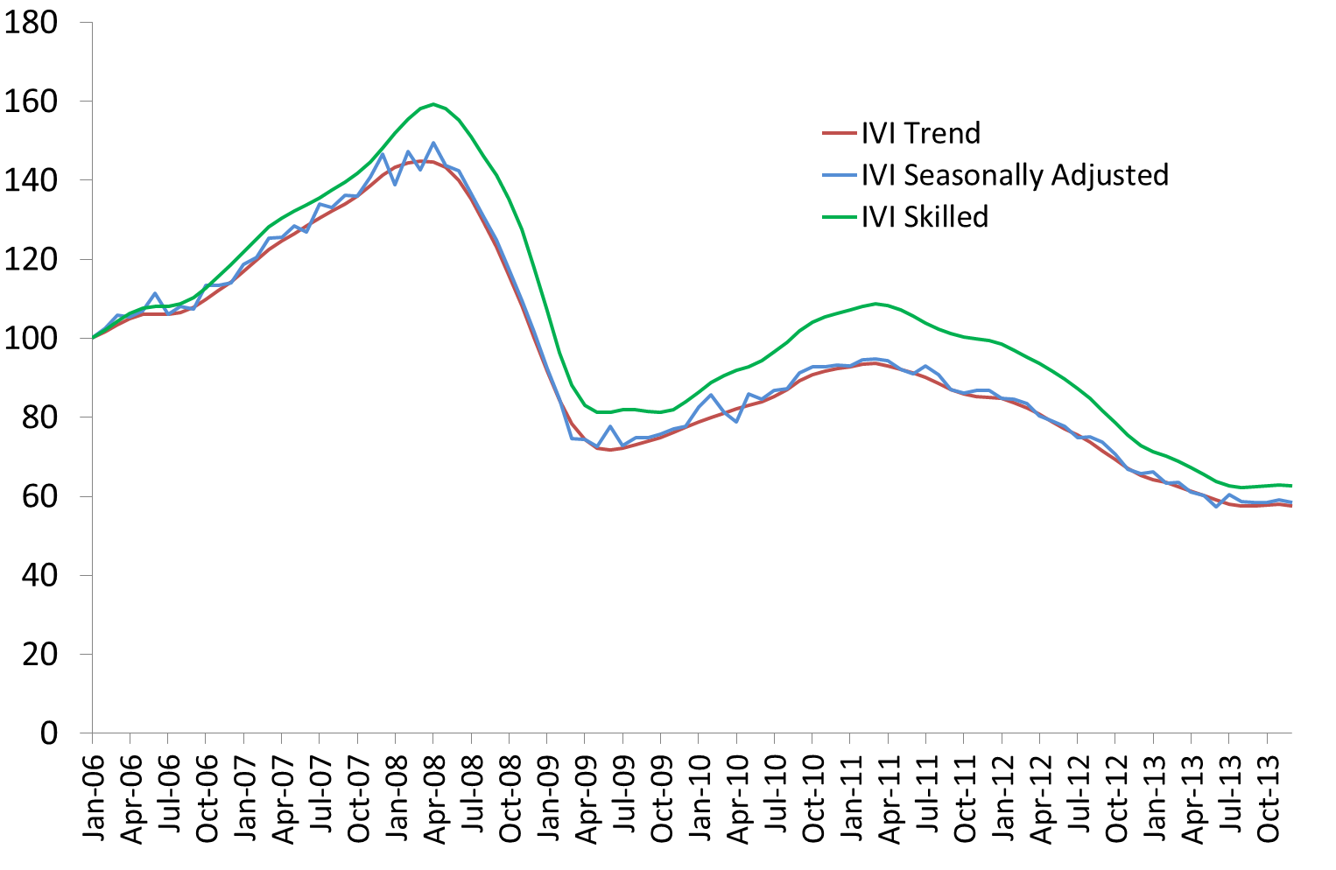

Internet Vacancy Index – Trend Series
In trend terms, the IVI decreased by 0.6% in December 2013, following rises in the two previous months. Over the month, vacancies increased in Tasmania (up by 0.2%) and the Australian Capital Territory (0.1%) but declined in all other states and the Northern Territory. Five of the occupational groups recorded a decrease in December, with the largest decreases recorded for Labourers and Managers (both down by 1.3%). Increases were recorded for Sales Workers (up by 0.7%), Community and Personal Service Workers (0.6%) and Technicians and Trades Workers (0.5%).
While recent data suggest that the IVI may be stabilising, it remains 12.0% lower than a year ago. Over the year to December 2013, vacancies have declined in all states and territories, with the strongest falls recorded in Western Australia (down by 27.2%) and the Northern Territory (25.5%). Vacancies also fell across all eight occupational groups, with the strongest fall recorded for Professionals (down by 18.2%). Around 162,800 newly lodged vacancies were advertised during December.

Internet Vacancy Index – Seasonally Adjusted Series
IVI - December 2013 | Index (Jan '06 = 100) | Monthly  % change | Yearly  % change | Number of vacancies
Managers | 71.2 | -1.3 | -9.0 | 20,763
Professionals | 60.8 | -1.1 | -18.2 | 43,404
Technicians and Trades Workers | 66.2 | 0.5 | -7.5 | 20,470
Community and Personal Service Workers | 83.3 | 0.6 | -5.9 | 13,561
Clerical and Administrative Workers | 47.7 | -0.5 | -11.4 | 28,013
Sales Workers | 57.7 | 0.7 | -2.2 | 17,164
Machinery Operators and Drivers | 53.5 | -1.0 | -16.0 | 7695
Labourers | 36.3 | -1.3 | -17.6 | 11,636
States and Territories
New South Wales | 54.5 | -0.5 | -5.7 | 58,130
Victoria | 57.4 | -0.1 | -6.0 | 40,375
Queensland | 53.0 | -0.2 | -13.9 | 30,880
South Australia | 50.5 | -1.5 | -11.6 | 7409
Western Australia | 80.4 | -1.3 | -27.2 | 17,893
Tasmania | 52.1 | 0.2 | -0.9 | 1662
Northern Territory | 92.6 | -2.8 | -25.5 | 2541
Australian Capital Territory | 88.6 | 0.1 | -22.9 | 4086
Australia | 57.6 | -0.6 | -12.0 | 162,831
In seasonally adjusted terms, the IVI decreased by 1.2% in December 2013. Over the month, vacancies decreased in all states and the Northern Territory but increased in the Australian Capital Territory (up by 7.7%). Vacancies decreased in five of the eight occupational groups, with Professionals (down by 3.3%) and Labourers (2.7%) recording the largest falls.
Over the year to December 2013, the IVI has decreased by 11.1% in seasonally adjusted terms, with a decline in vacancies recorded across all occupational groups except Sales Workers (up by 0.1%) and all states and territories, except Tasmania (up by 0.9%, albeit from a relatively low base).
IVI - Seasonally Adjusted | Index (Jan '06 = 100) | Monthly  % change | Yearly  % change | Number of vacancies
Managers | 72.4 | -2.4 | -8.2 | 20,837
Professionals | 60.3 | -3.3 | -16.0 | 43,147
Technicians and Trades Workers | 68.3 | 1.8 | -6.4 | 20,684
Community and Personal Service Workers | 85.1 | 0.2 | -6.4 | 13,630
Clerical and Administrative Workers | 48.4 | -1.6 | -8.9 | 28,264
Sales Workers | 59.2 | 2.3 | 0.1 | 17,410
Machinery Operators and Drivers | 54.4 | -1.7 | -16.7 | 7677
Labourers | 36.8 | -2.7 | -19.2 | 11,585
States and Territories
New South Wales | 55.1 | -1.4 | -5.0 | 58,142
Victoria | 58.7 | -0.2 | -4.3 | 40,744
Queensland | 53.3 | -0.3 | -12.3 | 31,320
South Australia | 50.9 | -4.3 | -10.9 | 7372
Western Australia | 81.6 | -1.7 | -27.1 | 17,864
Tasmania | 51.6 | -4.4 | 0.9 | 1663
Northern Territory | 81.3 | -19.4 | -33.2 | 2312
Australian Capital Territory | 95.6 | 7.7 | -18.9 | 4244
Australia | 58.4 | -1.2 | -11.1 | 163,224

Skilled Internet Vacancy Index
The Skilled IVI decreased by 0.5% in December 2013. Vacancies increased in seven occupational groups over the month, with the strongest increases recorded for Education Professionals (up by 3.2%), followed by Construction Trades (2.4%) and Automotive and Engineering Trades (2.3%). Engineers recorded the strongest decrease over the month (down by 5.4%), followed by Science Professionals and Veterinarians (3.1%).
Over the year to December 2013, the Skilled IVI has fallen by 14.1%, with decreases recorded across 15 of the 20 occupational groups. The strongest declines were recorded for Science Professionals and Veterinarians (down by 67.2%) and Engineers (60.5%) while the strongest increases were recorded for Construction Trades (up by 14.9%), Medical Practitioners and Nurses (14.8%) and Education Professionals (13.4%).
Skilled IVI - December 2013 | Index (Jan '06 = 100) | Monthly % change | Yearly  % change | Number of vacancies
Professionals | 60.8 | -1.1 | -18.2 | 43,404
Arts and Media Professionals | 52.2 | -1.3 | -15.0 | 696
Education Professionals | 97.4 | 3.2 | 13.4 | 1858
ICT Professionals | 54.3 | -1.0 | -13.6 | 9560
Legal, Social and Welfare Professionals | 61.1 | -0.6 | -9.8 | 3718
Business, Finance and Human Resource Professionals | 44.2 | -2.0 | -18.5 | 9969
Information Professionals | 80.4 | -1.9 | -17.4 | 1627
Sales, Marketing & Public Relations Professionals | 78.4 | -0.4 | -6.8 | 3064
Transport and Design Professionals, and Architects | 74.1 | -0.4 | -11.2 | 1808
Engineers | 40.6 | -5.4 | -60.5 | 3010
Science Professionals and Veterinarians | 48.2 | -3.1 | -67.2 | 542
Health Diagnostic and Therapy Professionals | 154.1 | 0.9 | 8.3 | 2838
Medical Practitioners and Nurses | 135.2 | 1.9 | 14.8 | 4704
Technicians and Trades Workers | 66.2 | 0.5 | -7.5 | 20,470
Engineering, ICT and Science Technicians | 64.2 | -0.3 | -12.2 | 4821
Automotive and Engineering Trades | 66.7 | 2.3 | -16.5 | 4883
Construction Trades | 72.3 | 2.4 | 14.9 | 2247
Electrotechnology and Telecommunications Trades | 64.7 | -0.6 | -13.3 | 1945
Food Trades | 75.7 | 1.0 | 0.1 | 3980
Skilled Animal and Horticultural Workers | 60.6 | 0.8 | -1.0 | 737
Hairdressers, Printing, Clothing and Wood Trades | 56.0 | -1.6 | -10.4 | 1336
Jewellers, Arts and Other Trades Workers | 56.2 | -0.5 | -10.8 | 379
Skilled IVI Total | 62.6 | -0.5 | -14.1 | 64,104

Regional Internet Vacancy Index
Over the year to December 2013, the number of online vacancies increased in 14 of the 38 regions. The strongest increase was recorded in Southern Highlands & Snowy NSW (up by 20.7%), albeit from a relatively low base, while the strongest falls were recorded in Outback Queensland (down by 40.4%) and Pilbara & Kimberley WA (36.1%). Despite vacancies rising in some regions over the last 12 months, vacancies in many regions across Australia are significantly lower than the levels recorded in May 2010 when the regional vacancy series began.

Change in internet vacancies over the year to December 2013

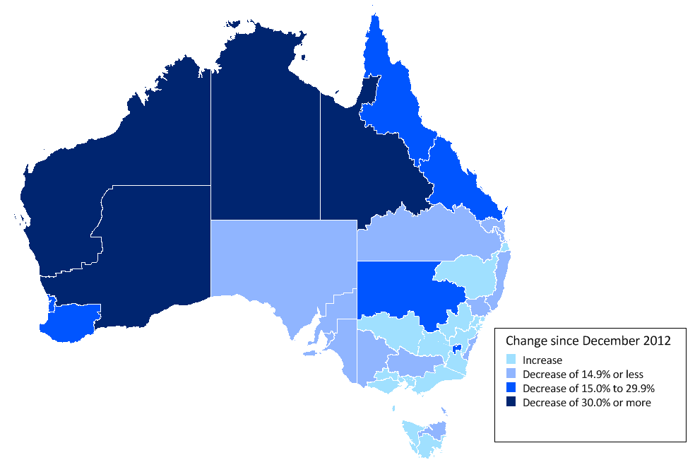
Over the past year, there has been a shift in the distribution of vacancies across Australia. With softening conditions in mining related activities over the past year, vacancies in Western Australia, Queensland and the Northern Territory have declined at a faster rate than other regions. For example, the proportion of vacancies lodged in Western Australia has fallen by 2.4 percentage points over the past year to stand at 11.0 per cent in December 2013. By contrast, the proportion of vacancies lodged in New South Wales has increased by 2.1 percentage points over the past year to stand at 35.7 per cent in December 2013.

Regional IVI – three month moving average
Regional IVI - December 2013 | Index (May '10 = 100) | Yearly  % change | Number of vacancies
New South Wales
Bathurst & Central West NSW | 38.6 | 1.7 | 304
Blue Mountains | 95.8 | 5.0 | 900
Dubbo & Western NSW | 69.3 | -21.3 | 582
Gosford & Central Coast | 101.5 | 1.1 | 915
Illawarra & South Coast | 76.7 | -7.3 | 1217
NSW North Coast | 92.0 | -14.1 | 1604
Newcastle & Hunter | 63.3 | -8.9 | 2658
Riverina & Murray | 89.3 | 9.5 | 699
Southern Highlands & Snowy | 75.3 | 20.7 | 403
Sydney | 77.2 | 6.5 | 43,791
Tamworth & North West NSW | 62.8 | 17.2 | 686
Victoria
Ballarat & Central Highlands | 98.0 | 3.8 | 436
Bendigo & High Country | 79.7 | -8.4 | 1130
Geelong & Surf Coast | 90.1 | 0.2 | 1176
Gippsland | 169.1 | 10.8 | 1062
Melbourne | 73.2 | 2.5 | 33,223
Wimmera & Western | 91.1 | -4.0 | 486
Queensland
Brisbane | 67.3 | -8.4 | 16,575
Central Queensland | 91.2 | -17.9 | 2449
Far North Queensland | 96.3 | -28.0 | 3553
Gold Coast | 85.0 | 7.1 | 3151
Outback Queensland | 90.0 | -40.4 | 293
Sunshine Coast | 110.0 | -0.1 | 1322
Toowoomba & South West QLD | 140.2 | -10.4 | 1566
South Australia
Adelaide | 60.1 | -5.6 | 6227
Fleurieu Peninsula & Murray Mallee | 101.5 | -5.6 | 465
Port Augusta & Eyre Peninsula | 95.6 | -11.4 | 278
Yorke Peninsula & Clare Valley | 74.5 | -13.7 | 113
Western Australia
Goldfields & Southern WA | 142.4 | -33.4 | 928
Perth | 77.5 | -19.8 | 14,084
Pilbara & Kimberley | 258.7 | -36.1 | 1626
South West WA | 49.2 | -23.3 | 588
Tasmania
Hobart & Southeast Tasmania | 64.5 | 11.5 | 999
Launceston & Northeast Tasmania | 52.6 | -3.6 | 336
North West Tasmania | 79.9 | 5.5 | 297
Northern Territory
Darwin | 74.8 | -9.4 | 2022
Regional Northern Territory | 53.4 | -32.4 | 507

State and Territory IVI – trend
State IVI - December 2013 | Index (Jan '06 = 100) | Monthly  % change | Yearly  % change | Number of vacancies
Australia | 57.6 | -0.6 | -12.0 | 162,831
Managers | 71.2 | -1.3 | -9.0 | 20,763
Professionals | 60.8 | -1.1 | -18.2 | 43,404
Technicians and Trades Workers | 66.2 | 0.5 | -7.5 | 20,470
Community and Personal Service Workers | 83.3 | 0.6 | -5.9 | 13,561
Clerical and Administrative Workers | 47.7 | -0.5 | -11.4 | 28,013
Sales Workers | 57.7 | 0.7 | -2.2 | 17,164
Machinery Operators and Drivers | 53.5 | -1.0 | -16.0 | 7695
Labourers | 36.3 | -1.3 | -17.6 | 11,636
New South Wales | 54.5 | -0.5 | -5.7 | 58,130
Managers | 62.7 | -0.9 | -2.4 | 8305
Professionals | 53.0 | -1.6 | -10.3 | 16,518
Technicians and Trades Workers | 68.8 | 0.0 | 4.1 | 6185
Community and Personal Service Workers | 83.0 | 0.1 | -5.0 | 4578
Clerical and Administrative Workers | 44.3 | 0.4 | -7.7 | 10,803
Sales Workers | 49.2 | -0.2 | -3.0 | 5836
Machinery Operators and Drivers | 60.3 | 0.3 | 5.0 | 2200
Labourers | 46.8 | -0.8 | -9.9 | 3652
Victoria | 57.4 | -0.1 | -6.0 | 40,375
Managers | 77.2 | -1.0 | -4.3 | 5340
Professionals | 65.4 | -0.2 | -8.3 | 11,232
Technicians and Trades Workers | 61.5 | 1.0 | -4.3 | 4446
Community and Personal Service Workers | 84.0 | 0.4 | -1.1 | 3557
Clerical and Administrative Workers | 46.4 | -0.5 | -12.0 | 6957
Sales Workers | 54.8 | 0.7 | 0.4 | 4462
Machinery Operators and Drivers | 46.2 | -0.6 | -11.0 | 1536
Labourers | 34.6 | -0.5 | -16.3 | 2687
Queensland | 53.0 | -0.2 | -13.9 | 30,880
Managers | 67.1 | -1.6 | -15.3 | 3269
Professionals | 59.7 | -0.2 | -20.2 | 7575
Technicians and Trades Workers | 51.7 | 0.2 | -16.2 | 4497
Community and Personal Service Workers | 73.3 | 0.7 | -5.1 | 2634
Clerical and Administrative Workers | 46.9 | 0.6 | -9.1 | 4942
Sales Workers | 61.6 | 0.7 | -2.8 | 3375
Machinery Operators and Drivers | 46.3 | -0.8 | -27.2 | 1783
Labourers | 31.8 | -2.2 | -18.0 | 2653
South Australia | 50.5 | -1.5 | -11.6 | 7409
Managers | 66.4 | -0.3 | -2.6 | 771
Professionals | 71.1 | 0.1 | -12.6 | 1603
Technicians and Trades Workers | 49.8 | -0.5 | -12.7 | 1058
Community and Personal Service Workers | 64.8 | 0.3 | 3.2 | 722
Clerical and Administrative Workers | 47.1 | -2.2 | -15.1 | 1126
Sales Workers | 47.7 | -2.8 | -12.4 | 749
Machinery Operators and Drivers | 40.9 | -0.6 | -19.5 | 507
Labourers | 29.6 | -2.1 | -17.0 | 883
Western Australia | 80.4 | -1.3 | -27.2 | 17,893
Managers | 117.1 | -1.7 | -25.7 | 2167
Professionals | 77.5 | -2.1 | -43.3 | 4230
Technicians and Trades Workers | 117.6 | -0.2 | -15.5 | 3057
Community and Personal Service Workers | 126.9 | 0.8 | -8.1 | 1183
Clerical and Administrative Workers | 63.0 | -1.9 | -27.6 | 2840
Sales Workers | 103.9 | 1.7 | -1.8 | 1897
Machinery Operators and Drivers | 77.7 | -3.0 | -27.8 | 1263
Labourers | 38.7 | -0.5 | -23.3 | 1227
Tasmania | 52.1 | 0.2 | -0.9 | 1662
Managers | 79.2 | 0.7 | 20.8 | 169
Professionals | 83.1 | 0.2 | -5.1 | 355
Technicians and Trades Workers | 52.9 | -0.2 | -1.3 | 222
Community and Personal Service Workers | 66.8 | 1.4 | 1.5 | 201
Clerical and Administrative Workers | 55.3 | -1.1 | -0.2 | 221
Sales Workers | 60.5 | 1.5 | 12.2 | 200
Machinery Operators and Drivers | 29.2 | 2.0 | -22.9 | 94
Labourers | 20.8 | -1.6 | -26.7 | 182
Northern Territory | 92.6 | -2.8 | -25.5 | 2541
Managers | 107.0 | -1.8 | -18.2 | 273
Professionals | 162.4 | -0.4 | -13.4 | 632
Technicians and Trades Workers | 94.1 | -0.5 | -14.2 | 417
Community and Personal Service Workers | 88.6 | -5.1 | -33.0 | 230
Clerical and Administrative Workers | 102.6 | -3.1 | -23.6 | 420
Sales Workers | 97.0 | -0.7 | -8.8 | 244
Machinery Operators and Drivers | 86.1 | -4.3 | -35.3 | 185
Labourers | 46.5 | -3.7 | -31.0 | 197
Australian Capital Territory | 88.6 | 0.1 | -22.9 | 4086
Managers | 69.0 | -2.1 | -25.3 | 518
Professionals | 79.4 | -0.1 | -22.0 | 1489
Technicians and Trades Workers | 149.0 | 1.3 | -14.3 | 436
Community and Personal Service Workers | 277.9 | 4.3 | 6.0 | 454
Clerical and Administrative Workers | 66.4 | -4.5 | -30.4 | 567
Sales Workers | 114.5 | 2.3 | -9.4 | 359
Machinery Operators and Drivers | 128.2 | 4.5 | -3.6 | 88
Labourers | 89.1 | 2.5 | -36.6 | 178

Occupational IVI – trend
Occupational IVI - December 2013 | Index (Jan  '06 = 100) | Monthly % change | Yearly  % change | Number of vacancies
Managers | 71.2 | -1.3 | -9.0 | 20,763
Chief Executives, Managing Directors & Legislators | 103.9 | 0.7 | -13.5 | 743
Farmers and Farm Managers | 49.2 | 0.7 | -12.2 | 65
Hospitality, Retail and Service Managers | 84.4 | -0.7 | -3.3 | 4704
Corporate Managers | 70.7 | -0.6 | -7.4 | 9771
Construction, Production and Distribution Managers | 62.7 | -2.3 | -13.5 | 4301
Health, Education, ICT and Other Managers | 53.3 | -2.1 | -17.1 | 1203
Professionals | 60.8 | -1.1 | -18.2 | 43,404
Arts and Media Professionals | 52.2 | -1.3 | -15.0 | 696
Education Professionals | 97.4 | 3.2 | 13.4 | 1858
ICT Professionals | 54.3 | -1.0 | -13.6 | 9560
Legal, Social and Welfare Professionals | 61.1 | -0.6 | -9.8 | 3718
Business, Finance and Human Resource Professionals | 44.2 | -2.0 | -18.5 | 9969
Information Professionals | 80.4 | -1.9 | -17.4 | 1627
Sales, Marketing & Public Relations Professionals | 78.4 | -0.4 | -6.8 | 3064
Transport and Design Professionals, and Architects | 74.1 | -0.4 | -11.2 | 1808
Engineers | 40.6 | -5.4 | -60.5 | 3010
Science Professionals and Veterinarians | 48.2 | -3.1 | -67.2 | 542
Health Diagnostic and Therapy Professionals | 154.1 | 0.9 | 8.3 | 2838
Medical Practitioners and Nurses | 135.2 | 1.9 | 14.8 | 4704
Technicians and Trades Workers | 66.2 | 0.5 | -7.5 | 20,470
Engineering, ICT and Science Technicians | 64.2 | -0.3 | -12.2 | 4821
Automotive and Engineering Trades | 66.7 | 2.3 | -16.5 | 4883
Construction Trades | 72.3 | 2.4 | 14.9 | 2247
Electrotechnology and Telecommunications Trades | 64.7 | -0.6 | -13.3 | 1945
Food Trades | 75.7 | 1.0 | 0.1 | 3980
Skilled Animal and Horticultural Workers | 60.6 | 0.8 | -1.0 | 737
Hairdressers, Printing, Clothing and Wood Trades | 56.0 | -1.6 | -10.4 | 1336
Jewellers, Arts and Other Trades Workers | 56.2 | -0.5 | -10.8 | 379
Community and Personal Service Workers | 83.3 | 0.6 | -5.9 | 13,561
Health and Welfare Support Workers | 112.8 | 0.3 | 0.4 | 981
Carers and Aides | 114.6 | 0.3 | -8.0 | 6452
Hospitality Workers | 54.2 | -0.7 | -12.3 | 3335
Protective Service Workers | 42.0 | -2.1 | -12.7 | 553
Sports, Travel and Personal Service Workers | 101.1 | 0.5 | 10.7 | 2157
Clerical and Administrative Workers | 47.7 | -0.5 | -11.4 | 28,013
Numerical Clerks | 36.4 | -1.4 | -21.7 | 6072
Clerical and Office Support Workers, Couriers | 70.4 | 1.8 | -6.5 | 775
Other Clerical and Administrative Workers | 64.5 | -0.8 | -4.5 | 4204
Office Managers, Administrators and Secretaries | 47.8 | -0.8 | -13.8 | 4695
General-Inquiry Clerks, Call Centre, Receptionists | 49.4 | 0.5 | -8.0 | 12,210
Sales Workers | 57.7 | 0.7 | -2.2 | 17,164
Sales Representatives and Agents | 71.8 | 2.4 | 12.9 | 6678
Sales Assistants and Salespersons | 51.5 | -0.9 | -9.4 | 8985
Sales Support Workers | 44.9 | -1.4 | -9.7 | 1482
Machinery Operators and Drivers | 53.5 | -1.0 | -16.0 | 7695
Machine and Stationary Plant Operators | 57.1 | -0.4 | -27.4 | 1691
Mobile Plant Operators | 75.1 | 0.4 | -7.8 | 1999
Drivers and Storepersons | 46.1 | -1.6 | -13.7 | 4015
Labourers | 36.3 | -1.3 | -17.6 | 11,636
Cleaners and Laundry Workers | 46.5 | -0.2 | -16.9 | 2291
Construction and Mining Labourers | 54.6 | 0.3 | -0.6 | 1110
Factory Process Workers | 45.7 | -0.6 | -14.8 | 1902
Farm, Forestry and Garden Workers | 32.0 | 1.7 | -7.2 | 762
Food Preparation Assistants | 41.9 | -2.1 | -16.2 | 1101
Other Labourers | 28.6 | -2.4 | -22.8 | 4491
Australian Total | 57.6 | -0.6 | -12.0 | 162,831

Explanatory Notes
- The monthly Internet Vacancy Index (IVI) is based on a count of online job advertisements newly lodged on SEEK, MyCareer, CareerOne and Australian JobSearch during the month. Duplicate advertisements are removed before the IVI vacancies are coded by the Department of Employment to occupations based on the Australian and New Zealand Standard Classification of Occupations (ANZSCO). The data are seasonally adjusted and trended, and then indexed (January 2006 = 100).
- The Skilled IVI is based on the aggregation of Professionals and Technicians and Trades Workers.
- The Regional IVI was first published in September 2010 and back cast to May 2010. The Regional IVI concords vacancies to 38 best fit regions across the states and territories from the four job boards.
- For more information, please contact Carmel O’Regan (02 6240 2599) or email carmel.oregan@deewr.gov.au. Any media enquiries should be directed to the Department of Employment media unit (media@deewr.gov.au).

Adjustment for MyCareer’s shift to free job advertising
- Since July 2013, the IVI has been affected by MyCareer’s move to free job advertising. The Department has made an adjustment to the data to take account of this change, in order to provide a more reliable indicator of recent vacancy trends.
- The adjustment has been made by estimating the change in the level of job advertisements between the period up to June 2013 compared with the period from July 2013 onwards. This estimated level shift was then used to adjust upwards the data for the period up to June 2013 in order to make the level more comparable with the period thereafter. Seasonal adjustment and trending were then performed on the revised series.
- The adjustment has been applied to all seasonally adjusted and trend series, except for some series at the two digit occupation by state level, where the effect of the MyCareer change could not be estimated accurately. Data have not been adjusted at the regional and four digit occupational level, as these series are only published as three month averages of original data.
- As each month of IVI data becomes available, the estimated size of the level shift may change. As a result, trend revisions to the data may be larger than usual in the coming months.

Acknowledgements
The Department of Employment thanks the following job boards for their contribution to the Vacancy Report:



Forthcoming release dates for 2014 (release time 11am):
For data covering: | Release date:
January 2014 | 19 February 2014
February 2014 | 19 March 2014
March 2014 | 23 April 2014
April 2014 | 21 May 2014
May 2014 | 25 June 2014
June 2014 | 23 July 2014
July 2014 | 20 August 2014
August 2014 | 24 September 2014
September 2014 | 22 October 2014
October 2014 | 19 November 2014
November 2014 | 17 December 2014

The Regional IVI is in three month moving average terms, and is not seasonally adjusted, trended or adjusted for MyCareer’s shift to free job advertising in July 2013. As such, these series should be used with caution, as they typically exhibit more volatility than the overall IVI series.

